Using the STAT_873 listserv

The online version of the liststerv can be accessed through the course website in order to obtain the window below.

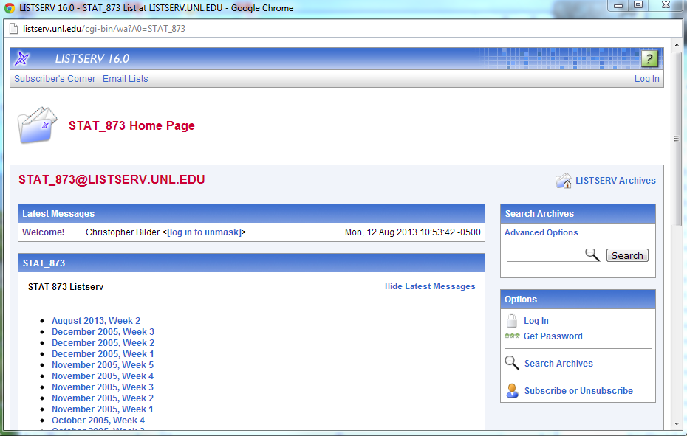

This web interface works much like a regular message board. Past posts to the listserv are archived here by week, so that you can easily access them. New posts can be made through the web interface in addition to the usual way of by e-mail.

All students are required to subscribe to the listserv. All new posts will be sent to your e-mail address automatically. Also, you will be allowed to submit your own posts by joining the listserv. To join the listserv, select the “Subscribe or Unsubscribe” link in the previous window to take you to the following window:

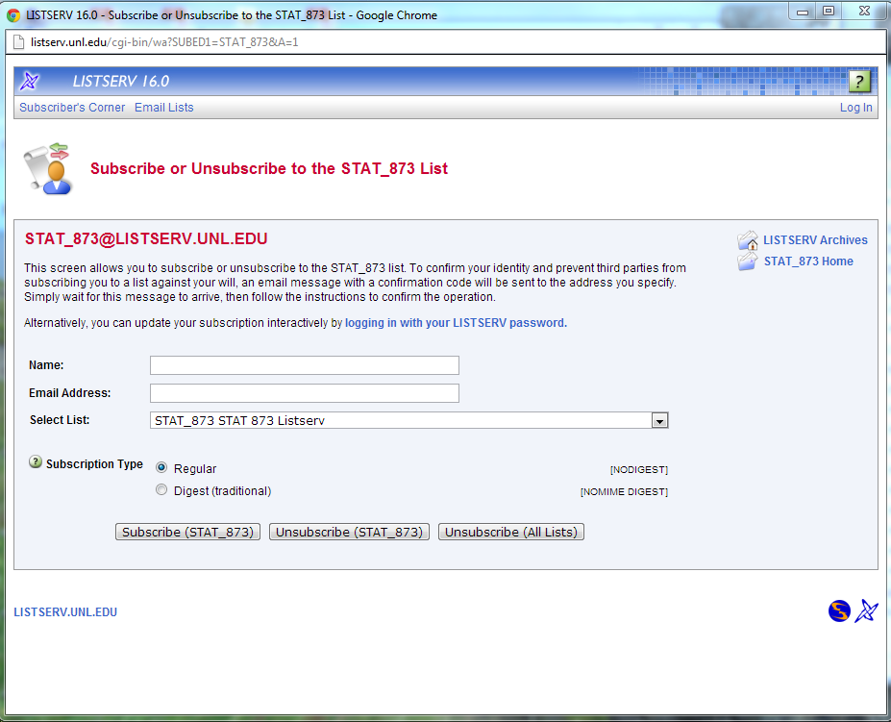

You can enter your e-mail address and full name in the boxes above and select the “Subscribe (STAT_873)” button to complete the joining of the listserv. I recommend using “Regular” subscription type rather than “Digest” because you may miss timely posts to the listserv.

As mentioned earlier, messages are automatically e-mailed to all students in the class, but they are also posted to an archive of all posts to form a message board. The archive is indexed by week. Selecting the week from the listserv home page gives you access to those week’s messages.

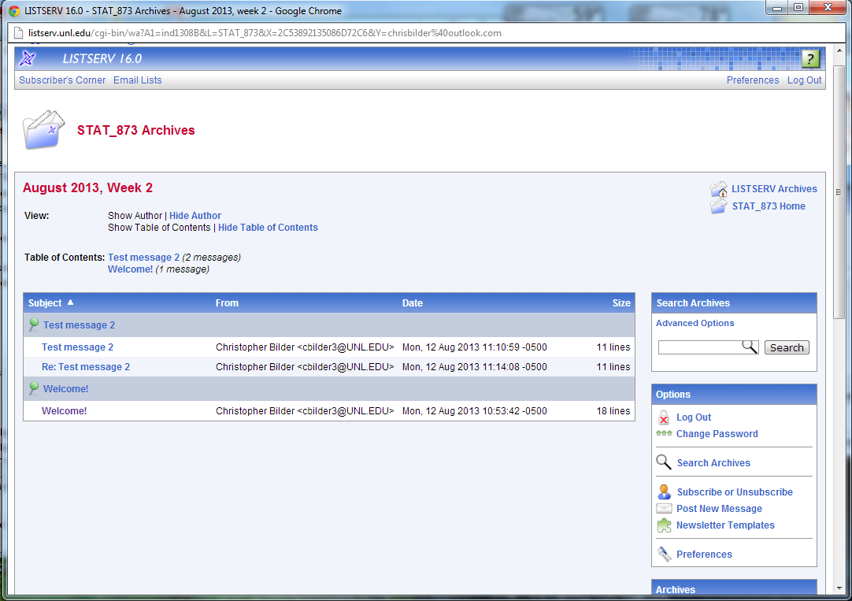

In order to read a message, select the message title of interest. Below is the “Welcome!” message.

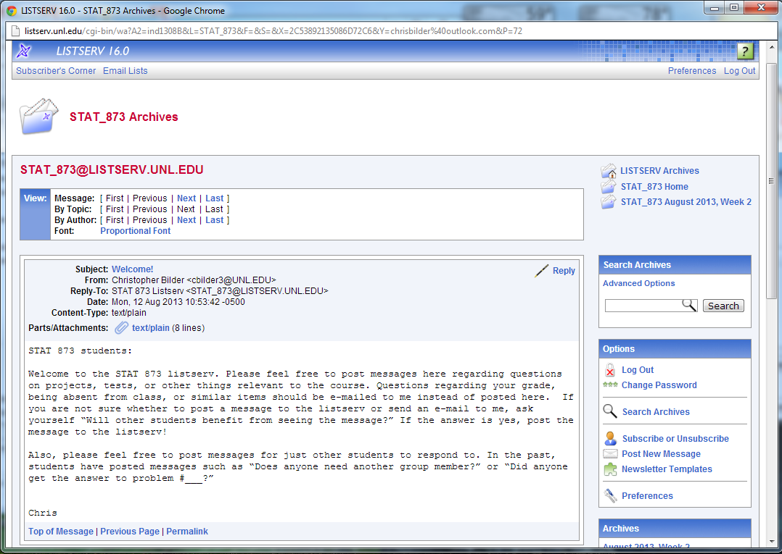

There are two ways to post a message to the listserv:

  - You can send an e-mail to stat_873@listserv.unl.edu or reply to someone else’s posting via that e-mail address. Please be careful when replying to past messages this way as a reply! The name given in the original listserv post to you will be the name of the person who posted. Sometimes, students will see this name and think they are replying directly to the original person ONLY. Instead, a post will be distributed to everyone in the class! A few times every semester, I usually will have a student who thinks they are e-mailing me directly with some private information, but instead reply to one of my past listserv posts so that everyone in class ends up receiving it. Do not let this be you!

  - You can simply use the web interface to post a message. If you have not registered for a listserv password (this is different from subscribing to the message board), you will need to register. This can be done by selecting “Log In” on the right side of the listserv’s home page and following the directions listed there (set up a listserv password).

