Project #2 Answers
STAT 494/873
Fall 2025

This project continues to use the data from Project #1. Complete the following problems using this data. While you are welcome to use your football knowledge to help with interpretations, this is not needed to perform well on this project. Include your R program output with code inside of it for each part and any additional information needed to explain your answer. Your R code and output should be formatted in the same manner as in the Project #1 answer key.

- (22 total points) The purpose of this problem is to use the furthest neighbor method for hierarchical clustering with the NFL combine data. Use only the numerical variables in the data set and exclude the OverallGrade variable (remove the first four columns of the original data set). Standardize the data for the analysis.
  - (4 points) Which two observations are joined into a cluster first?

> Z <- scale(fb[,-c(1:4)])
> head(Z)
Height ArmLength Weight HandLength Dash40
[1,] -0.1408421 -0.6548626 -0.9151200 0.1153049 -0.81510508
[2,] -0.1408421 0.2653692 -0.5534588 -1.0651980 -0.61881033
[3,] 1.2303750 1.2776241 0.5740733 -1.0651980 -0.02992607
[4,] -1.1692549 -0.7468858 -0.2768943 -0.1207956 0.23180026
[5,] -1.8548634 -0.9309322 -1.3831521 -1.3012985 -1.60028409
[6,] -0.1408421 0.7254851 -0.4258136 -0.3568962 -0.88053667
BenchPress VerticalJump BroadJump Cone3Drill Shuttle20
[1,] -2.22399139 -0.595858101 0.1339942 -0.99067766 -1.0609538
[2,] -0.76024195 1.539300095 0.8395147 -0.94192793 -0.1919821
[3,] 1.28900725 -0.002758602 0.2515810 0.52056398 -0.1919821
[4,] 0.11800771 -0.833097901 -1.1594601 0.08181641 0.5584934
[5,] 0.11800771 1.183440396 0.7219280 -0.84442847 -1.1399512
[6,] -0.02836724 1.183440396 0.6043412 -0.33255630 0.4399973

> dist.mat <- dist(x = Z, method = "euclidean")
> clust.fn <- hclust(d = dist.mat, method = "complete")
> head(clust.fn$merge)
[,1] [,2]
[1,] -12 -54
[2,] -18 -43
[3,] -57 -61
[4,] -52 -100
[5,] -111 -117
[6,] -38 -121

Observations 12 and 54 are joined first.

  - (6 points) What is the standardized Euclidean distance for the two observations in a)? Show how this distance calculation is completed using matrix algebra in R and through by-hand calculations by setting up the actual mathematical equations.

> Z[12,]
Height ArmLength Weight HandLength Dash40
-1.1692549 -1.2070017 -0.9576684 -2.0096003 -0.1280734
BenchPress VerticalJump BroadJump Cone3Drill Shuttle20
-0.6138670 0.5903409 0.1339942 -0.3081814 -0.5079718
> Z[54,]
Height ArmLength Weight HandLength Dash40
-1.1692549 -1.2990249 -1.0640393 -1.7734997 -0.8151051
BenchPress VerticalJump BroadJump Cone3Drill Shuttle20
-0.6138670 0.5903409 0.3691677 -0.1619322 -0.3104782

> fb[12,1:3]
Player College Position
12 Berhe, Nat San Diego St. S
> fb[54,1:3]
Player College Position
54 Hal, Andre Vanderbilt DB

> sqrt(t(Z[12,] - Z[54,])%*%(Z[12,] - Z[54,]))
[,1]
[1,] 0.8143943
> head(clust.fn$height) #Check for above result
[1] 0.8143943 0.8170746 0.8826242 0.9723103 0.9964279 0.9988705

The standardized Euclidean distance between observations 12 and 54 is

  - (6 points) Construct a hierarchical tree diagram. How many clusters are appropriate for the data? Choose two possible values and explain your choices.

> plot(clust.fn)
> abline(h = 6, lty = "dashed", lwd = 2) #3
> abline(h = 4.5, lty = "dashed", lwd = 2) #7 like the number of positions, I would
not normally draw a line here
> abline(h = 4.95, lty = "dashed", lwd = 2) #9

Three clusters are the best choice because of the relatively large distance between 3 and 4 clusters in the hierarchical tree diagram. If a larger number of clusters were desired, 9 clusters may be a good choice due to perhaps a slightly larger distance at that location than elsewhere around it.

Two clusters would also be a justifiable choice (line omitted).

  - (6 points) For the two choices in the previous part, construct parallel coordinate plots with cluster memberships appropriately identified. Interpret the clusters.

3 clusters:

> clusters <- cutree(tree = clust.fn, k = 3)
> fb2 <- data.frame(player = 1:nrow(fb), fb[,-c(1:4)])
> dev.new(width = 12)
> parcoord(x = fb2, col = clusters, main = "Parallel coordinate plot", lwd = 1)
Green: This cluster separates out the observations rather well with respect to the Weight, Dash40m, VerticalJump, BroadJump, and Cone3Drill variables. Thus, these are individuals that have a large weight, large 40-yard dash and 3-cone drill time, while having small vertical and broad jumps.

Red and black: The red and black clusters are not as well separated, but we do see some distinguishing characteristics. The players in the black cluster tend to have more middle values than the red. For example, notice that the players in the black have middle 40-yard dash times and weights, while the red players tend to have smaller 40-yard dash times and weights.
9 clusters:

> clusters9 <- cutree(tree = clust.fn, k = 9)
> library(plyr)

> # Need to convert clusters9 to a factor before use revalue()
> cluster.color <- revalue(x = as.factor(clusters9), replace = c("9" = "brown"))
> fb2[cluster.color == "brown",]
player Height ArmLength Weight HandLength Dash40 BenchPress
67 67 75 32.50 219 9.000 4.42 20
85 85 69 30.25 209 8.625 4.41 32
95 95 72 32.25 232 10.125 4.51 28
103 103 69 31.00 209 10.000 4.49 26
116 116 75 30.75 234 9.625 4.67 22
VerticalJump BroadJump Cone3Drill Shuttle20
67 37.5 123 6.64 3.98
85 40.5 132 6.83 4.12
95 39.0 128 6.92 4.02
103 35.5 126 6.75 4.00
116 37.5 120 6.89 3.96

> # Need to use cluster.color here because R has only 8 distinct numerical colors.
Thus, color “1” is the same as color “9”.
> parcoord(x = fb2, col = cluster.color, lwd = 1, main = "Parallel coordinate
plot")
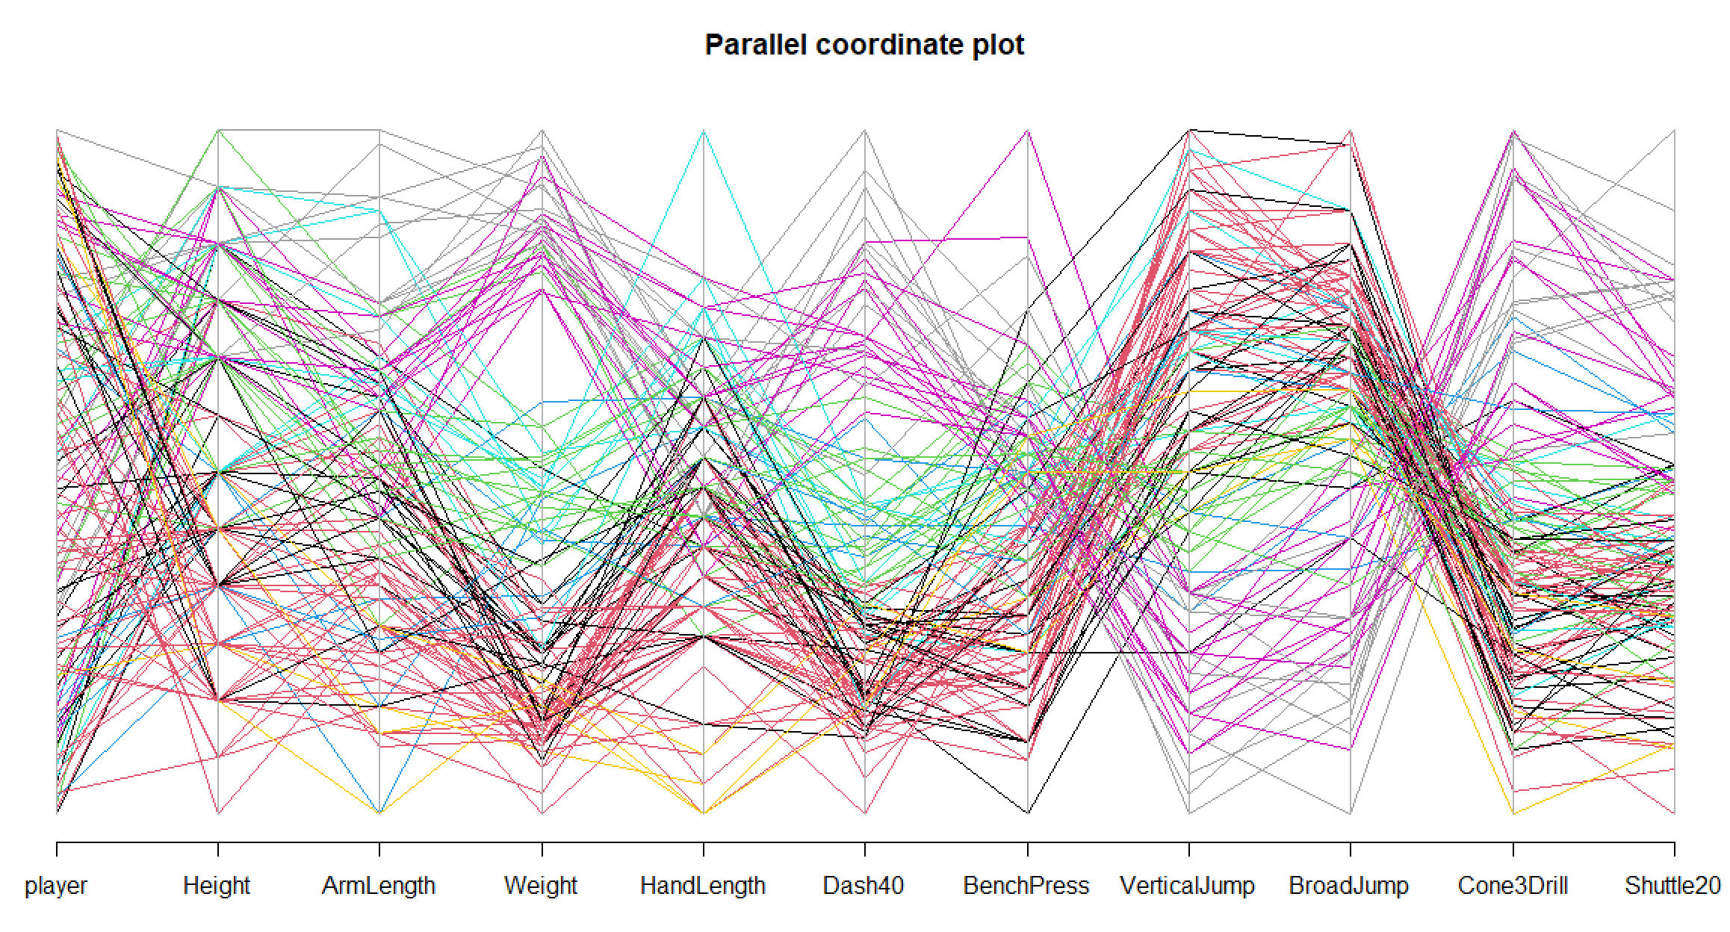

It is difficult to distinguish between the clusters! We see that the pink and gray clusters are similar in that they have large weights and small vertical and broad jumps. However, the arm lengths and 40 yard dash times appear to be larger for the grays. It is difficult to develop any other judgments. This is a sign that 9 clusters may not be appropriate!

- (18 total points) The purpose of this problem is to use K-means clustering with the NFL combine data. Use only the numerical variables in the data set and exclude the OverallGrade variable (remove the first four columns of the original data set). Standardize the data for the analysis.
  - (4 points) Based on using the W statistic, why are 3 or 4 clusters good choices? Investigate by examining W for 1 to 10 clusters and set a seed of 9919 before running kmeans() with 1 cluster. Use nstart = 10 with kmeans(). Explain your final decision for the appropriate number of clusters.

> K.levels <- 1:10
> save.wss <- numeric(length(K.levels))
> set.seed(9919)
> for(K in K.levels) {
clust.means <- kmeans(x = Z, centers = K, nstart = 10)
save.wss[K] <- sum(clust.means$withinss)
}
> tss <- clust.means$totss
> data.frame(K, save.wss/tss)
K save.wss.tss
1 10 1.0000000
2 10 0.4921775
3 10 0.3864452
4 10 0.3523056
5 10 0.3258154
6 10 0.3046536
7 10 0.2858747
8 10 0.2706561
9 10 0.2537706
10 10 0.2400083

> # W vs. K
> plot(x = K.levels, y = save.wss/tss, ylab = "Within SS / Total SS",
xlab = "K", type = "o", panel.first = grid())

The plot begins to level off at about 3 clusters and definitely by 4 clusters. I think 3 is the best choice.

  - (4 points) Run kmeans() with nstart = 10 and centers equal to 3 and 4. Set a seed of 6767 before each run. Show the corresponding default printed output from kmeans().

> set.seed(6767)
> clust.3means <- kmeans(x = Z, centers = 3, nstart = 10)
> clust.3means
K-means clustering with 3 clusters of sizes 28, 67, 34

Cluster means:
Height ArmLength Weight HandLength Dash40
1 0.4741891 0.4006974 0.1742437 0.5180647 0.04993895
2 -0.6883056 -0.6356339 -0.7617553 -0.5295668 -0.70328544
3 1.0712159 1.0344200 1.6111900 0.6380991 1.62222143
BenchPress VerticalJump BroadJump Cone3Drill
1 0.2945187 -0.1109120 0.01986589 -0.03647338
2 -0.5745424 0.6523065 0.62540153 -0.59958840
3 1.0171681 -1.4261974 -1.52061939 1.47901850
Shuttle20
1 -0.04328108
2 -0.56338790
3 1.40066236

Clustering vector:
[1] 2 2 1 1 2 2 1 1 2 1 2 2 1 1 3 3 1 2 2 2 3 1 1 2 2 1 2
[28] 2 2 2 2 2 2 1 2 1 2 2 3 3 2 2 2 3 1 3 2 2 3 2 2 2 3 2
[55] 2 3 2 2 1 1 2 2 3 2 3 3 2 1 2 3 1 2 2 1 3 2 1 2 2 1 1
[82] 1 3 1 2 3 2 2 1 1 1 2 3 2 2 2 2 3 3 2 3 1 2 1 2 2 1 2
[109] 1 2 3 3 3 2 3 2 3 3 1 2 2 2 2 2 1 2 1 2 3
Within cluster sum of squares by cluster:
[1] 143.58876 253.75982 97.30124
(between_SS / total_SS = 61.4 %)

Available components:

[1] "cluster" "centers" "totss"
[4] "withinss" "tot.withinss" "betweenss"
[7] "size" "iter" "ifault"

> set.seed(6767)
> clust.4means <- kmeans(x = Z, centers = 4, nstart = 10)
> clust.4means
K-means clustering with 4 clusters of sizes 31, 33, 37, 28

Cluster means:
Height ArmLength Weight HandLength Dash40
1 1.0712159 1.0344200 1.6111900 0.6380991 1.6222214
2 -0.3168767 -0.1574400 -0.7311270 -0.1654633 -0.7001577
3 -1.0861508 -1.1623844 -0.7578199 -0.8147883 -0.6594572
4 0.5668829 0.4909744 0.2240786 0.4884962 0.0724427
BenchPress VerticalJump BroadJump Cone3Drill
1 1.0171681 -1.4261974 -1.52061939 1.47901850
2 -0.9145291 0.5871350 0.68379173 -0.57762251
3 -0.1703066 0.6478536 0.50457064 -0.57704358
4 0.3540963 -0.1022463 0.02020057 -0.03219506
Shuttle20
1 1.40066236
2 -0.38520553
3 -0.69828377
4 -0.06201861

Clustering vector:
[1] 2 2 4 4 3 2 4 4 2 4 3 3 4 2 1 1 3 2 3 2 1 4 4 2 2 4 3
[28] 3 3 2 3 3 3 4 2 4 2 2 1 1 3 2 2 1 4 1 2 2 1 2 2 2 1 3
[55] 3 1 2 3 4 4 3 2 1 2 1 1 2 4 2 1 4 3 3 4 1 3 4 2 2 4 4
[82] 4 1 4 3 1 2 3 4 4 4 2 1 3 2 2 3 1 1 2 1 4 3 4 3 2 2 3
[109] 4 3 1 1 1 3 1 3 1 1 4 3 2 2 2 3 4 3 4 3 1

Within cluster sum of squares by cluster:
[1] 97.30124 104.75800 124.67240 124.21584
(between_SS / total_SS = 64.8 %)

Available components:

[1] "cluster" "centers" "totss"
[4] "withinss" "tot.withinss" "betweenss"
[7] "size" "iter" "ifault"

> # 7 was not required for this part; I tried it because of 7 positions
> set.seed(6767)
> clust.7means <- kmeans(x = Z, centers = 7, nstart = 10)
> clust.7means
K-means clustering with 7 clusters of sizes 13, 17, 18, 14, 24, 25, 18

Cluster means:
Height ArmLength Weight HandLength Dash40
1 -0.1999462 -0.1534950 -0.76986861 -0.29176503 -0.76433920
2 -0.6336232 -0.5225793 -0.27689429 0.13006122 -0.04832871
3 1.0712159 1.0344200 1.61119001 0.63809907 1.62222143
4 0.9561316 0.5230341 0.32410156 0.23335522 0.09275815
5 -1.6055512 -1.0731498 -0.95573434 -0.09933196 -1.01437400
6 -0.9407187 -1.0996413 -0.81938612 -1.47181562 -0.63153314
7 0.2019622 0.7123389 0.06045357 1.63309436 -0.25893662
BenchPress VerticalJump BroadJump Cone3Drill
1 -0.9924229 0.74168353 0.750310980 -0.7687823
2 -0.2479297 -0.05465481 -0.035036750 0.1336130
3 1.0171681 -1.42619740 -1.520619386 1.4790185
4 0.4107576 -0.23999840 0.004648779 -0.1034326
5 0.1712350 0.98933511 0.871583838 -0.8067582
6 -0.5488115 0.39923106 0.362635115 -0.4097434
7 0.5780432 0.86147210 0.738726078 -0.4196094
Shuttle20
1 -0.6400882
2 0.3535938
3 1.4006624
4 -0.1406338
5 -0.9999103
6 -0.4882224
7 -0.5305425

Clustering vector:
[1] 1 1 4 2 5 1 4 7 1 4 6 6 4 2 3 3 2 2 2 6 3 2 7 1 1 4 6
[28] 5 2 1 6 5 1 2 1 2 6 1 3 3 5 1 1 3 4 3 1 1 3 1 1 1 3 6
[55] 6 3 1 5 2 4 6 2 3 1 3 3 1 4 1 3 4 5 5 4 3 6 4 2 2 4 4
[82] 7 3 7 5 3 1 2 4 7 4 1 3 5 7 1 5 3 3 1 3 4 5 7 6 2 2 6
[109] 4 6 3 3 3 6 3 1 3 3 4 6 1 1 1 6 4 6 4 6 3

Within cluster sum of squares by cluster:
[1] 74.84009 47.93929 97.30124 59.68079 25.84389 45.06013
[7] 14.81998
(between_SS / total_SS = 71.4 %)

Available components:

[1] "cluster" "centers" "totss"
[4] "withinss" "tot.withinss" "betweenss"
[7] "size" "iter" "ifault"

  - (4 points) For 3 and 4 clusters, construct parallel coordinate plots with cluster memberships appropriately identified. Interpret the clusters.

3 clusters:

> dev.new(width = 12)
> fb2<-data.frame(player = 1:nrow(fb), fb[,-c(1:4)])
> parcoord(x = fb2, col = clust.3means$cluster, main = "Parallel coordinate plot",
lwd = 1)
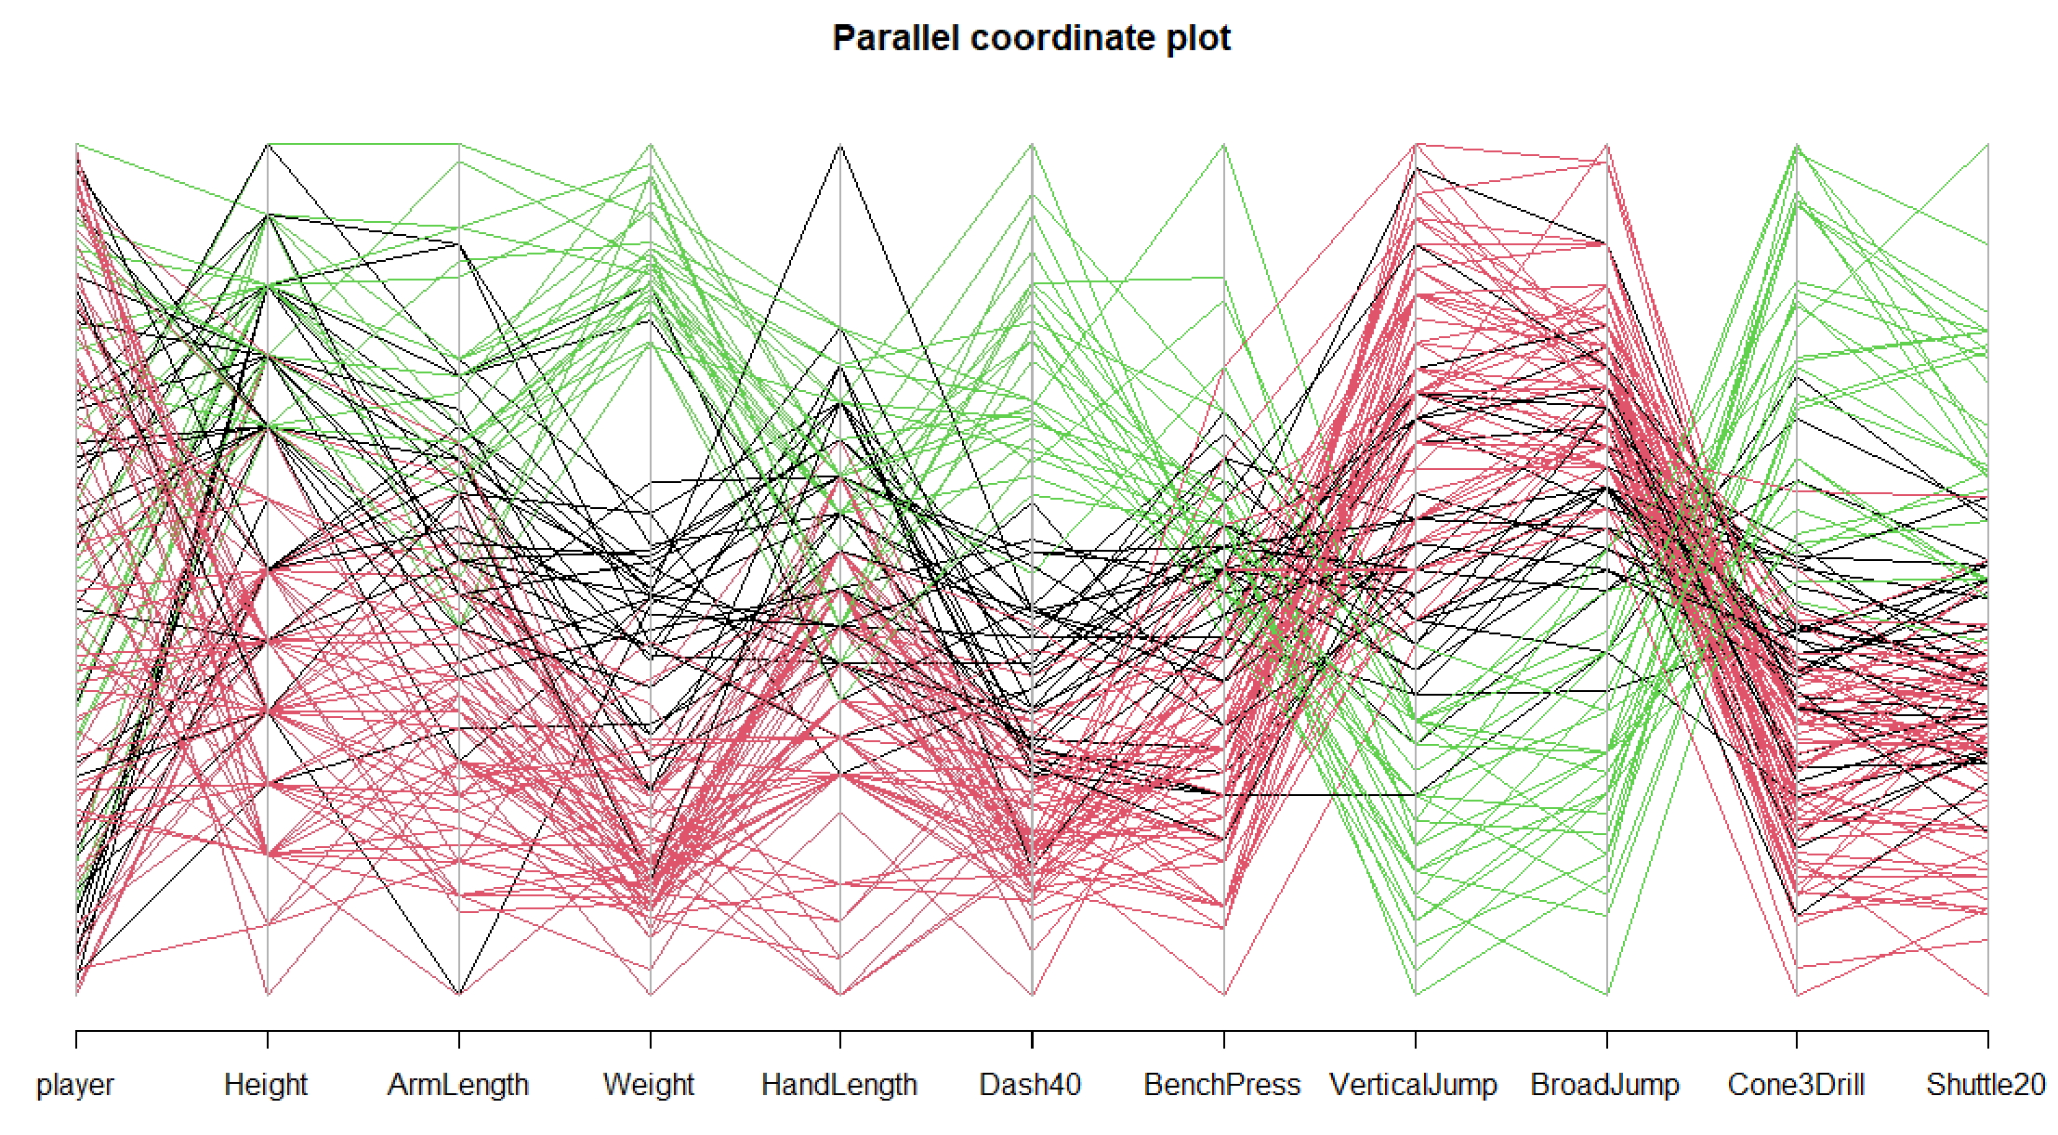

The results are very similar to what we obtained by the furthest neighbor method.

Green: This cluster separates out the observations rather well with respect to the Weight, Dash40m, VerticalJump, BroadJump, and Cone3Drill variables. Thus, these are individuals that have a large weight, a large 40-yard dash time, while having small vertical and broad jumps.

Red and green: The red and green clusters are not as well separated, but we do see some distinguishing characteristics. The black players tend of have more middle values than the red. For example, notice that the black players have middle 40-yard dash times and weights, while the red players tend to have smaller 40-yard dash times and weights.

4 clusters:

> parcoord(x = fb2, col = clust.4means$cluster, main = "Parallel coordinate plot", lwd = 1)
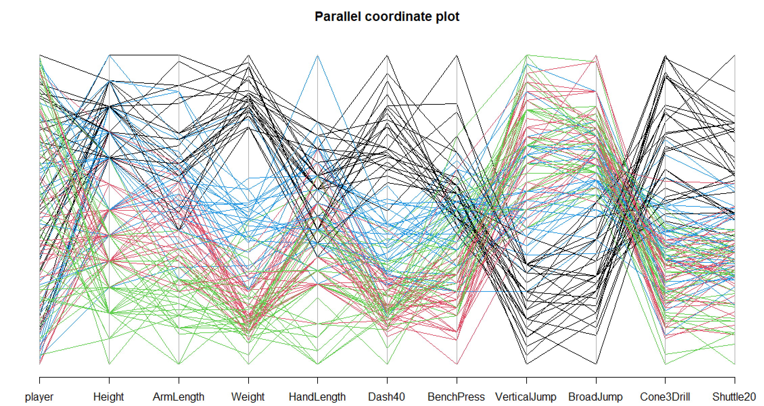

The black lines roughly correspond to the green lines for three clusters, so the interpretation presented previously holds here. The ArmLength variable may distinguish the players among the other colors the most – green is for smaller values, red for middle values, and black for larger values. The same holds, but maybe less so, for the other physical measurement variables (Height, Weight, HandLength).

  - (3 points) Based on the parallel coordinate plots, which is the more appropriate number of clusters – 3 or 4? Explain.

3 - Three clusters show mostly a distinct separation among the cluster members when taking into account multiple variables.

  - (3 points) Suppose the goal was to actually have the clusters correspond to the seven different positions of players in the data set. While it would not make sense to do a cluster analysis then, it does provide a way to see how well a clustering method is at distinguishing between these positions. For K-means clustering with K = 7 (seed number of 6767), construct a contingency table with the actual positions of the players represented by the rows and the clusters represented by the columns. Discuss how well the clustering method does in distinguishing between the positions.

> set.seed(6767)
> clust.7means <- kmeans(x = Z, centers = 7, nstart = 10)
> clust.7means
K-means clustering with 7 clusters of sizes 13, 17, 18, 14, 24, 25, 18

Cluster means:
Height ArmLength Weight HandLength Dash40 BenchPress
1 -1.1428853 -1.1645295 -0.5943707 0.15162810 -0.74212370 0.4557960
2 -1.0079352 -1.2070017 -0.8538003 -1.50962257 -0.67269516 -0.4847126
3 -0.7121825 -0.2918823 -0.5629140 0.01037134 -0.40252259 -0.4593601
4 0.7896267 0.6860466 1.2852390 0.35140551 1.22963192 0.6825968
5 0.7590191 0.5452730 0.1734094 0.64653123 -0.01220502 0.3802628
6 -0.1956907 -0.1542565 -0.8189606 -0.39467231 -0.77977203 -1.1583818
7 1.1351516 1.2265002 1.7051510 0.71867308 1.71673371 1.1588962
VerticalJump BroadJump Cone3Drill Shuttle20
1 0.90057756 0.7942890 -0.7375541 -1.0305701
2 0.47869864 0.3691677 -0.4515630 -0.5614112
3 0.20153123 0.2254506 -0.1294324 0.1964219
4 -1.16353905 -1.0754695 0.7643126 0.6515975
5 0.02689637 0.1633909 -0.2147445 -0.2561675
6 0.72793998 0.7830731 -0.8015287 -0.6533271
7 -1.44596738 -1.6167419 1.8936814 1.8202578

Clustering vector:
[1] 6 6 5 3 2 3 5 5 6 5 2 2 4 3 7 4 1 3 1 6 7 4 5 6 6 5 2 1 3 6 2 1
[33] 6 4 6 3 3 6 7 7 1 6 3 7 5 7 6 6 7 6 6 6 4 2 2 7 6 1 3 5 2 3 4 6
[65] 7 4 6 5 6 4 5 1 3 5 7 2 4 3 3 5 5 5 4 5 1 7 6 3 5 5 5 6 4 1 1 6
[97] 1 7 4 6 7 5 1 5 2 3 3 2 5 2 7 4 7 2 7 1 7 4 5 2 6 3 3 2 5 2 5 2
[129] 7

Within cluster sum of squares by cluster:
[1] 42.39071 44.28427 40.28087 40.28705 79.95161 62.05881 56.20458
(between_SS / total_SS = 71.4 %)

Available components:

[1] "cluster" "centers" "totss" "withinss"
[5] "tot.withinss" "betweenss" "size" "iter"
[9] "ifault"

> actual.cluster<-data.frame(position = fb$Position, cluster7means = clust.7means$cluster)

> head(actual.cluster)
position cluster7means
1 WO 1
2 WO 1
3 TE 4
4 RB 2
5 RB 5
6 RB 1

> xtabs(formula = ~ position + cluster7means, data = actual.cluster)
cluster7means
position 1 2 3 4 5 6 7
DB 9 0 0 0 2 7 0
LB 1 5 0 6 0 0 6
OL 0 0 28 2 0 0 0
RB 1 5 0 1 5 4 0
S 3 4 0 0 0 4 0
TE 0 0 0 8 0 0 0
WO 15 2 0 3 4 3 1

If the clustering method worked well, we would expect all players to fit into one unique column per row (the same column would not be used across rows). This obviously does not happen here. Cluster analysis is best with the TE players (8 of 8 are classified into the same cluster) and OL players (28 of 30 are classified into the same cluster).

- (18 total points) The purpose of this problem is to use DA with the NFL combine data. For this analysis, use the numerical variables (exclude the OverallGrade variable) to differentiate among the positions.
  - (8 points) Perform a linear discriminant analysis using proportional priors. Provide the 7×7 classification table. What types of classifications result in the largest correct and incorrect classification rates? Explain.

> summarize.class <- function(original, classify) {
class.table <- table(original, classify)
numb <- rowSums(class.table)
prop <- round(class.table/numb,4)
overall <- round(sum(diag(class.table))/sum(class.table),4)
list(class.table = class.table, prop = prop, overall.correct = overall)
}

> library(MASS)
> DA2 <- lda(formula = Position ~ Height + ArmLength + Weight + HandLength +
Dash40 + BenchPress + VerticalJump + BroadJump + Cone3Drill + Shuttle20,
data = fb, CV = TRUE)

> lda.accuracy <- summarize.class(original = fb$Position, classify = DA2$class)
> lda.accuracy
$class.table
classify
original DB LB OL RB S TE WO
DB 9 0 0 1 0 0 8
LB 0 14 0 2 0 2 0
OL 0 0 30 0 0 0 0
RB 1 1 1 10 0 0 3
S 1 0 0 3 0 0 7
TE 0 3 0 0 0 5 0
WO 7 0 0 2 2 0 17

$prop
classify
original DB LB OL RB S TE WO
DB 0.5000 0.0000 0.0000 0.0556 0.0000 0.0000 0.4444
LB 0.0000 0.7778 0.0000 0.1111 0.0000 0.1111 0.0000
OL 0.0000 0.0000 1.0000 0.0000 0.0000 0.0000 0.0000
RB 0.0625 0.0625 0.0625 0.6250 0.0000 0.0000 0.1875
S 0.0909 0.0000 0.0000 0.2727 0.0000 0.0000 0.6364
TE 0.0000 0.3750 0.0000 0.0000 0.0000 0.6250 0.0000
WO 0.2500 0.0000 0.0000 0.0714 0.0714 0.0000 0.6071

$overall.correct
[1] 0.6589

The OL players are all classified correctly! Unfortunately, none of the safeties are classified correctly. The other positions have correct classifications rates around 0.6.

Especially for football fans, it is interesting to see where the errors occur. For example, notice that a large proportion of S and DBs are classified incorrectly as wide receivers. This makes sense because they are often of similar body types and skill levels. Defensive backs are matched up against wide receivers during a game. Safeties are often asked to match up against a wide receiver. Similarly, tight ends are often misclassified as linebackers. When tight ends go out for a pass, they are often covered by linebackers.

  - (2 points) Try to perform a quadratic discriminant analysis using qda() and report the error message given by R.

Below is what happens when I try to use qda():

> DA4 <- qda(formula = Position ~ Height + ArmLength + Weight + HandLength + Dash40 + BenchPress + VerticalJump + BroadJump + Cone3Drill + Shuttle20,
data = fb, CV = TRUE)
Error in qda.default(x, grouping, ...) :
some group is too small for 'qda'

Based on the error message, it appears that there are not enough observations for a particular position to complete the calculations.

  - (2 points extra credit) By looking at the code inside of qda(), determine why the error message is given for the previous part.

The qda() function calls a method function based on the type of argument (data frame, matrix, formula) used to specify the variables and data.

> methods(generic.function = qda)
[1] qda.data.frame* qda.default* qda.formula*
[4] qda.matrix*

Non-visible functions are asterisked

Inside of qda.formula(), the data are arranged so that qda.default() can be executed. You can use the getAnywhere() function to see the code inside of these method functions. Inside of qda.default(), we see the following code

if (any(counts < p + 1))
stop("some group is too small for 'qda'")

Further investigation prior to this code in the function reveals that a check is being done here to compare the number of observations from each population to the number of variables. If the number of observations is less than or equal to the number of variables, qda.default() stops and returns the error message.

  - (8 points) The DA practice problems show a scatter plot where there are two plotting points for each observation. The smaller point denotes the original population for the observation, and the larger point denotes the classification. Construct a similar plot here, but now plot the first two PCs for it. Interpret the plot in the context of what the 7×7 classification table gives as the correct and incorrect classification rates. Use the cross-validation classifications found in part a) for the plot. Please use the following code to create unique plotting characters for the observations (fb is a data frame containing the data):

library(plyr)
pch7 <- 1:7
Position.pch <- as.numeric(revalue(x = fb$Position, replace = c(DB=1, LB=2, OL=3,
RB=4, S=5, TE=6, WO=7)))
color.position <- palette()[1:length(levels(fb$Position))]
Position.color <- revalue(x = fb$Position, replace = c(DB=color.position[1],
LB=color.position[2], OL=color.position[3], RB=color.position[4],
S=color.position[5], TE=color.position[6], WO=color.position[7]))

Similar code can be used with the classifications.

> save <- princomp(formula = ~ Height + ArmLength + Weight + HandLength + Dash40 +
BenchPress + VerticalJump + BroadJump + Cone3Drill + Shuttle20, data = fb,
cor = TRUE, scores = TRUE)
> #summary(save, loadings = TRUE, cutoff = 0.0)
> save$scale <- apply(X = fb[,-c(1:4)], MARGIN = 2, FUN = sd)
> score.cor <- predict(save, newdata = fb)
> #head(score.cor)

> library(plyr)
> pch7 < -1:7
> Position.pch <- as.numeric(revalue(x = fb$Position, replace = c(DB=1, LB=2,
OL=3, RB=4, S=5, TE=6, WO=7)))
> color.position <- palette()[1:length(levels(fb$Position))]
> Position.color <- revalue(x = fb$Position, replace = c(DB=color.position[1],
LB=color.position[2], OL=color.position[3], RB=color.position[4],
S=color.position[5], TE=color.position[6], WO=color.position[7]))

> par(pty = "s")
> plot(x = score.cor[,1], y = score.cor[,2], pch = Position.pch,
col = Position.color, cex = 0.75,
xlab = "Principal component 1", ylab = "Principal component 2",
main = "PC score plot \n LDA classified (large points) overlaid on the original
(small points)",
xlim = c(min(score.cor[,1], score.cor[,2]), max(score.cor[,1], score.cor[,2])),
ylim = c(min(score.cor[,1], score.cor[,2]), max(score.cor[,1], score.cor[,2])))
> abline(h = 0, lty = 1, lwd = 2)
> abline(v = 0, lty = 1, lwd = 2)

> classify.pch <- as.numeric(revalue(x = DA2$class, replace = c(DB=pch7[1],
LB=pch7[2], OL=pch7[3], RB=pch7[4], S=pch7[5], TE=pch7[6], WO=pch7[7])))
> points(x = score.cor[,1], y = score.cor[,2], pch = classify.pch, col = DA2$class,
cex = 1.5)
> legend(locator(1), legend = levels(fb$Position), pch = 1:7, col = 1:7, cex=1,
bty="n")
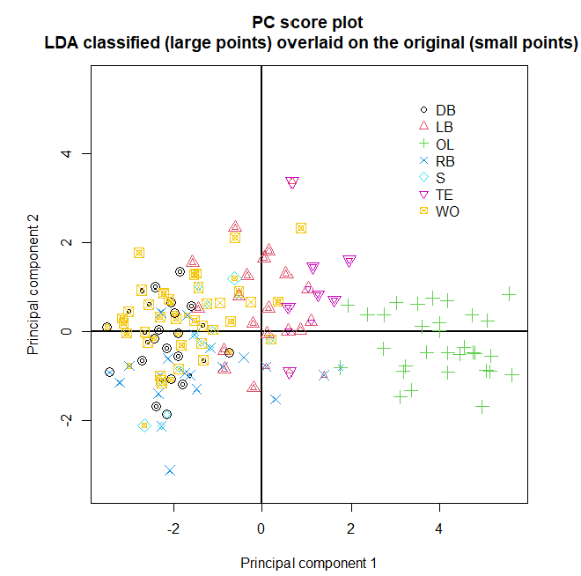

There are a number of items that can be commented on here. For example, the OL players all have larger values for PC #1 so this makes sense that they were all classified correctly. Also, notice that an RB player was misclassified as an OL player, which makes sense here given the observation is near all of the OL players in the above plot.

Many misclassifications occur for negative PC #1 values when there is a mixture of different positions. For example, we see a lot of DB and WO players are misclassified as the other position, which is what we saw in the 7×7 table.

