Project #3 Answers
STAT 494/873
Fall 2025

This project continues with the data from Project #1. Complete the following problems using this data. While you are welcome to use your football knowledge to help with interpretations, this is not needed to perform well on this project. Include your R program output with code inside of it for each part and any additional information needed to explain your answer. Your R code and output should be formatted in the same manner as in the Project #1 answer key.

- (8 total points) The purpose of this problem is to use NNC with the NFL combine data. Use NNC with the standardized numerical variables (exclude the OverallGrade variable) to differentiate among the positions.
  - (2 points) Determine an appropriate value for K using cross-validation. Set a seed number of 8971 before using NNC so that I can duplicate your results.

> Z <- scale(fb[,-c(1:4)])

> set.seed(8971)
> save.results.cv <- matrix(data = NA, nrow = 40, ncol = 9)

> for (K in 1:40) {
NNC.cv <- knn.cv(train = Z, cl = fb$Position, k = K, prob = TRUE)
NNC.cv.accuracy <- summarize.class(original = fb$Position, classify = NNC.cv)
save.results.cv[K,] <- c(K, diag(NNC.cv.accuracy$prop),
NNC.cv.accuracy$overall.correct)
}

> plot(x = save.results.cv[,1], y = save.results.cv[,9], ylim = c(0, 1), main =
"Cross-validation", panel.first = grid(), type = "l", xlab = "K", ylab =
"Accuracy", xlim = c(0,50), col = 1, lwd = 3)
> for(i in 1:7) {
points(x = save.results.cv[,1], y = save.results.cv[,i+1], ylim = c(0, 1), type
= "o", col = i, pch = i)
}
> legend(x = 40, y = 1, legend = c(levels(fb$Position), "Overall"), col = c(1:7,1),
bty = "n", cex = 1, lty = 1, pch = c(1:7,NA), lwd = c(rep(1,times=7),3))

> max(save.results.cv[,9])
[1] 0.6047
> save.results.cv[save.results.cv[,9] == max(save.results.cv[,9]),]
[1] 6.0000 0.5556 0.7222 0.9667 0.2500 0.1818 0.8750 0.4643
[9] 0.6047
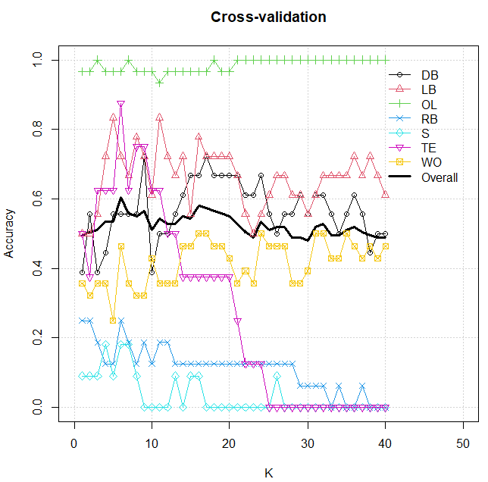

The largest correct classification rate is 60.47% at K = 6. This is the value that I will use for the rest of the analysis.

  - (2 points) What are the three nearest neighbors to observation #1 (excluding this observation)? Show how the probabilities for classifying this observation are calculated with K = 3. Verify your calculations with knn.cv(). Note that I used the as.matrix() and order() functions to help me find the three nearest neighbors.

> dist.mat <- dist(x = Z, method = "euclidean")
> #head(dist.mat)
> #Needed as.matrix() to make R treat dist.mat as a matrix
> all.dist <- data.frame(obs = 1:nrow(Z), distance = as.matrix(dist.mat)[,1])
> head(all.dist[order(all.dist[,2]),])
obs distance
1 1 0.000000
96 96 1.455797
52 52 1.521688
92 92 1.682980
50 50 2.011990
100 100 2.016626

> # Examine the three nearest neighbors
> fb[c(96,52,92),]
Player College Position OverallGrade Height
96 Powell, Walt Murray St. WO 4.70 71
52 Grant, Ryan Tulane WO 5.12 72
92 Norwood, Kevin Alabama WO 5.15 74
ArmLength Weight HandLength Dash40 BenchPress
96 31.625 189 9.500 4.63 10
52 31.000 199 9.625 4.64 8
92 32.125 198 10.000 4.48 8
VerticalJump BroadJump Cone3Drill Shuttle20
96 31.5 120 6.70 4.23
52 35.5 119 6.68 4.11
92 33.0 121 6.68 4.32

> set.seed(1334)
> NNC3 <- knn.cv(train = Z, cl = fb$Position, k = 3, prob = TRUE)
> head(NNC3)
[1] WO DB OL LB DB WO
Levels: DB LB OL RB S TE WO
> head(attributes(NNC3)$prob)
[1] 1.0000000 1.0000000 0.6666667 0.3333333 0.3333333
[6] 0.6666667

The three nearest neighbors to observation #1 are observations 52, 92, and 96. These observations are all WO players, so the probability of WO is 1. Note that observation #1 is also WO, so this is a correct classification!

  - (2 points) Suppose K = 6 was chosen. With this value of K, perform NNC with cross-validation and provide the 7×7 classification table. Set a seed number of 8811 before using knn.cv() so that I can duplicate your results. What types of classifications result in the largest correct and incorrect classification rates? Explain.

> set.seed(8811)
> NNC6 <- knn.cv(train = Z, cl = fb$Position, k = 6, prob = TRUE)
> NNC6.accuracy <- summarize.class(original = fb$Position, classify = NNC6)
> NNC6.accuracy
$class.table
classify
original DB LB OL RB S TE WO
DB 10 0 0 0 3 0 5
LB 0 15 0 1 0 1 1
OL 0 0 29 0 0 1 0
RB 2 2 1 4 4 0 3
S 5 0 0 2 2 0 2
TE 0 1 0 0 0 7 0
WO 9 2 0 2 6 1 8

$prop
classify
original DB LB OL RB S TE WO
DB 0.5556 0.0000 0.0000 0.0000 0.1667 0.0000 0.2778
LB 0.0000 0.8333 0.0000 0.0556 0.0000 0.0556 0.0556
OL 0.0000 0.0000 0.9667 0.0000 0.0000 0.0333 0.0000
RB 0.1250 0.1250 0.0625 0.2500 0.2500 0.0000 0.1875
S 0.4545 0.0000 0.0000 0.1818 0.1818 0.0000 0.1818
TE 0.0000 0.1250 0.0000 0.0000 0.0000 0.8750 0.0000
WO 0.3214 0.0714 0.0000 0.0714 0.2143 0.0357 0.2857

$overall.correct
[1] 0.5814

The overall correct classification rate is 0.5814 this time. This is different than before due to using a different seed number.

The OL players are again correctly classified the most often at a rate of 0.9667. The TE and LB players are close behind with 0.8750 and 0.8333 correct classification rates, respectively. The worse overall again are the safeties at a rate of 0.1818.

The DB and WO players are often misclassified as the other position. The RB players are misclassified much more frequently here than with LDA. There is not necessarily a trend of where they are misclassified. The S players are most often classified as DB players.

  - (2 points) Construct a similar plot as done in 3d) of Project #2 with the NNC classifications obtained in c). Interpret the plot in the context of what the 7×7 classification table in b) gives as the correct and incorrect classification rates. Compare the plot for this problem to the one found in 3d) of Project #2.

> pch7 <- 1:7
> Position.pch <- as.numeric(revalue(x = fb$Position, replace = c(DB=1, LB=2, OL=3, RB=4, S=5, TE=6, WO=7)))
> color.position <- palette()[1:length(levels(fb$Position))]
> Position.color <- revalue(x = fb$Position, replace = c(DB=color.position[1], LB=color.position[2], OL=color.position[3], RB=color.position[4], S=color.position[5], TE=color.position[6], WO=color.position[7]))

> pca.cor<-princomp(formula = ~ Height + ArmLength + Weight + HandLength + Dash40 + BenchPress + VerticalJump + BroadJump + Cone3Drill + Shuttle20, data = fb, cor = TRUE, scores = TRUE)
> # summary(pca.cor, loadings = TRUE, cutoff = 0.0)

> #Scores with the adjustment
> pca.cor$scale <- apply(X = fb[,-c(1:4)], MARGIN = 2, FUN = sd)
> score.cor <- predict(pca.cor, newdata = fb)
> head(score.cor[,1:3])

> par(pty = "s")
> min.scores <- min(score.cor[,1], y = score.cor[,2])
> max.scores <- max(score.cor[,1], y = score.cor[,2])

> plot(x = score.cor[,1], y = score.cor[,2], pch = Position.pch, col = Position.color, cex = 0.75, xlim = c(min(score.cor[,1], score.cor[,2]), max(score.cor[,1], score.cor[,2])), ylim = c(min(score.cor[,1], score.cor[,2]), max(score.cor[,1], score.cor[,2])), xlab = "Principal component 1", ylab = "Principal component 2", main = "PC score plot \n NNC classified (large points) overlaid on the original (small points)")
> abline(h = 0, lty = 1, lwd = 2)
> abline(v = 0, lty = 1, lwd = 2)

> classify.pch <- as.numeric(revalue(x = NNC6, replace = c(DB=pch7[1], LB=pch7[2], OL=pch7[3], RB=pch7[4], S=pch7[5], TE=pch7[6], WO=pch7[7])))
> color.position2 <- palette()[1:length(levels(NNC6))]
> Position.color2 <- revalue(x = NNC6, replace = c(DB=color.position[1], LB=color.position[2], OL=color.position[3], RB=color.position[4], S=color.position[5], TE=color.position[6], WO=color.position[7]))
> points(x = score.cor[,1], y = score.cor[,2], pch = classify.pch, col = Position.color2, cex = 1.5)
> legend(locator(1), legend = levels(fb$Position), pch = 1:7, col = 1:7, cex=1, bty="n")

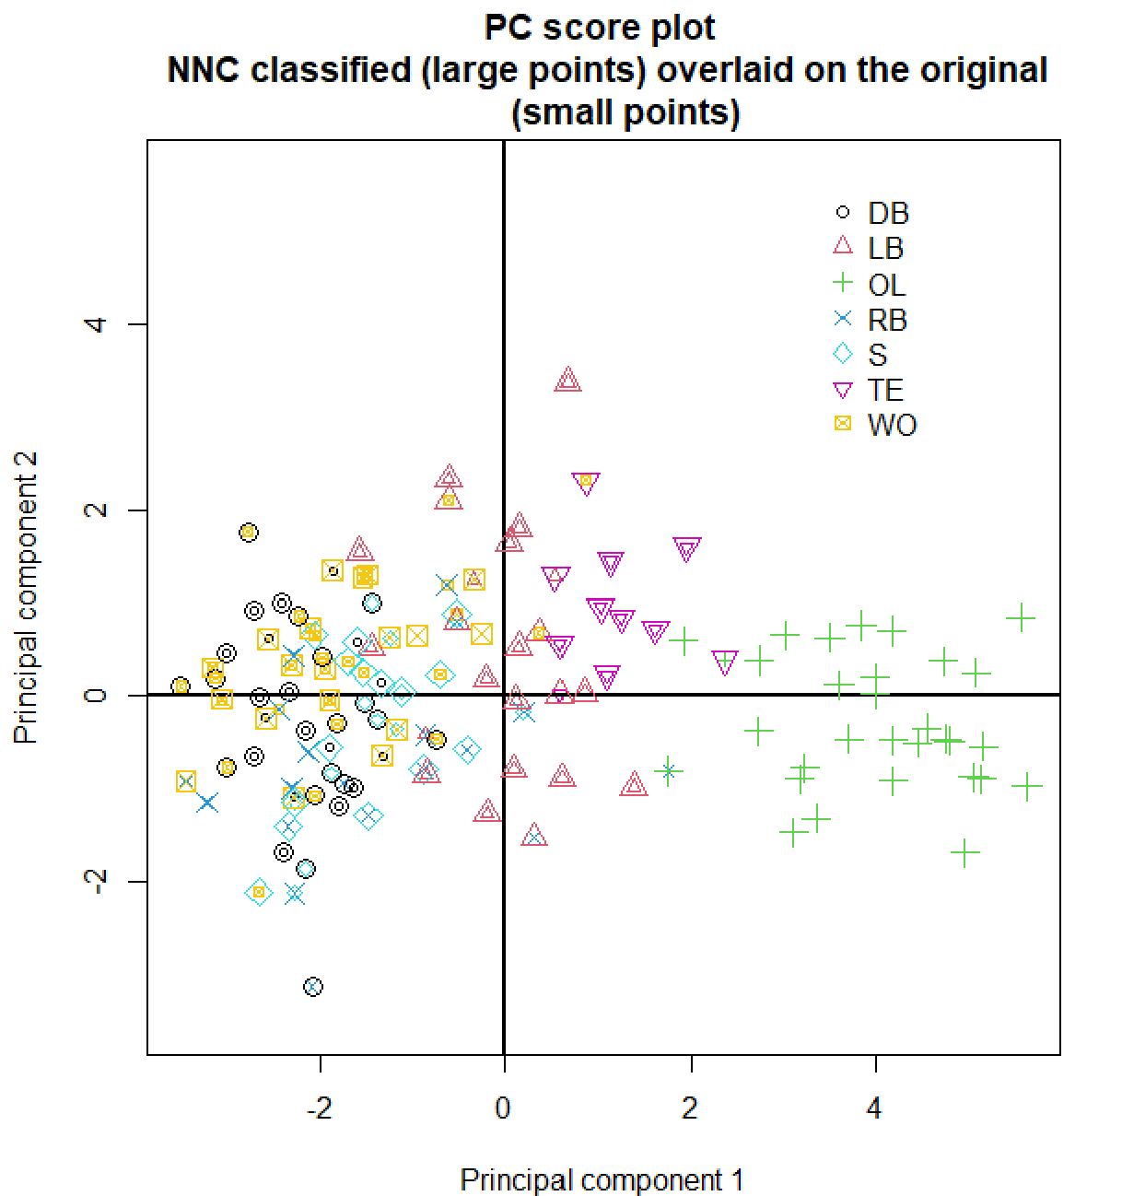

There is now an OL who is misclassified as a TE. We still have the RB who is misclassified as an OL.

There are a much larger number of people classified as safeties! With LDA, there were only 2. Now, there are 15. Unfortunately, only two of these are correct classifications.

There a large number of individuals misclassified as WO and DB, which is similar to what happened with LDA.

- (2 points) Compare the correct classification rates obtained in 3a of Project #2 and 1c by completing the table below:

 | Correct classification rates
 | DB | LB | OL | RB | S | TE | WO | Overall
LDA
NNC

Which method should be used? Explain.

In terms of overall correctness, LDA is better than NNC. If one were concerned about individual positions, then the correct classification rates for those positions could be factored into the decision process.

 | Correct classification rates
 | DB | LB | OL | RB | S | TE | WO | Overall
LDA | 0.50 | 0.78 | 1.00 | 0.63 | 0.00 | 0.63 | 0.61 | 0.66
NNC | 0.56 | 0.83 | 0.97 | 0.25 | 0.18 | 0.88 | 0.29 | 0.58

