Inserting Symbols

Some characters, such as: Greek letters, ≥, and ≤, can be inserted into a document by using Word’s “Insert Symbol” option (instead of the equation editor). To insert a symbol, click on Insert>Symbol to bring up the symbol window. For the symbols most often used in this class, change the font to Symbol.

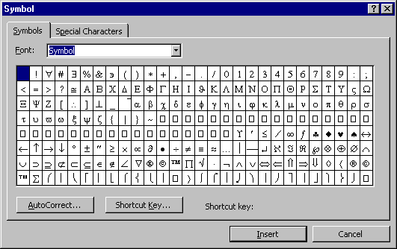

Any character can be inserted into a document by clicking on it and then clicking on the Insert button. Sortcut keys for often used symbols can be created by clicking on the Sortcut Cut button and following the directions.

