Homework
3.7
For a), please also construct side-by-side boxplots and dotplots for the two therapies.
3.21
Also make histograms for the two types of feeders.
3.31
For a), use the rule of thumb to construct intervals of the prices for the two types of hotels.
3.35
Please also sketch what the histograms may look like based on the two boxplots. You will not be able to get the bar heights relative to a numerical scale, but you will be able to determine if the histograms are skewed in one direction and if there are outliers.
3.40
For a), also calculate and interpret the 20% and 80% quantiles of the deviations of all suppliers combined.
3.43
For e), please also compare your results to the rule of thumb.

Additional problem (data set is from TIBCO Spotfire® help file):
Consider the following data table where a laboratory has measured the amount of various carbohydrates contained in various fruit and vegetables:
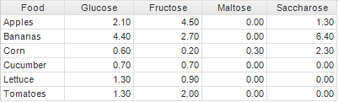
Please make a parallel coordinates plot for all the food and interpret the plot relative to the data.

