Partial answers for the Section 3 Homework

4.26

a.

P(A)=.10 +.15+.16 +.22=0.63

P(B)=.04+.10+.22=0.36

P(C)=.01+.02+.05+.06=0.14

b.

=0.22/0.36=0.61

(0.63-0.22)/(1-0.36)=0.64

1-0=1

c.

P(A∪B)=P(A)+P(B)-P(A∩B)=.63+.36-.22=0.77

P(A∩C)=0

P(B∩C)=0

d.

P(A∩B)=0.22≠0.63\*0.36=P(A)\*P(B)

Thus A and B are not independent of each other.

4.40

a. Used plot() with type = "h" argument

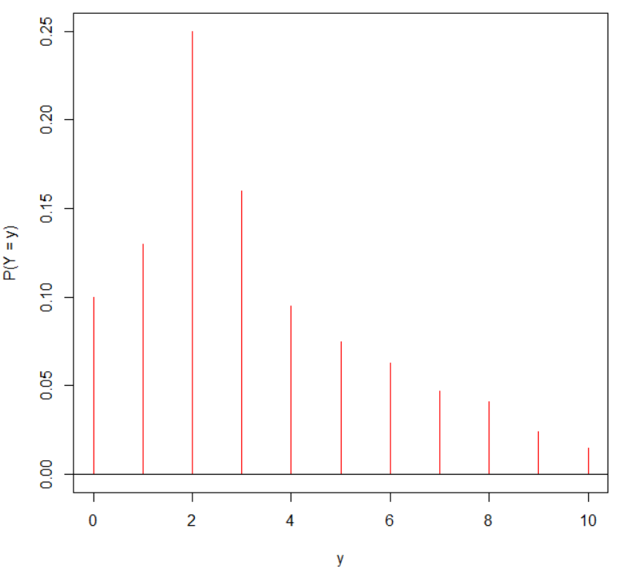

c. P(Y > 7) = P(Y = 8) + P(Y = 9) + P(Y = 10) = 0.08

> sum(prob[y>7])

[1] 0.08

where prob is an object with the probabilities in it and y is an object containing the values of Y.

4.45

a. P(Y = 15) = 0.215

b. dbinom(x = 6, size = 15, prob = 0.2)

c. sum(dbinom(x = 6:15, size = 15, prob = 0.2)) and 1 - pbinom(q = 5, size = 15, prob = 0.2); note that the pbinom() function finds 

d. No answer provided – see a. for a similar problem

Extra problem code:

plot(x = 0:15, y = dbinom(x = 0:15, size = 15, prob = 0.2), xlab = "y", ylab = "P(Y

= y)", type = "h", col = "red")

abline(h = 0)

mu <- 15\*0.2

sigma <- sqrt(15\*0.2\*0.8)

segments(x0 = mu, x1 = mu, y0 = -0.01, y1 = 0.01, col = "blue", lwd = 2)

segments(x0 = mu - 2\*sigma, x1 = mu - 2\*sigma, y0 = -0.01, y1 = 0.01, col = "blue", lwd = 2)

segments(x0 = mu + 2\*sigma, x1 = mu + 2\*sigma, y0 = -0.01, y1 = 0.01, col = "blue", lwd = 2)

mtext(side = 1, at = mu, text = expression(mu))

mtext(side = 1, at = mu - 2\*sigma, text = expression(mu - 2\*sigma))

mtext(side = 1, at = mu + 2\*sigma, text = expression(mu + 2\*sigma))

4.48

a. 1 - pbinom(q = 4, size = 50, prob = 0.10)

b. 0.1 remains as the probability of infection for this week as well

4.69

It’s a normal distribution with μ=39, σ=6.

P(Y>50)= 0.0334

> 1-pnorm(q=50, mean=39, sd=6)

[1] 0.03337651

b.

The probability that the elapsed time between submission and reimbursement exceeds 50 is really small. Thus if it’s been more than 55 days already, I suspect that the voucher is lost.

Use the following code to make the plot:

curve(expr = dnorm(x = x, mean = 39, sd =

6), from = 15, to = 65, col = "darkgreen",

lwd = 2, ylab = "f(y)", xlab = "y", main =

paste("Plot of a normal distribution with mu =",

39, "and sigma =", 6))

abline(h = 0)

segments(x0 = 50, y0 = 0, x1 = 50, y1 = dnorm(x = 50, mean = 39, sd = 6), col = "red",

lwd = 5)

segments(x0 = 55, y0 = 0, x1 = 55, y1 = dnorm(x = 55, mean = 39, sd = 6), col = "red",

lwd = 5)

4.70

It’s a normal distribution with μ=500, σ=100.

a. 0.1587

> 1-pnorm(q=600, mean=500, sd=100)

[1] 0.1586553

b. 0.0228

> 1-pnorm(q=700, mean=500, sd=100)

[1] 0.02275013

c. 0.3085

> pnorm(q=450, mean=500, sd=100)

[1] 0.3085375

d. 0.5328

> pnorm(q=600, mean=500, sd=100)-pnorm(q=450, mean=500, sd=100)

[1] 0.5328072

4.72

a. 628.2

> qnorm(p=.9, mean=500, sd=100)

[1] 628.1552

b. 432.6, 0.25 quantile

> qnorm(p=.25, mean=500, sd=100)

[1] 432.551

Use the following code to make the plot:

curve(expr = dnorm(x = x, mean = 500, sd =

100), xlim = c(100, 900), col = "darkgreen",

lwd = 2, ylab = "f(y)", xlab = "y", main = "Plot of a normal distribution \n with mu

= 500 and sigma = 100")

abline(h = 0)

segments(x0 = 628.2, y0 = 0, x1 = 628.2, y1 = dnorm(x = 628.2, mean = 500, sd = 100), col

= "red", lwd = 5)

segments(x0 = 432.6, y0 = 0, x1 = 432.6, y1 = dnorm(x = 432.6, mean = 500, sd = 100), col

= "red", lwd = 5)

4.76

a. Use R code:

sample(x=1:1000, size=50, replace=FALSE)

b.

Using the same numbers for precinct will probably lead to bias in making inferences about the population.

4.77 – If n = 16 is large enough, we can use the central limit theorem here.

4.83

It is approximately a normal distribution with μ=2.1, σ=0.3.

a. 0.0228

> 1-pnorm(q=2.7, mean=2.1, sd=0.3)

[1] 0.02275013

b. 2.30

> qnorm(p=.75, mean=2.1, sd=0.3)

[1] 2.302347

c. Let μN be the new value of the mean.

0.05=P(Y>2.7)=

And thus, 

> qnorm(p=.95)

[1] 1.644854

Additional problems:

1) a)

P(A)=63/352=0.179

P(B)=53/352=0.151

P(A∩B)=12/352=0.034

P(A∪B)=P(A)+P(B)-P(A∩B)=0.296

b)

P(A|B)= P(A∩B)/P(B)=.034/.151=0.225

(.179-.034)/(1-.151)=0.171

P(A|B)≠ P(A), thus A and B are not independent. There appears to be a relationship between birth defects and underweight problems for newborns.

2) a)

Note that  has an approximate normal PDF with mean 240 and standard deviation of  = 2.3717 through the use of the CLT. Thus, we need to approximate P(235.25 <  < 244.75) = P( < 244.75) – P( < 235.25) using the normal PDF. The probability is 0.9774 – 0.0226 = 0.9548.

b)

No, observing a sample mean this extreme would be unlikely to happen since the approximation to P(235.25 <  < 244.75) is large.