Week 3 class – Group testing

- Testing for SARS-CoV-2, the virus that leads to COVID-19
  - Importance

  - Cannot do as many tests as would like or needed to eliminate the virus
  - Group testing (a.k.a., pooled testing)
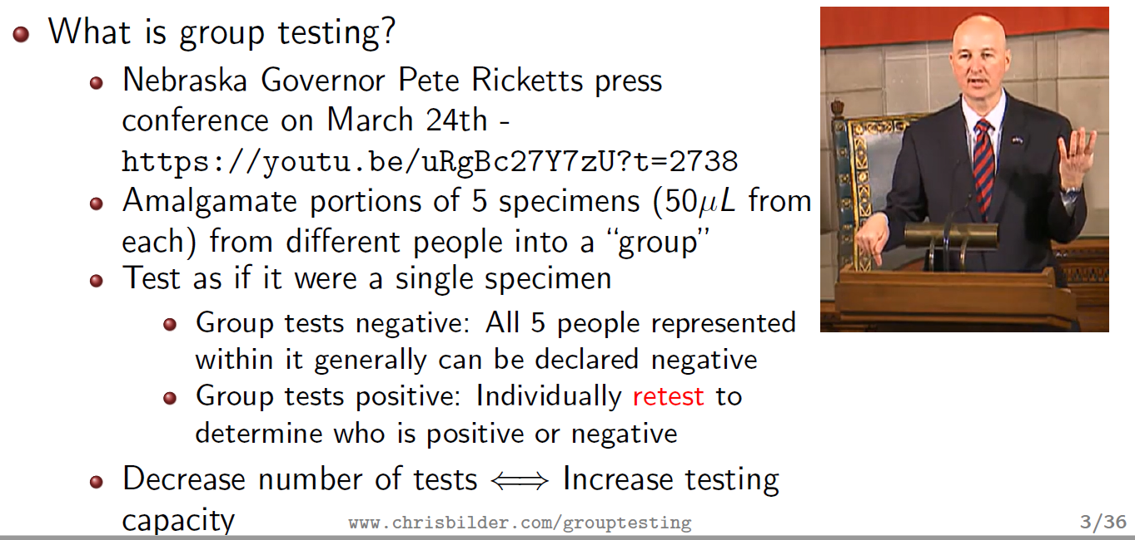

    - Simplest implementation
    - Abdalhamid et al. (American Journal of Clinical Pathology, 2020)
  - News articles – poll

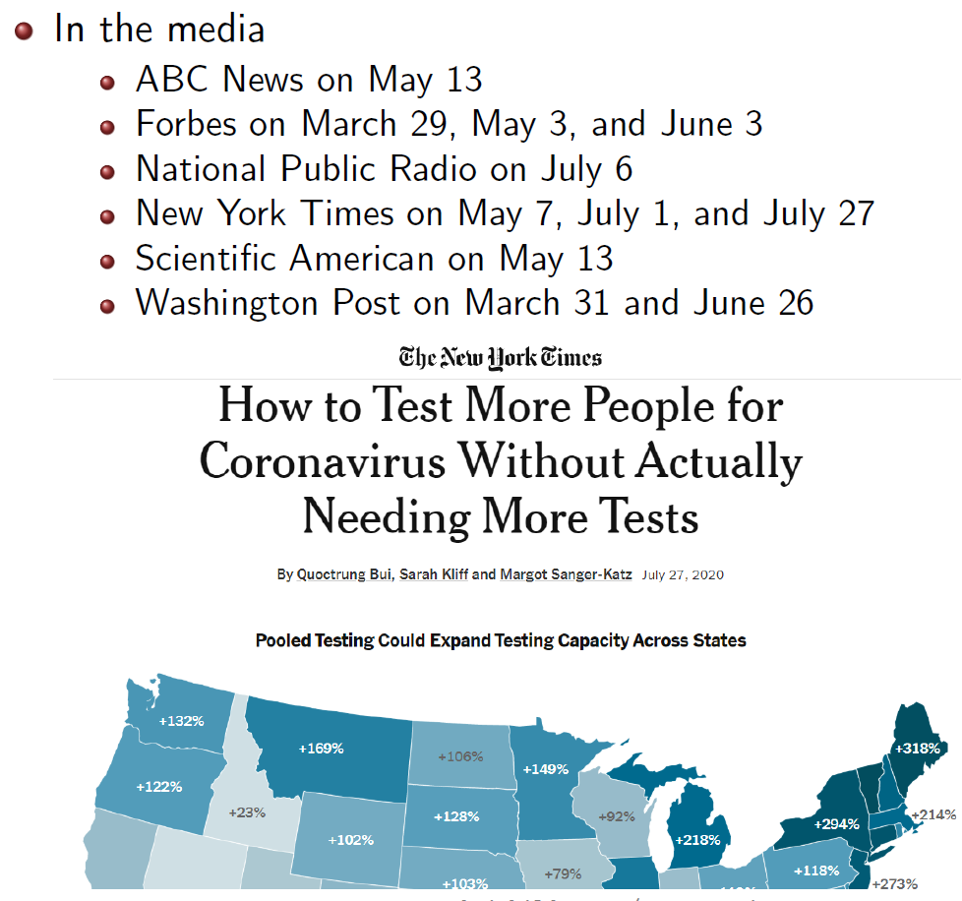

  - Define T as a discrete random variable for the number of tests for a group of size 5
    - t = 1 if the group tests negative
    - t = 6 if the group tests positive
  - Define p as the disease prevalence in the population
    - Group of size 5
    - P(T = 1) = (1 – p)⁵
    - P(T = 6) = 1 – (1 – p)⁵
  - Expected number of tests

  - If p = 0.05, then E(T) = 2.13

> p <- 0.05
> I <- 5 # group size
> 1*(1-p)^I + 6*(1 - (1-p)^I)
[1] 2.131095
> 2.13/5 # Expected number of tests per person
[1] 0.426
> 1-0.426 # Expected reduction in the number of tests
[1] 0.574
> 1/0.426-1 # Expected increase in testing capacity
[1] 1.347418

  - Goal is to use a group size that minimizes the E(T)
    - No closed form expression
    - OTC1() function in the binGroup2 package of R
    - Shiny app – www.chrisbilder.com/shiny

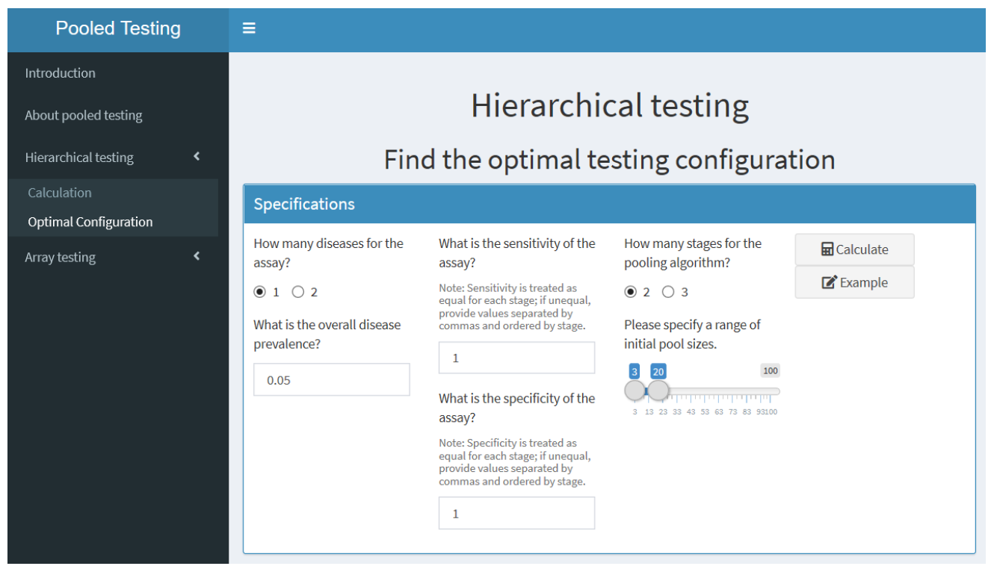

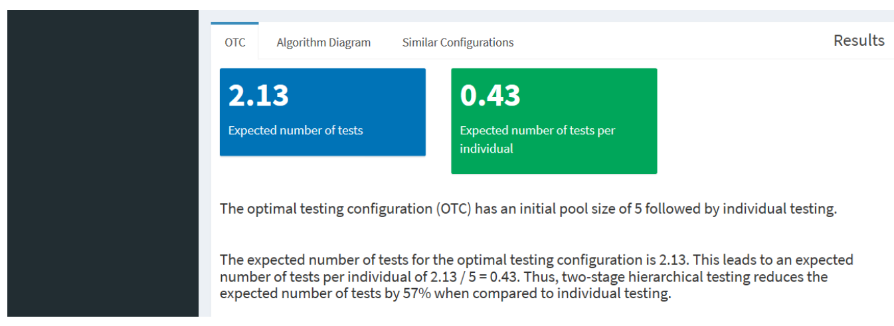

  - Worldwide use – 76 counties, 44 US states

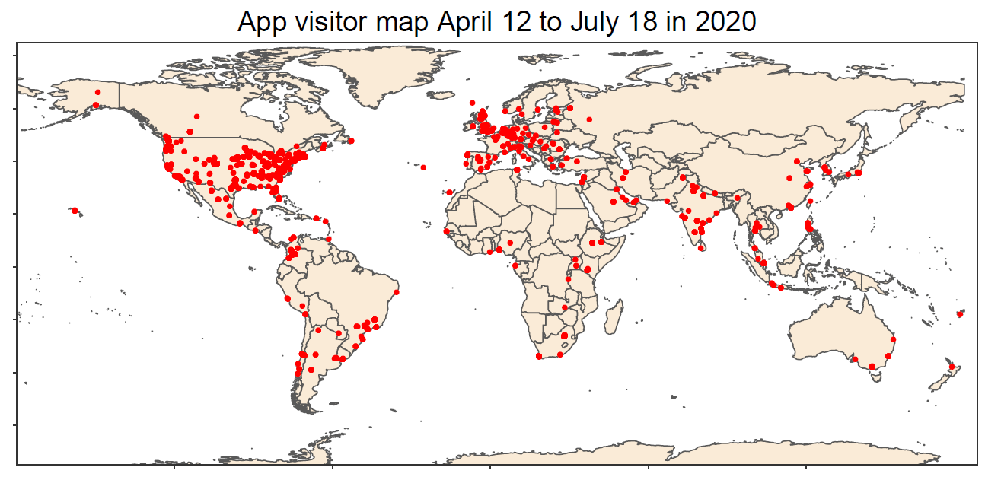

  - Seminars

