* Emergency Use Authorization (EUA) from FDA for group testing
  + Verily

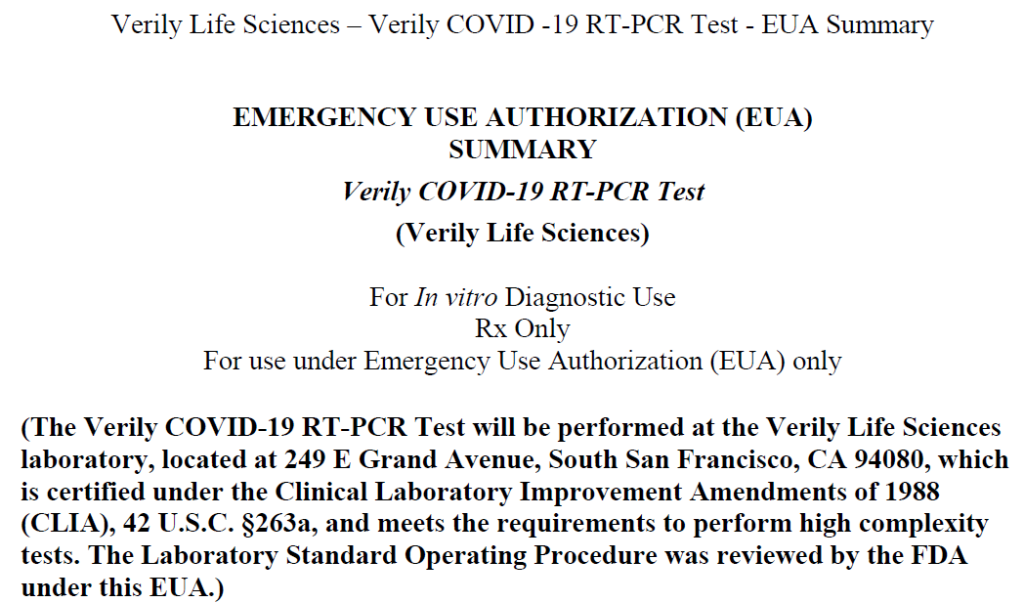

* + - Compare group testing outcomes to individual testing
    - Percent positive agreement (PPA)
    - Percent negative agreement (NPA)

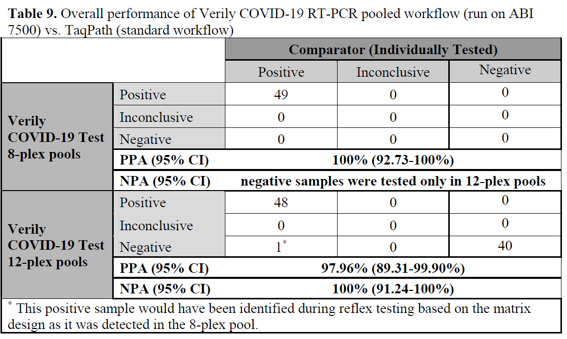

> binom.confint(x = 49, n = 49, conf.level = 1-alpha,



methods = "wilson")



method x n mean lower upper

1 wilson 49 49 1 0.9273022 1

> binom.confint(x = 48, n = 49, conf.level = 1-alpha,

methods = "wilson")

method x n mean lower upper

1 wilson 48 49 0.9795918 0.8930648 0.9963883

> binom.confint(x = 40, n = 40, conf.level = 1-alpha,

methods = "wilson")

method x n mean lower upper

1 wilson 40 40 1 0.9123784 1

* + - LabCorp

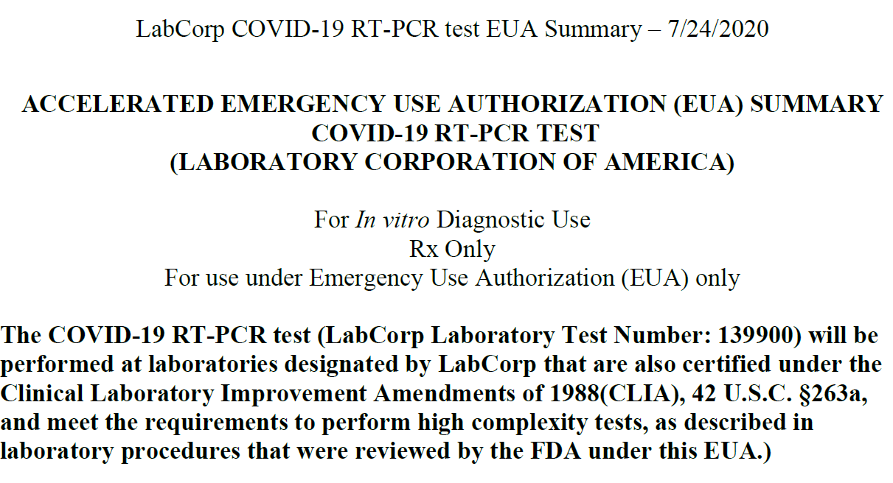

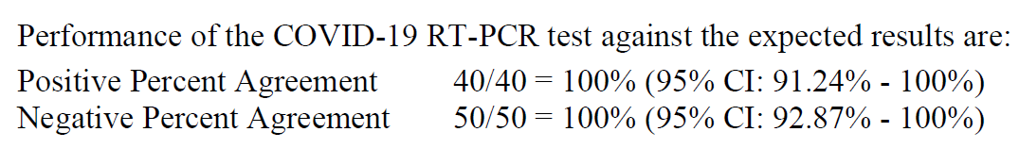

> binom.confint(x = 40, n = 40, conf.level = 1-alpha,

methods = "wilson")

method x n mean lower upper

1 wilson 40 40 1 0.9123784 1

> binom.confint(x = 50, n = 50, conf.level = 1-alpha,

methods = "wilson")

method x n mean lower upper

1 wilson 50 50 1 0.9286524 1

* + - <https://www.fda.gov/medical-devices/coronavirus-disease-2019-covid-19-emergency-use-authorizations-medical-devices/vitro-diagnostics-euas#covid19ivdTemplates>