Subscripts and Superscripts

These character formats can be created in the equation editor or also by changing the font type. To do the later, highlight what you want subscripted (or superscripted) and click on Format>Font. Select the subscript box to checkmark it, and then select OK.

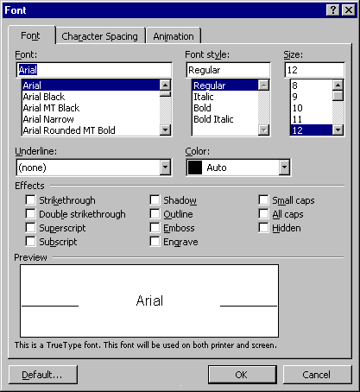

Shortcut superscript and subscript boxes can be placed on your formating toolbar (where the bold and underline boxes are) to make the insertion of these effects easier. Select View>Toolbars>Custmize to bring up the window below.
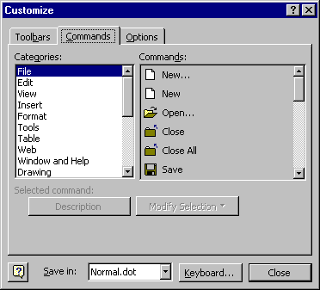

Select the Commands tab and then select Format>Superscript.

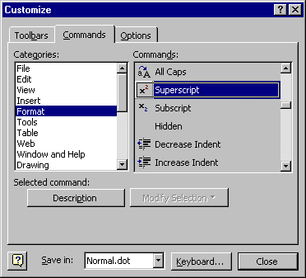

Drag the Superscript symbol out to a toolbar. This produces a shortcut key (similar to bold or underline) to perform superscripts. A similar procedure can produce the Subscript shortcut key.

