**Section 3.4.3 – Non-proportional odds model**

A proportional odds model is one of the preferred ways to account for an ordered multicategory response, because it includes only one parameter for each explanatory variable. While this can greatly simplify the model, it may not work well for some problems.

A more general model is

 for j = 1, …, J - 1

which I will simply refer to as a non-proportional odds model (another type of cumulative probability model). Notice the j subscript on the βj1, …, βjp parameters in the model. By allowing for the regression parameters to change for each response category, we can construct a test of the proportional odds assumption:

H0: β1r = = βJ-1,r for r = 1, …, p

Ha: Not all equal for some r

If the proportional odds assumption is rejected, it may be preferred to use the non-proportional odds model for the data analysis of interest. However, the proportional odds model may still be preferred due to its smaller number of parameters. For example, a very large sample size could result in a rejection of the null hypothesis even though there is little practical violation of the assumption.

There is another reason why the proportional odds model may be preferred. The non-proportional odds model allows for

P(Y ≤ j) < P(Y ≤ j′) for j > j′

Why is this a problem?

For this reason, care needs to be used with these models so that nonsensical probabilities do not occur.

Example: Non-proportional odds model plots (CumulativeLogitModelPlot.R)

The purpose here is to show the problems that can occur with the non-proportional odds model. Consider the model of



where  and J = 4. Notice this is the same model as we saw at the beginning of this proportional odds model section except  and 

Below is a plot of the model:

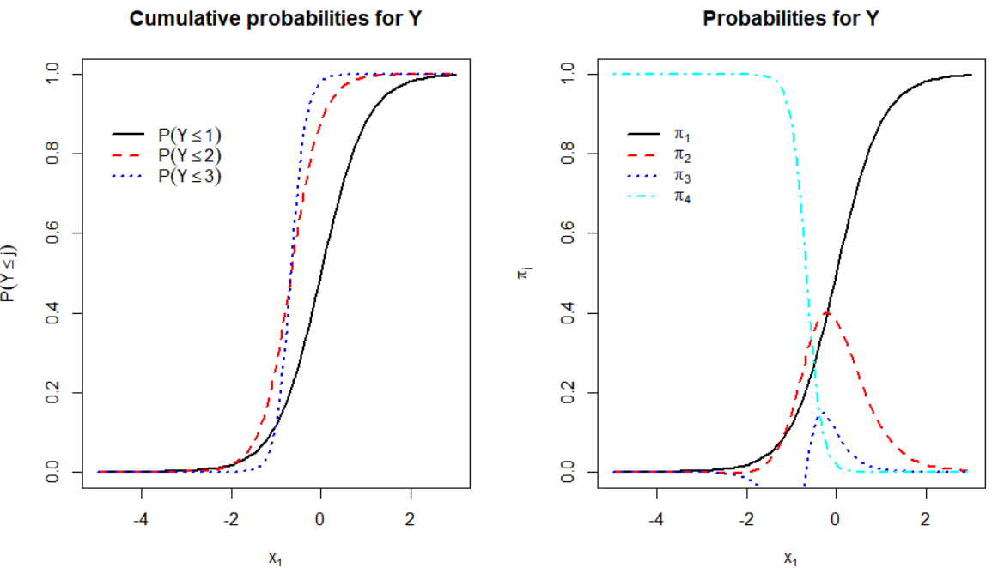

The cumulative probability curve for P(Y ≤ 3) crosses the other two curves! This means that P(Y ≤ 3) < P(Y ≤ 2) and P(Y ≤ 3) < P(Y ≤ 1) for some value of x1. As a result, π3 < 0 for some x1, which can be seen in the plot of the right.

The LRT for the proportional odds assumption cannot be performed through using the polr() function. Instead, I show in my book how to use the vglm() function from the VGAM package to help perform the test.

**Section 3.5 – Additional regression models**

There are a number of other models that can be used with multinomial responses. One of these is the adjacent-categories model:



where j = 1, …, J – 1, which is somewhat similar to the multinomial regression model. To take advantage of an ordinal response, one could use the model



where j = 1, …, J – 1. Notice the removal of the j subscript on the last p – 1 regression parameters. Both of these models can be fit in R using the vglm() function of the VGAM package.