Exercise from Chapter 3 and part of an old test problem (DAVF.R)

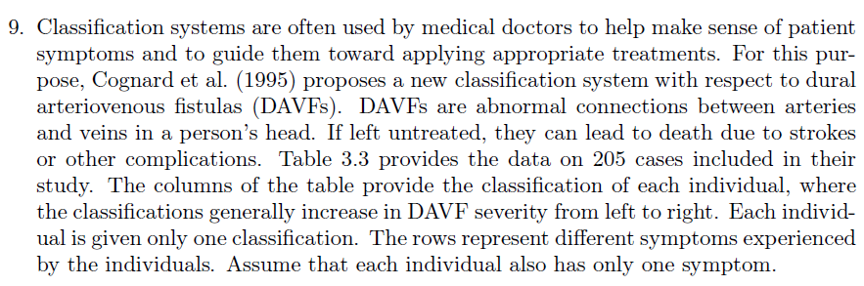

 |  | Classification
 |  | I | IIa | IIb | IIa and b | III | IV | V
Symptoms | Hemorrhage | 0 | 0 | 2 | 1 | 10 | 19 | 5
 | Intracranial hypertension | 1 | 8 | 1 | 2 | 0 | 4 | 1
 | Focal neurologic deficit | 0 | 0 | 0 | 6 | 8 | 2 | 0
 | Seizures | 0 | 1 | 0 | 2 | 1 | 3 | 0
 | Cardiac deficiency | 0 | 1 | 0 | 1 | 0 | 0 | 0
 | Myelopathy | 0 | 0 | 0 | 0 | 0 | 0 | 6
 | Nonaggresive symptoms | 83 | 17 | 7 | 6 | 6 | 1 | 0

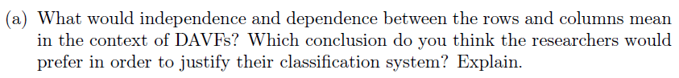

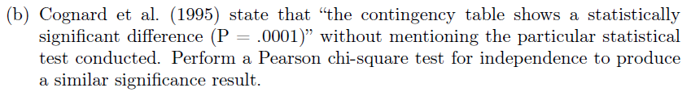

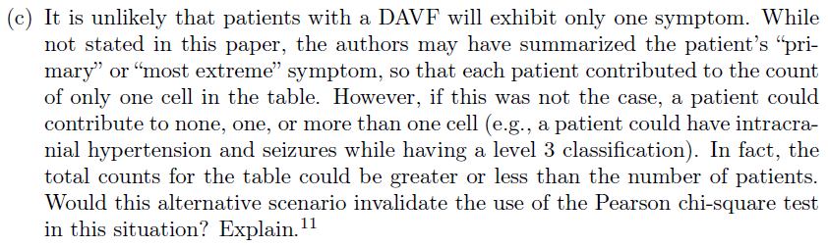

d) There are two aspects of dependence here:
- Matches the goals of the classification system
- Does not match the goals of the classification system

