Let’s play Plinko! (Plinko.R)

Description

Plinko is a game played on The Price is Right TV show. Contestants drop a circular disk, referred to as a “chip”, from the top of a board. The chip travels down the board and bumps into pegs that can change its direction. Eventually, the chip will reach the bottom of the board and land in a slot. Each slot has a dollar amount that the contestant wins. Below is a picture of the board.

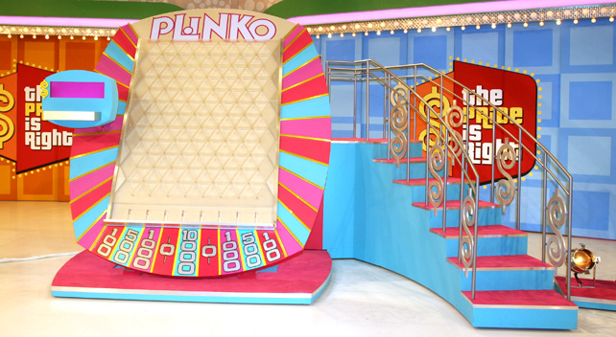

An example of the game being played is available at https://youtu.be/hOIWhnoU5Pw?t=113. Notice the contestant is not sure where to drop the chip.

Research question

Where should the chip be dropped?

Study description

I recorded The Price is Right every day it was on TV for one year! If Plinko was played, I kept the recording. Otherwise, I deleted it. A graduate student watched ALL of these recordings and collected data about where the chip was dropped and the amount won.

Variables of interest

Response: The landing slot (location)

This is an ordinal categorical variable! How should we represent it?

Explanatory: The drop slot (relative to the landing slot)

This is an ordinal categorical variable as well. How should we represent it?

Data

The data is available in Plinko.csv.

Questions

- Why would a proportional odds regression model potentially be better than a multinomial regression model for this data?

- Estimate and state a proportional odds regression model using the landing slot as the response variable and the drop slot as the explanatory variable.

- For the odds ratio corresponding to the drop slot:
  - What should we use for c?
  - Estimate
  - Find 95% profile LR confidence interval
  - Interpret

- Use a likelihood ratio test to evaluate the importance of the drop slot. Relate this to the profile LR confidence interval result.

- Estimate the probabilities for the landing slots when the chip is dropped in the middle of the board.

- While the odds ratios indicate that one should drop more toward the middle of the board, why is winning $10,000 not the largest estimated probability in 5)?

- Plot the estimated model allowing for the drop slot to be a continuous variable.

- Where should the chip be dropped?

Additional questions/comments
- From a research prospective, what could be done next?

- There are alternative ways to look at this problem. In particular, one could derive a probability distribution for the amount won. This would allow for the calculation of
  - The probability of wining $10,000 for each drop slot and
  - The expected winnings for each drop slot.

However, the derivation for this probability distribution makes some assumptions that may not be true!

