I use MathType (<https://www.wiris.com/en/mathtype>) for equations in my notes. On some computers, an equation like



may look like

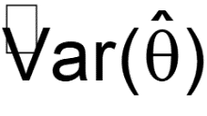

This is because a computer may not have an updated version of the MT extra font. To fix this issue, complete the following:

1. Uninstall the current MT Extra font. In Windows, this is done by going to Settings on your computer and selecting Personalization > Fonts. Type in MT Extra in the Available Fonts search box. Select the font found, and select Uninstall.
2. Download the MT Extra font (mtextra.ttf) from my website
3. Install the new MT Extra font. In Windows, this is done by right clicking on it and selecting Install.

Additional information about the issue is available at <https://docs.wiris.com/en/mathtype/office_tools/support_notices/tn84>.