**Stationary time series**

Stationarity is a VERY important concept to understand because it allow us to construct time series models.

Strictly stationary time series – The probabilistic behavior of  is exactly the same as that of the shifted set  for ANY collection of time points t1,…, tk, for ANY k = 1, 2, …, and for ANY shift h = 0, ±1, ±2, … .

What does this mean??? Let c1,…, ck be constants. Then

   
= 

Thus, the probability distribution is INVARIANT to time shifts! For example,

P(x1 ≤ c1, x2 ≤ c2) = P(x10 ≤ c1, x11 ≤ c2)

Requiring a time series to be strictly stationary is VERY restrictive! A less restrictive requirement is weakly stationary.

Weakly stationary time series – The first two moments (mean and covariance) of the time series are invariant to time shifts. In other words,

E(xt) = μ for ALL time t and

γ(t, t+h) = γ(0, h) for ALL time t.

Notes:

* μ and γ(0, h) are NOT functions of t.
* h is the lag
* γ(t, t+h) = γ(0, h) for ALL time t means that the autocovariance function ONLY depends on the number of **lags** of the time shift. Thus, γ(0, h) =   
  γ(1, h+1) = γ(2, 2+h) = γ(3, 3+h) = … .
* Because we will generally be dealing with a weakly stationary time series, we can make the following notational change: γ(h) = γ(0, h) = γ(t, t+h).
* **The variance of xt is γ(0).**
* The same notational change can be made to the autocorrelation function (ACF). Thus, ρ(h) denotes the ACF at lag h. Note that



so the ACF simplifies to ρ(h) = γ(h)/γ(0).

* Strictly stationary implies weakly stationary, but the reverse is not necessarily true.
* Frequently, we will just say “stationary” to refer to weakly stationary and say the full “strictly stationary” to refer to strictly stationary.

Example: White noise

Suppose wt ~ ind. N(0,) for t = 1,…,n. Is this a weakly stationary time series?

Yes – mean is 0 for all wt, variance is constant for all wt, and the covariance is 0 because the random variables are independent. AND, it is also strictly stationary.

Note that the joint distribution is the product of the one-dimensional distributions because wt are independent.

Example: Moving Average

Let mt = (wt + wt-1 + wt-2)/3 where wt~ ind. N(0,1) for t = 1, …, n.

Previously, we found that μt = 0 for all t and



Is the time series weakly stationary? Hint: let h=s-t.

Comments:

* γ(h) = γ(-h) for all h if the series is weakly stationary. This means that it does not matter which way the shift occurs.
* Stationarity can also be examined when two time series are of interest. We will examine this in more detail later in the course. In summary,
  + - Both time series must have constant mean
    - Both autocovariance functions must depend only on the lag difference
    - The “cross-covariance” function, the extension of the autocovariance function for one time series to two time series, must depend only on the lag difference. The cross-covariance function is defined as

γxy(h) = E[(xt+h – μx)(yt – μy)]

Note that  is not necessarily equal to  (usually will be different).

Example: This is an example from Shumway and Stoffer’s textbook.

Let xt = wt + wt-1 and yt = wt - wt-1 where wt ~ ind. N(0,) for t = 1, …, n

Show xt and yt are weakly stationary.

* xt

E(xt) = E(wt + wt-1)

= E(wt) + E(wt-1)

= 0 + 0 =0

Thus E(xt) = μxt = 0 for all t.

γ(s,t) = E[(xs - μxs)(xt - μxt)] = E[xsxt] because μxs = μxt = 0

Then E[xsxt] = E[(ws + ws-1)(wt + wt-1)]

= E[wswt + ws-1wt + wswt-1 + ws-1wt-1]

If s = t, then

γ(t,t) = E[ + wt-1wt + wtwt-1 + ]

= E[] + E[wt-1wt] + E[wtwt-1]+ E[]

= Var(wt) + E[wt]2 + 2E[wt-1]E[wt] + Var(wt-1) + E[wt-1]2

= + 02 + 2×0×0 +  + 02

= 2

If s = t - 1, then

γ(t - 1,t) = E[wt-1wt + wt-2wt + + wt-2wt-1]

= E[wt-1wt] + E[wt-2wt] + E[]+ E[wt-2wt-1]

= E[wt-1]E[wt] + E[wt-2]E[wt] + Var(wt-1) + E[wt-1]2+

E[wt-2]E[wt-1]

= 0×0 + 0×0 +  + 02 + 0×0

= .

Note that γ(t - 1, t) =  and γ(s,t) = 0 for |s - t|>1.

Therefore, 

After recording the video: I just want to emphasize that this result is found from also examining cases like s = t + 1, s = t + 2, s = t – 2, …

and xt is weakly stationary.

* yt

E(yt) = E(wt - wt-1)

= E(wt) - E(wt-1)

= 0 - 0 =0

Thus E(yt) = μyt = 0 for all t

γ(s,t) = E[(ys - μxs)(yt - μxt)] = E[ysyt] because μys = μyt = 0

Then E[ysyt] = E[(ws - ws-1)(wt - wt-1)]

= E[wswt - ws-1wt - wswt-1 + ws-1wt-1]

If s = t, then

γ(t,t) = E[ - wt-1wt - wtwt-1 + ]

= E[] - E[wt-1wt] - E[wtwt-1]+ E[]

= Var(wt) + E[wt]2 - 2E[wt-1]E[wt] + Var(wt-1) + E[wt-1]2

= + 02 – 2×0×0 +  + 02

= 2

If s = t - 1, then

γ(t-1,t) = E[wt-1wt - wt-2wt - + wt-2wt-1]

= E[wt-1wt] - E[wt-2wt] - E[]+ E[wt-2wt-1]

= E[wt-1]E[wt] - E[wt-2]E[wt] - Var(wt-1) - E[wt-1]2

+ E[wt-2]E[wt-1]

= 0×0 - 0×0 -  - 02 + 0×0

= -.

Note that γ(t - 1,t) = - and γ(s,t) = 0 for |s-t|>1.

Therefore, .

Thus, yt is weakly stationary.

Linear Process

The previous examples are special cases of a “linear process”. In general, a linear process can be defined as

 with  and

wt ~ ind. N(0,). It can be shown that  for h ≥ 0 provided the series is stationary (remember that and γ(h) = γ(-h)).

After recording the video: I wrote Cov(Y+3) = Cov(Y) in the video. I meant to write Cov(Y+3,X) = Cov(Y,X) with Y and X as random variables.

Proof: Without loss of generality, let μ = 0 because constants do not affect a covariance.

E(xt) =  = 

=  =  = 0.

Note that γ(h) = Cov(xt, xt+h) = E(xtxt+h) – E(xt)E(xt+h) = E(xtxt+h) because E(xt) = E(xt+h) = 0.

Then E(xtxt+h)

 because E(wt-iwt+h-j) = 0 when -i ≠ h-j and E(wt-iwt+h-j) =  =  when -i = h - j ⇒ j - i = h

Therefore,  for h ≥ 0.

Compare the previous examples to this result!

Important!:

There is a very important case when weakly stationary implies strictly stationary. This occurs when the time series has a multivariate normal distribution. Remember that a univariate normal distribution is defined only by its mean and variance. The multivariate normal distribution is defined only by its mean vector and covariance matrix.

Thus, if we can assume a multivariate normal distribution, we ONLY need to check if the time series satisfies the weakly stationary requirements to say the time series is strongly stationary. Thus, notice what the word “stationary” would mean in this case.

Example: Visualizing stationarity

Below are a few plots of the observed values of a time series. Identify which plots correspond to a weakly stationary series. There is no program given for this example.







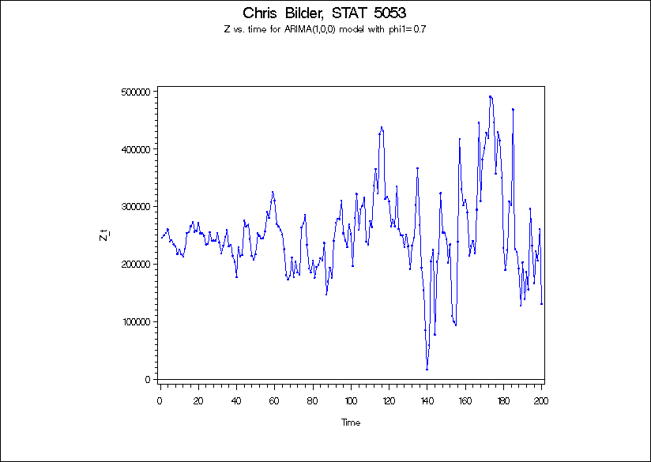

From examining these plots, why is it important to have stationarity?

Estimation of the mean and variance

Need consistency to construct a model

To look at stationary with respect to the autocovariance (not variance h = 0), need to look at ACF plot.

After recording the video: Please remove this last sentence. One can look for dependence patterns that change over time. For example, the first half of the series may be smooth (indicating positive dependence) and the second half of the series could be choppy (indicating negative dependence). Due to these changes in dependence, the series is non-stationary with respect the autocovariance.