**ARMA Models**

Autoregressive moving average (ARMA) models

Combines MA and AR models into one model. An “ARMA(p,q)” model is:



(1-ϕ1B-ϕ2B2-…-ϕpBp)xt = (1+θ1B+θ2B2+…+θqBq)wt

⇔ ϕ(B)xt = θ(B)wt

assuming xt is stationary

Notes:

* If E(xt) = μ ≠ 0, then we could rewrite the model as

ϕ(B)xt = α + θ(B)wt where α = μ(1-ϕ1-ϕ2-…-ϕp)

or let zt = xt-μ so that the model is ϕ(B)zt = θ(B)wt

* If the model is casual, then it can be rewritten as

xt = [θ(B)/ϕ(B)]wt = ψ(B)wt

where ψ(B) = 1+Bψ1+B2ψ2+… . If the model is invertible, then it can be rewritten as

[ϕ(B)/θ(B)]xt = π(B)xt = wt

where π(B) = 1+π1B+π2B2+ … .

* Problem with parameter redundancy

ARMA(1,1): (1-0.5B)xt = (1-0.5B)wt

Notice that xt = (1-0.5B)/(1-0.5B)wt = wt! Thus, this ARMA(1,1) can also be represented by a white noise process.

Another example illustrating this is the following ARMA(2,1):

(1-0.1B-0.2B2)xt = (1-0.5B)wt

⇔ (1+0.4B)(1-0.5B)xt = (1-0.5B)wt

⇔ (1+0.4B)xt = (1-0.5B)/ (1-0.5B)wt

Thus, this ARMA(2,1) can also be represented by an ARMA(1,0).

The problem here is that both the AR and MA parts have a “common factor”. To avoid this problem, we need to assume that AR and MA operators have no common factors.

To overcome the problems with stationary AR models that depend on the future and MA models that are not unique, we require ARMA models to be causal and invertible.

Let

ϕ(z) = 1-ϕ1z-ϕ2z2-…-ϕpzp, ϕp≠0

and

θ(z) = 1+θ1z+θ2z2+…+θqzq, θq≠0

be the AR and MA operators with “z” used in it to emphasize they are as polynomials and z is an ordinary algebraic variable. Note that z is possibly a complex number.

Assume that ϕ(z) and θ(z) have no common factors.

Causality of an ARMA(p,q) process

An ARMA(p,q) model is causal when the roots of ϕ(z) lie outside the unit circle; that is, ϕ(z) = 0 only when |z| > 1. The coefficients of the linear process for  can be determined from solving .

Note that when z is a real number, |z| means absolute value of z. When z is a complex number c+di, |z| means  where i = .

Again, this means the model can be rewritten as an infinite order MA model.

Reason: Stationarity that is not future dependent

The appendix of Shumway and Stoffer’s textbook includes a proof.

Invertibility of an ARMA(p,q) process

An ARMA(p,q) model is invertible when the roots of θ(z) lie outside the unit circle; that is, θ(z) = 0 only when |z|>1. The coefficients of the linear process for  can be determined from solving .

Again, this means the model can be rewritten as an infinite order AR model.

Reason: Model has a unique representation

The appendix of Shumway and Stoffer’s textbook includes a proof.

Example: AR(1), (1-ϕB)xt = wt

Causal: Let ϕ(z) = (1-ϕz). Note that (1-ϕz) = 0 has a root of z = 1/ϕ. For this to be causal,

|1/ϕ|>1 ⇔ -1 < ϕ < 1.

Therefore, an AR(1) model is causal if -1 < ϕ < 1. Relate this back to earlier in the notes when we used the sum of an infinite series to find the infinite MA representation.

Invertible: Yes, because the model is already written in terms of an AR only model.

What happens if the causal conditions are violated? The model will not be causal and thus will not be “backward” stationary.

Suppose ϕ1 = 2 in an AR(1). Then  . Using a program similar to ar1.R in Chapter 1 (with wt~ind. N(0,1) and the for() function), the data generated from this series produces

time x w

1 -0.7978 -0.79783

2 -0.1010 1.49470

3 0.5721 0.77406

4 1.0049 -0.13939

5 1.4271 -0.58269

6 1.7471 -1.10709

7 3.9113 0.41711

8 7.6294 -0.19317

9 15.1353 -0.12357

10 30.6147 0.34411

11 60.6889 -0.54051

199 2.3571E58 -0.39787

200 4.7142E58 2.49789

Notice that xt is increasing rapidly (not stationary in the mean).

Note: All AR only models are invertible!

Example: AR(2) (poly_root_example.R)

(1-ϕ1B-ϕ2B2)xt = wt

Invertible: Yes, because the model is already written in terms of an AR only model.

Causal: (1-ϕ1z-ϕ2z2) = 0 needs to have roots z1 and z2 outside of the unit circle.

R has a function called polyroot() that can find the roots of a polynomial automatically. Below are some examples of working with it.

> #Syntax for a AR(2): 1 - phi1*z - phi2*z^2

> # phi1 = 0.5, phi2 = 0

> polyroot(z = c(1, -0.5, 0))

[1] 2+0i

> ########################################################

> #Outside unit circle examples - causal

> #phi1 = 0, phi2 = 0.5

> polyroot(z = c(1, 0, -0.5))

[1] 1.414214+0i -1.414214+0i

> #phi1 = 0, phi2 = -0.5

> polyroot(z = c(1, 0, 0.5))

[1] 0+1.414214i 0-1.414214i

> #phi1 = -0.2, phi2 = -0.5

> polyroot(z = c(1, 0.2, 0.5))

[1] -0.2+1.4i -0.2-1.4i

> abs(polyroot(z = c(1, 0.2, 0.5))) #Check if outside

[1] 1.414214 1.414214

> sqrt((-0.2)^2+1.4^2) #Verify abs() function did it

correctly

[1] 1.414214

> #phi1 = -1, phi2 = -0.5

> polyroot(z = c(1, 1, 0.5))

[1] -1+1i -1-1i

> abs(polyroot(z = c(1, 1, 0.5)))

[1] 1.414214 1.414214

> #phi1 = -1.8, phi2 = -0.9

> polyroot(z = c(1, 1.8, 0.9))

[1] -1+0.333333i -1-0.333333i

> abs(polyroot(z = c(1, 1.8, 0.9)))

[1] 1.054093 1.054093

> #phi1 = 0.5, phi2 = 0.25

> polyroot(z = c(1, -0.5, -0.25))

[1] 1.236068+0i -3.236068+0i

> abs(polyroot(z = c(1, -0.5, -0.25)))

[1] 1.236068 3.236068

> ######################################################

> # Inside unit circle examples - not causal

> #phi1 = 1.8, phi2 = 0.9

> polyroot(z = c(1, -1.8, -0.9))

[1] 0.4529663+0i -2.4529663-0i

> abs(polyroot(z = c(1, -1.8, -0.9)))

[1] 0.4529663 2.4529663

> #phi1 = -1.2, phi2 = 0.8

> polyroot(z = c(1, 1.2, -0.8))

[1] -0.5962912-0i 2.0962912+0i

> abs(polyroot(z = c(1, 1.2, -0.8)))

[1] 0.5962912 2.0962912

It can be shown that the conditions are -1 < ϕ2 < 1, ϕ2+ϕ1 < 1, and ϕ2-ϕ1 < 1. Shumway and Stoffer and Wei’s textbooks provides proofs via the quadratic formula.

Below is a plot of the region from the Box, Jenkins, and Reinsel textbook. The ACF plots (labeled ρk) inside the triangle show what ACFs would look like. The other plots inside of the triangle are plots of the “partial” autocorrelation function, which will be discussed later in the course.

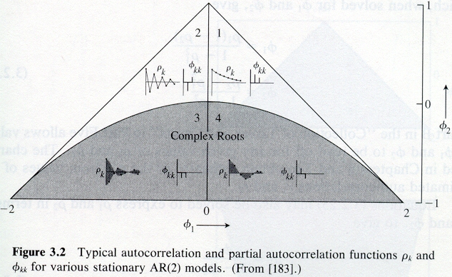

> #By default, R goes 4% more on y and x-axis limits,

> # These par() options make it stop at specified limits

> par(xaxs = "i", yaxs = "i")

> #dummy plot

> plot(x = -2, y = -1, xlim = c(-2,2), ylim = c(-1,1),

type = "n", frame.plot = FALSE, xlab =

expression(phi1[1]), ylab = expression(phi1[2]))

> #abline() draws y = a + bx

> abline(a = 1, b = -1) #Draw line of phi2 = 1 – phi1

> abline(a = 1, b = 1) #Draw line of phi2 = 1 + phi1

> #Plot the phi1 and phi2 values

> points(x = 0.5, y = 0, pch = 1, col = "red")

> points(x = 0, y = -0.5, pch = 2, col = "darkgreen")

> points(x = -0.2, y = -0.5, pch = 2, col = "darkgreen")

> points(x = -1, y = -0.5, pch = 2, col = "darkgreen")

> points(x = -1.8, y = -0.9, pch = 2, col = "darkgreen")

> points(x = 0.5, y = 0.25, pch = 1, col = "red")

> points(x = 1.8, y = 0.9, pch = 3, col = "blue")

> points(x = -1.2, y = 0.8, pch = 3, col = "blue")

> legend(locator(1), legend = c("Causal, real roots",

"Causal, complex roots", "Not Casual"), pch =

c(1,2,3), col = c("red", "darkgreen", "blue"), cex =

0.75, bty = "n")

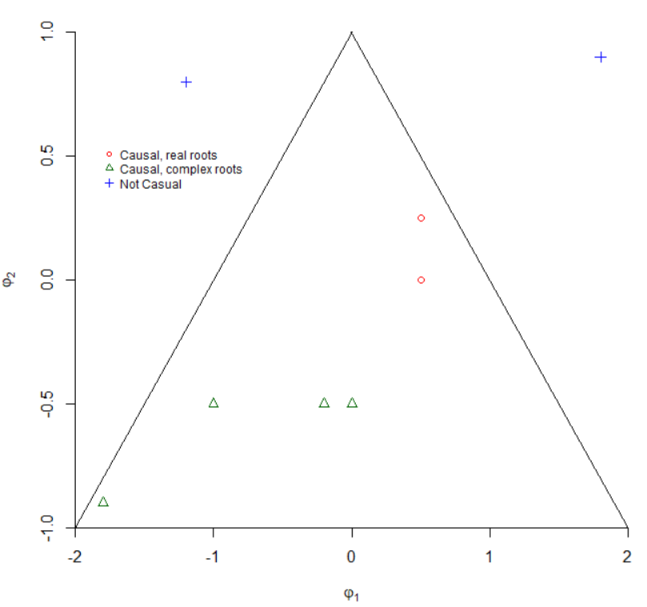

Example: MA(1)

xt = (1 + θB)wt

Causal: Yes, because the model is already written in terms of an MA only model.

Invertible: Let θ(z) = (1 + θz). Note that (1 + θz) = 0 has a root of z = -1/θ. For this to be invertible,

|-1/θ| > 1 ⇔ -1 < θ < 1.

Therefore, a MA(1) model is invertible if -1 < θ < 1.

Notes:

* MA only model will always be causal.
* MA(2) model has similar invertibility conditions as the AR(2) model’s causal conditions.
* ARMA(1,1) model has the same causal conditions as an AR(1) and the same invertible conditions as a MA(1).
* ARMA(2,2) model has the same causal conditions as an AR(2) and the same invertible conditions as a MA(2).