**Regression with ARMA Errors**

Explanatory variables are incorporated into the time series model.

A regression model is typically written as

Yi = β0 + β1xi1 + … + βrxir + εi

where εi ~ INDEPENDENT N(0, σ2) and for i = 1, …, n. The xi1, …, xir represent the explanatory variable values for observation i. In matrix form, **Y** = **Xβ** + **ε**,

where





.

The least squares estimate of **β** is .

Because xt has been used in a different way for our course, I am going to write the model as follows:

yt = β0 + β1zt1 + … + βrztr + xt = **β**′**z**t + xt for t = 1, …, n

where **z**t = (zt1, … ,ztr)′ and **β** = (β0, …, βr)′. In matrix form, **y** = **Zβ** + **x**,where







is known. Note that γ(s,t) may not be 0 for s ≠ t.

What are the elements of **Γ**?

Suppose xt has an ARMA representation. Using this assumption, we could find a representation for **Γ**.

For example, suppose we assume xt has an AR(1) structure.

Then (1-ϕ1B)xt = wt where wt ~ independent N(0,). The model could also be written as xt = ϕ1xt-1 + wt = .

Remember the original model is yt = **β**′**z**t + xt for t = 1, …, n. Then the model can be written as

yt = **β**′**z**t + 

To find **Γ**, start finding variances and covariances for xt. These were already found previously in our course:

Var(xt) =  and Cov(xt, xt-h) = .

Therefore, the covariance matrix, **Γ** has the form of Cov(xt, xt-h) = . Written in matrix form,



For those of you who have studied models for repeated measures, you may have seen this as an AR(1) covariance matrix structure before.

For other ARMA models, the covariance matrix structures can be found as well.

The parameters of the model are **β** = (β1,…,βr)′, , (ϕ1,…, ϕp), and (θ1,…, θq). All of these need to be estimated! Again, we can use maximum likelihood estimation.

The details of the estimation process are not going to be discussed here. Brockwell and Davis’s textbook provides a small discussion.

Example: LA pollution (LApollution.R)

This example uses the LA pollution data from Shumway and Stoffer’s textbook. The authors are interested using the temperature, temperature squared, and particulates in the air to estimate cardiovascular mortality over time for LA county. The data consists of weekly observations for 10 years.

The authors do not provide information about the numerical scale for mortality, but this appears to be the number of deaths per week out of total number of individuals scale. Also, the numerical scale for the particulates is not given.

> library(package = astsa)

> # There are three separate time series, t is also created

> mtp <- data.frame(cmort, tempr, part, t =1:length(cmort))

> head(mtp)

cmort tempr part t

1 97.85 72.38 72.72 1

2 104.64 67.19 49.60 2

3 94.36 62.94 55.68 3

4 98.05 72.49 55.16 4

5 95.85 74.25 66.02 5

6 95.98 67.88 44.01 6

> #Plot of data

> par(mfrow = c(3,1))

> plot(x = mtp$cmort, ylab = expression(y[t]), xlab =

"t", type = "l", col = "red", lwd = 1, main = "Plot of

mortality data", panel.first = grid(col = "gray", lty =

"dotted"))

> points(x = mtp$cmort, pch = 20, col = "blue")

> plot(x = mtp$temp, ylab = expression(T[t]), xlab =

"t", type = "l", col = "red", lwd = 1, main = "Plot of

temperature data", panel.first = grid(col = "gray",

lty = "dotted"))

> points(x = mtp$temp, pch = 20, col = "blue")

> plot(x = mtp$part, ylab = expression(P[t]), xlab =

"t", type = "l", col = "red", lwd = 1, main = "Plot of

Particulate data", panel.first = grid(col = "gray", lty

= "dotted"))

> points(x = mtp$part, pch = 20, col = "blue")



There are trends over time! First, let’s ignore the potential dependence and estimate a regression model assuming independent error terms. Thus, the model is

Mt = β0 + β1t + β2Tt + β3 + β4Pt + xt

where

Mt = cardiovascular mortality at time t

t = time (1, …, 508)

Tt = temperature at time t

Pt = particulates at time t

xt = error term at time t (assumed independent for

each t)

> # Use t here because one would expect time to help

predict

> mod.fit.lm <- lm(formula = cmort ~ t + tempr + I(tempr^2)

+ part, data = mtp)

> summary(mod.fit.lm)

Call:

lm(formula = cmort ~ t + tempr + I(tempr^2) + part, data = mtp)

Residuals:

Min 1Q Median 3Q Max

-19.0760 -4.2153 -0.4878 3.7435 29.2448

Coefficients:

Estimate Std. Error t value Pr(>|t|)

(Intercept) 241.242229 15.813754 15.255 < 2e-16 ***

t -0.026844 0.001942 -13.820 < 2e-16 ***

tempr -3.827264 0.423570 -9.036 < 2e-16 ***

I(tempr^2) 0.022588 0.002827 7.990 9.26e-15 ***

part 0.255350 0.018857 13.541 < 2e-16 ***

---

Signif. codes: 0 ‘***’ 0.001 ‘**’ 0.01 ‘*’ 0.05 ‘.’ 0.1 ‘ ’ 1

Residual standard error: 6.385 on 503 degrees of freedom

Multiple R-squared: 0.5954, Adjusted R-squared: 0.5922

F-statistic: 185 on 4 and 503 DF, p-value: < 2.2e-16

> par(mfrow = c(1,1))

> plot(x = mod.fit.lm$residuals, ylab =

expression(residuals[t]), xlab = "t", type = "l", col =

"red", lwd = 1, panel.first = grid(col = "gray", lty =

"dotted"))

> points(x = mod.fit.lm$residuals, pch = 20, col = "blue")

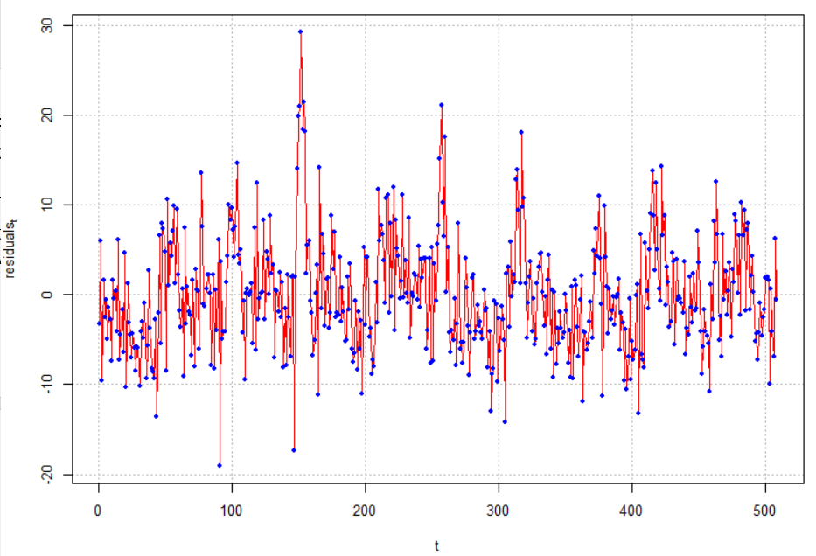

> par(mfrow = c(1,2))

> acf(x = mod.fit.lm$residuals, lag.max = 20, type =

"correlation", main = "Estimated ACF for residuals",

xlim = c(1,20), ylim = c(-1,1))

> pacf(x = mod.fit.lm$residuals, lag.max = 20, main =

"Estimated PACF for residuals", xlim = c(1,20), ylim =

c(-1,1))

> par(mfrow = c(1,1))

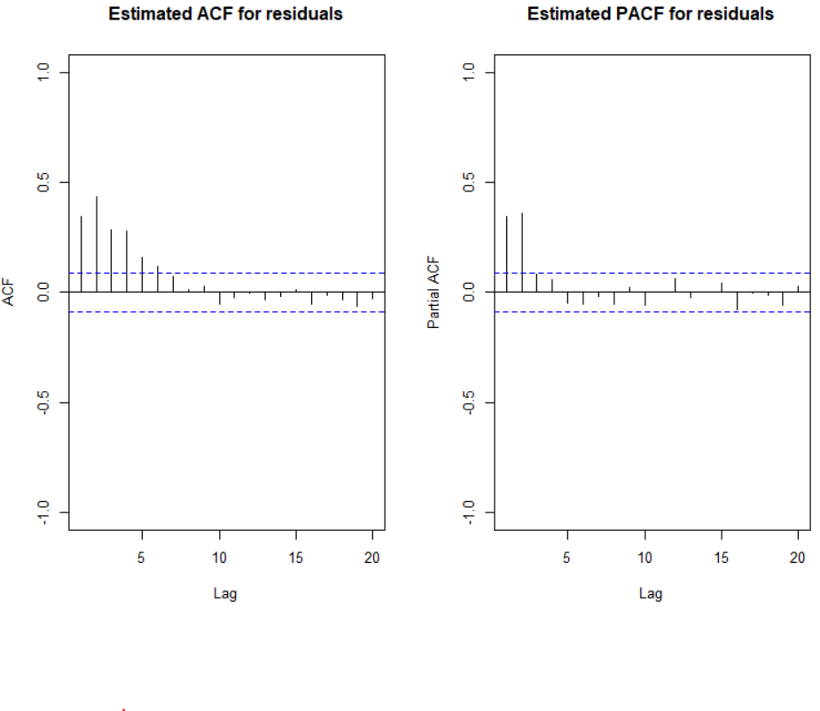

Notes:

* The t variable is included to take into account the mean dependence over time.
* The estimated model is

 = 241.24 - 0.0268t - 3.8273Tt + 0.0226 +

0.25554Pt

* The I() (identity) function used in the formula argument is the standard way in R to include quadratic terms because ^2 is associated with specifying interaction terms.
* The residuals are extracted from mod.fit.lm. There appears to be an ARMA(2,0) structure with them.
* Inferences should not be made with this model due to violations of independence among the error terms.

A similar model can be estimated using arima() by taking advantage of the xreg argument.

> mod.fit.arima1 <- arima(x = cmort, order = c(0, 0, 0),

xreg = cbind(mtp$t, tempr, tempr^2, part))

> mod.fit.arima1

Call:

arima(x = cmort, order = c(0, 0, 0), xreg = cbind(mtp$t, tempr, tempr^2, part))

Coefficients:

intercept mtp$t tempr tempr^2 part

241.2422 -0.0268 -3.8273 0.0226 0.2553

s.e. 15.7357 0.0019 0.4215 0.0028 0.0188

sigma^2 estimated as 40.37: log likelihood = -1660.14, aic = 3332.28

> par(mfrow = c(1,2))

> acf(x = ts(mod.fit.arima1$residuals), lag.max = 20, type

= "correlation", main = "Estimated ACF for residuals",

xlim = c(1,20), ylim = c(-1,1))

> pacf(x = ts(mod.fit.arima1$residuals), lag.max = 20, main

= "Estimated PACF for residuals", xlim = c(1,20), ylim

= c(-1,1))

> par(mfrow = c(1,1))

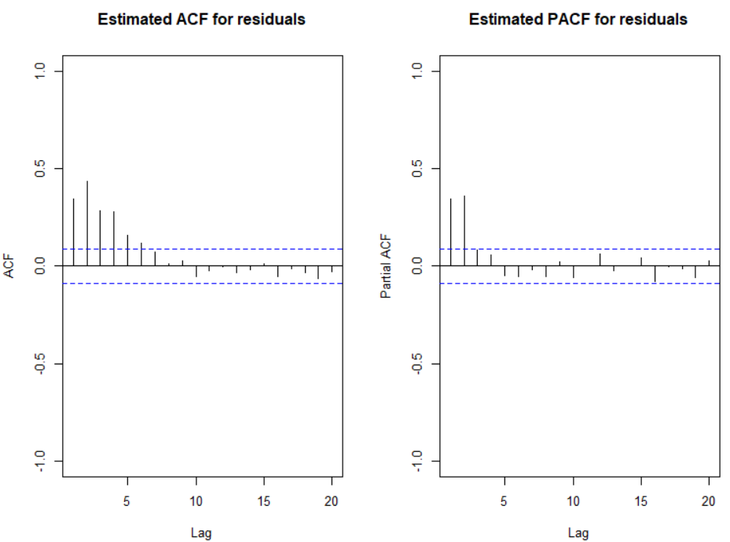

Notes:

* + - The cbind() function combines columns of the explanatory variable values together.
    - Notice the β0 term was included despite 1 not being specified in cbind().
    - Notice that the ts() function was needed with the residuals so that the ACF and PACF could be plotted.

The examine.mod() function can be used to examine the model as well.

> # source("examine.mod.R")

> examine.mod(mod.fit.obj = mod.fit.arima1, mod.name

= "regression with ind.")

$z

intercept mtp$t tempr tempr^2 part

15.330850 -13.884370 -9.080528 8.028930 13.608224

$p.value

intercept mtp$t tempr tempr^2 part

0.000000e+00 0.000000e+00 0.000000e+00 8.881784e-16 0.000000e+00

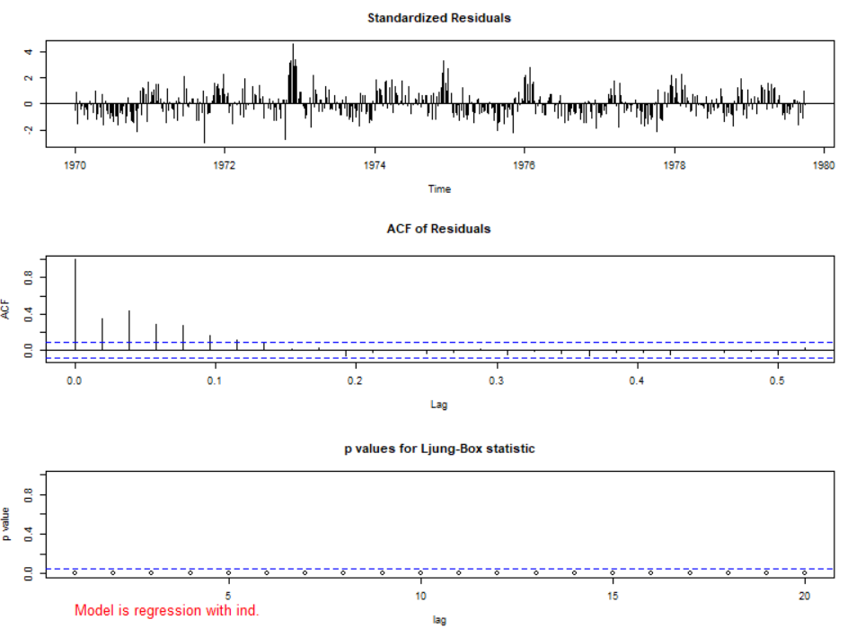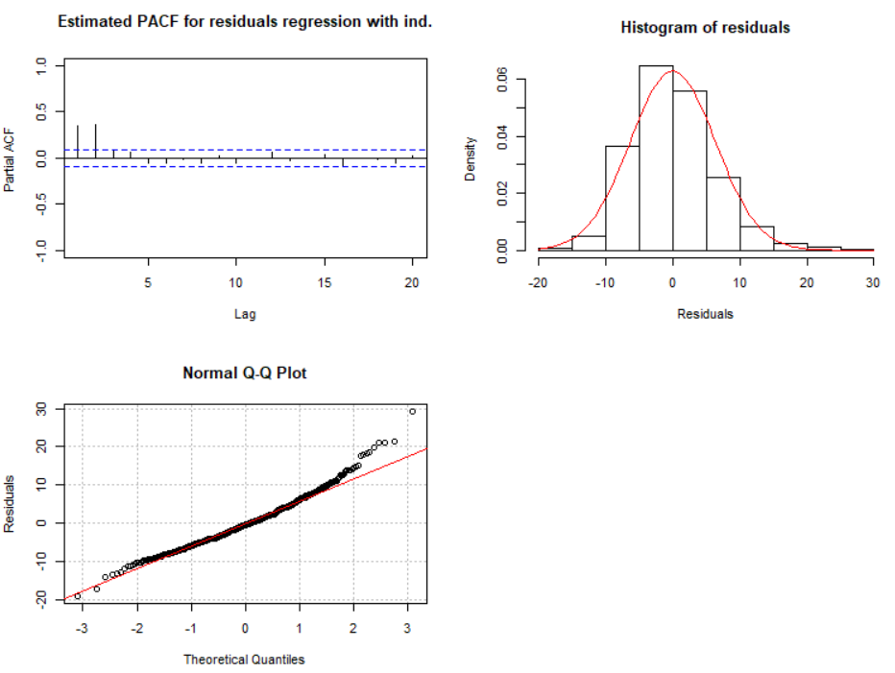

Notice the incorrect values given for the lags on the ACF plot. The lags given on the plot below it can be used to interpret correctly.

Estimate the same model but allow for an ARMA(2,0) structure for the error terms. This is the model estimated by the authors.

> mod.fit.arima2 <- arima(x = cmort, order = c(2, 0, 0),

xreg = cbind(mtp$t, tempr, tempr^2, part))

> mod.fit.arima2

Call:

arima(x = cmort, order = c(2, 0, 0), xreg = cbind(mtp$t, tempr, tempr^2, part))

Coefficients:

ar1 ar2 intercept mtp$t tempr tempr^2

0.3848 0.4326 174.1185 -0.0292 -2.3102 0.0154

s.e. 0.0436 0.0400 11.9080 0.0081 0.3103 0.0020

part

0.1545

s.e. 0.0272

sigma^2 estimated as 26.01: log likelihood = -1549.04, aic = 3114.07

> examine.mod(mod.fit.obj = mod.fit.arima2, mod.name

= "regression with AR(2) error")

$z

ar1 ar2 intercept mtp$t tempr tempr^2

8.832875 10.806154 14.621958 -3.588002 -7.445669 7.613531

part

5.680238

$p.value

ar1 ar2 intercept mtp$t

0.000000e+00 0.000000e+00 0.000000e+00 3.332222e-04

tempr tempr^2 part

9.636736e-14 2.664535e-14 1.345075e-08

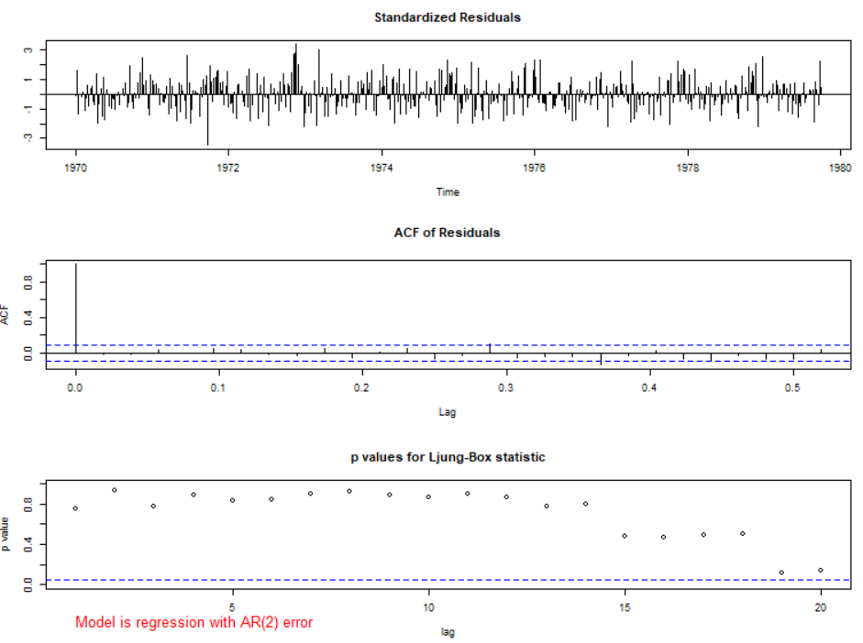

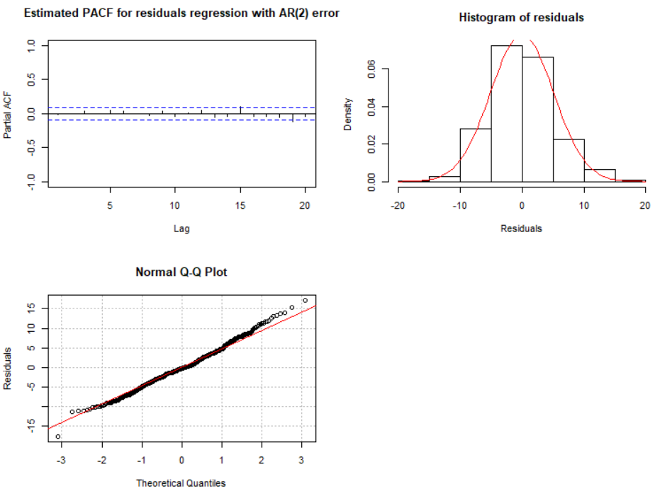

Notes:

* The estimated model is

 = 174.12 - 0.0292t - 2.3102Tt + 0.0154

+ 0.1545Pt

with (1 – 0.3848B – 0.4326B2)xt = wt.

* The ϕ and β parameters are significantly different from 0. See the parameter estimation information for the test statistics and p-values.
* There does not appear to be dependence among the residuals.
* QQ-plot looks o.k.

What if a regression model with ARMA(1,0) terms was estimated?

> mod.fit.arima3 <- arima(x = cmort, order = c(1, 0, 0),

xreg = cbind(mtp$t, tempr, tempr^2, part))

> mod.fit.arima3

Call:

arima(x = cmort, order = c(1, 0, 0), xreg = cbind(mtp$t, tempr, tempr^2, part))

Coefficients:

ar1 intercept mtp$t tempr tempr^2 part

0.6797 170.8419 -0.0293 -2.2252 0.0149 0.1568

s.e. 0.0521 13.1228 0.0053 0.3423 0.0022 0.0327

sigma^2 estimated as 32: log likelihood = -1601.43, aic = 3216.87

> examine.mod(mod.fit.obj = mod.fit.arima3, mod.name

= "regression with AR(1) error")

$z

ar1 intercept mtp$t tempr tempr^2 part

13.035456 13.018694 -5.534242 -6.500896 6.785260 4.790543

$p.value

ar1 intercept mtp$t tempr

0.000000e+00 0.000000e+00 3.125780e-08 7.984280e-11

tempr^2 part

1.158784e-11 1.663307e-06

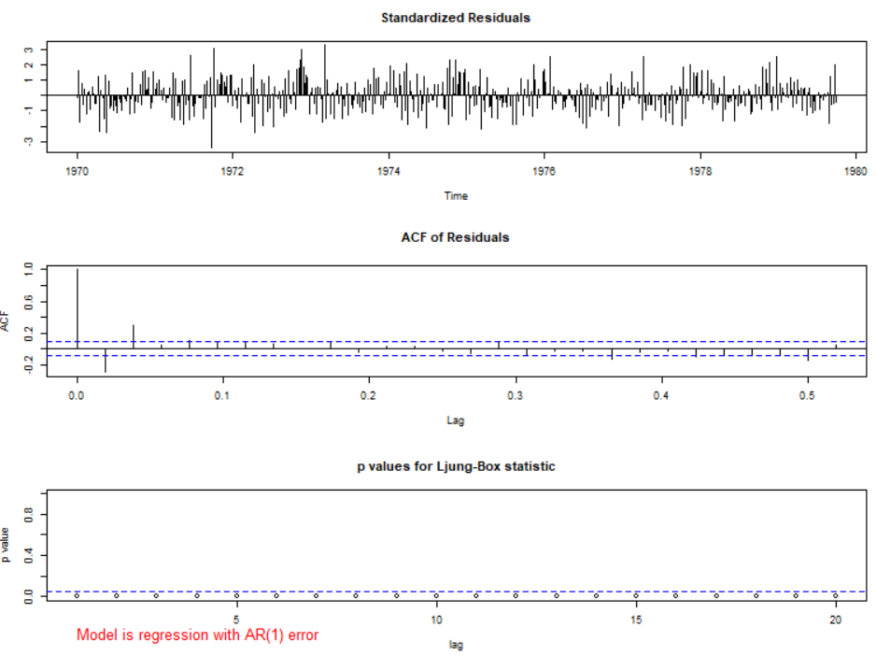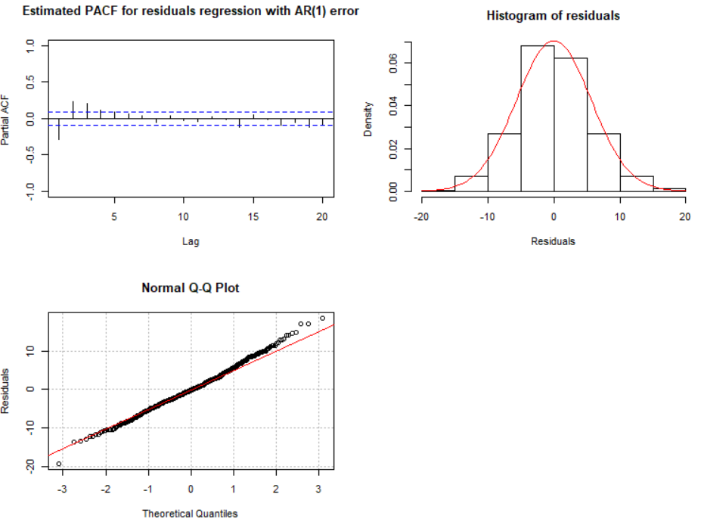

There is dependence among the residuals. This model should not be used.

What if a regression model with ARMA(3,0) terms was estimated?

> mod.fit.arima4

Call:

arima(x = cmort, order = c(3, 0, 0), xreg = cbind(mtp$t, tempr, tempr^2, part))

Coefficients:

ar1 ar2 ar3 intercept mtp$t tempr

0.3653 0.4175 0.0385 175.6741 -0.0291 -2.3503

s.e. 0.0494 0.0438 0.0458 12.1584 0.0083 0.3166

tempr^2 part

0.0156 0.1584

s.e. 0.0021 0.0276

sigma^2 estimated as 25.98: log likelihood = -1548.68, aic = 3115.37

> examine.mod(mod.fit.obj = mod.fit.arima4, mod.name

= "regression with AR(3) error")

$z

ar1 ar2 ar3 intercept mtp$t

7.3980779 9.5351104 0.8412562 14.4487380 -3.5143522

tempr tempr^2 part

-7.4246095 7.5917465 5.7410630

$p.value

ar1 ar2 ar3 intercept

1.381117e-13 0.000000e+00 4.002044e-01 0.000000e+00

mtp$t tempr tempr^2 part

4.408279e-04 1.130207e-13 3.153033e-14 9.408406e-09

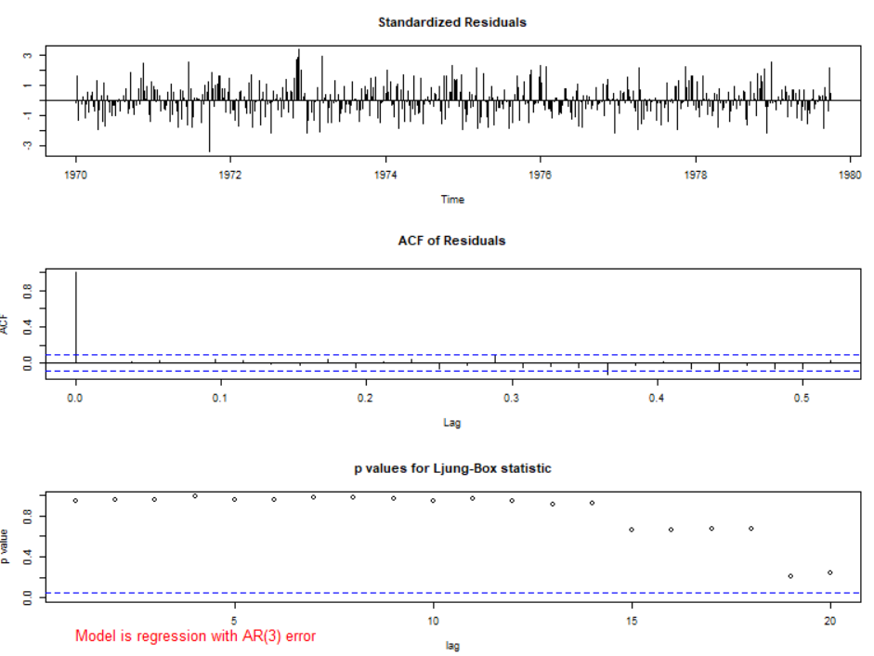

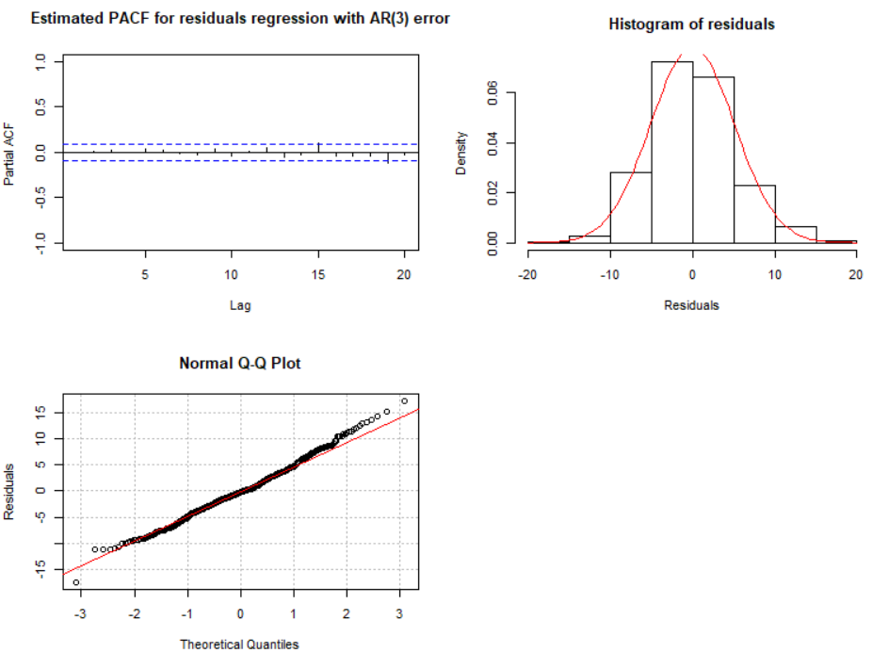

There does not appear to be dependence among the residuals. However, the ϕ3 parameter has a large p-value suggesting it is not needed.

Model building for regression models with ARMA errors

Suppose you do not know what an appropriate ARMA model is for the error terms? Below is a suggested model building strategy:

1. Fit a regular regression model with independent error terms.
2. Examine the ACF and PACF plots of the residuals to determine an appropriate ARMA model for the error terms.
3. Fit the regression model with ARMA error terms.
4. Examine ACF and PACF plots of the residuals adjusted for the ARMA error terms. If the plots are similar to the corresponding plots from a white noise process, then a good model has been chosen. If there are significant autocorrelations or partial autocorrelations, make changes to the model in a similar manner as you would for a regular ARMA model.

Forecasting for regression models with ARMA errors

A primary purpose for time series models is to forecast future values. The problem with doing this here is that we need to know future explanatory values as well!

If you have potential future explanatory variable values, these can be used with the ARMA error structure. Predicted values that account for the ARMA error structure, are:

yt+1 = **β**′**z**t+1 + 

where .

The variance for the predicted value with regular regression models is  where **z** is the vector of explanatory variable values and  is the estimated covariance matrix for . When the ARMA error terms are accounted for, this variance becomes  where r is the variance from the ARMA model. This variance can be used to find the approximate (1-α)100% C.I.s.

Example: LA pollution (LApollution.R)

Find 95% C.I. for one-time period into the future using explanatory variable values equal to the last time period observed and using t = n + 1.

> tail(mtp)

cmort tempr part t

503 73.46 82.37 69.14 503

504 79.03 75.35 42.17 504

505 76.56 72.29 45.59 505

506 78.52 75.68 70.72 506

507 89.43 73.33 57.58 507

508 85.49 70.52 62.61 508

> fore.mod <- predict(object = mod.fit.arima2, n.ahead = 1,

se.fit = TRUE, newxreg = data.frame(508+1, 70.52,

70.52^2, 62.61))

> fore.mod

$pred

Time Series:

Start = c(1979, 41)

End = c(1979, 41)

Frequency = 52

[1] 87.104

$se

Time Series:

Start = c(1979, 41)

End = c(1979, 41)

Frequency = 52

[1] 5.100467

> #Calculate 95% C.I.s

> low <- fore.mod$pred - qnorm(p = 0.975, mean = 0, sd =

1)*fore.mod$se

> up <- fore.mod$pred + qnorm(p = 0.975, mean = 0, sd =

1)*fore.mod$se

> data.frame(low, up)

low up

fore.mod$pred 77.10727 97.10073

The newxreg argument is used to specify future explanatory variable values. Be careful with how to specify these values (see program for comments).

Additional comments

* + - The estimation procedure that we followed is similar to what is known as the Cochrane and Orcutt approach to regression modeling with dependent errors.
    - The gls() function of the nlme package can be used to estimate these models as well. Very small differences in the parameter estimates occur from what I obtained when using the ARMA(2,0) error structure for the LA pollution example. Below is the corresponding code/output:

> library(nlme)

> mod.fit <- gls(model = cmort ~ t + tempr + I(tempr^2) +

part, data = mtp, correlation = corARMA(form = ~t, p =

2))

> summary(mod.fit)

Generalized least squares fit by REML

Model: cmort ~ t + tempr + I(tempr^2) + part

Data: mtp

AIC BIC logLik

3140.488 3174.253 -1562.244

Correlation Structure: ARMA(2,0)

Formula: ~t

Parameter estimate(s):

Phi1 Phi2

0.3939042 0.4381177

Coefficients:

Value Std.Error t-value p-value

(Intercept) 173.34218 11.768397 14.729464 0.000

t -0.02918 0.008841 -3.300541 0.001

tempr -2.29248 0.306589 -7.477358 0.000

I(tempr^2) 0.01537 0.002021 7.606690 0.000

part 0.15014 0.024912 6.026867 0.000

Correlation:

(Intr) t tempr I(t^2)

t -0.178

tempr -0.969 -0.013

I(tempr^2) 0.950 0.009 -0.990

part 0.091 0.033 -0.122 0.037

Standardized residuals:

Min Q1 Med Q3 Max

-2.1033378 -0.6999939 -0.1497608 0.5200921 4.1160089

Residual standard error: 7.996799

Degrees of freedom: 508 total; 503 residual

Note that the model fitting process takes longer to complete.

* + - Shumway and Stoffer reach the same conclusions with their model for the LA pollution example, but use a mean adjusted term for temperature. Thus, they use Tt - T., where T. is the mean observed temperature. This is done to alleviate potential model fitting problems that can occur in regression when a transformation of another explanatory variable is included in the model.
    - Transfer function models provide an additional way to incorporate explanatory variables into a time series model.