**Continuous uniform probability distribution**

Suppose Y is a continuous random variable of interest. The simplest PDF for continuous random variables is when the probability of observing a particular range of values for Y is the same for all equal length ranges! Because the probabilities are the same, this PDF is called the uniform PDF.

The uniform PDF is



Notes:

* We examined this PDF earlier!
* The parameters, α and β, control the location of the PDF. In general, this is what a graph of the PDF looks like.

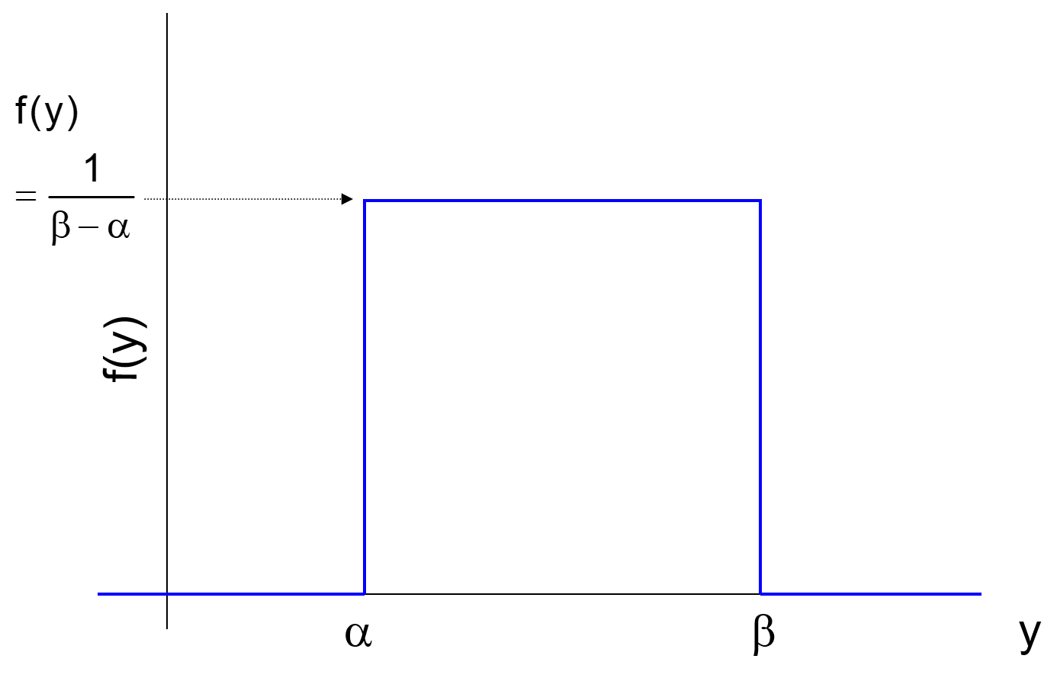

* The area under the curve is 1. Because the PDF looks like a rectangle, we can take base × height = (β-α) × [1/(β-α)] to find the area is 1.

The mean and variance of a random variable Y with a uniform PDF are

 and 

Prove these on your own!

Example: MPG (MPG-uniform.R)

Suppose we are interested in the miles per gallon (MPG) of gas a car gets. Let X be a continuous random variable denoting the MPG for a particular car for one tank of gas. In a very simplistic setting, let



The function quantifies probabilities of getting particular MPG.

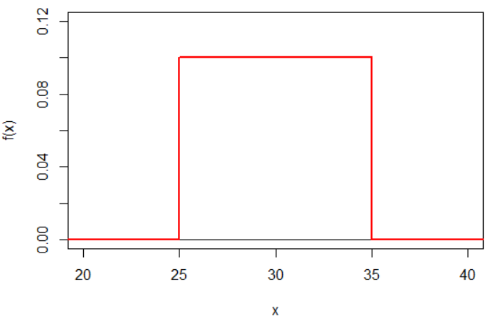

Areas underneath the curve correspond to probabilities. For example, P(25  X  30) = 0.5.