Arguments with the plot() function

  - x specifies what is plotted for the x-axis.
  - y specifies what is plotted for the y-axis.
  - xlab and ylab specify the x-axis and y-axis labels, respectively.
  - main specifies the main title of the plot.
  - xlim and ylim specify the x-axis and y-axis limits, respectively. Notice the use of the c() function.
  - col specifies the color of the plotting points. Run the colors() function to see what possible colors can be used. Also, you can see https://github.com/EarlGlynn/colorchart/wiki/Color-Chart-in-R for the colors from colors().
  - pch specifies the plotting characters. Below is a list of possible characters.
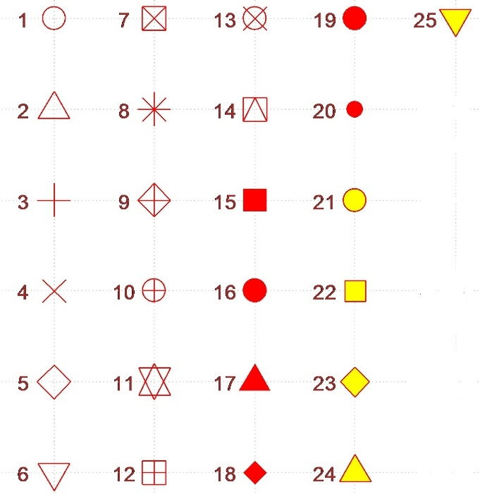

  - cex specifies the height of the plotting characters. The value 1.0 is the default.
  - panel.first = grid() specifies grid lines will be plotted. The line types can be specified as follows: 1=solid, 2=dashed, 3=dotted, 4=dotdash, 5=longdash, 6=twodash or as one of the character strings "blank", "solid", "dashed", "dotted", "dotdash", "longdash", or "twodash". These line type specifications can be used in other functions.

