Partial answer key to homework for Chapter 5 – Part II

5.36 extension
The level of significance is chosen to be α = 0.05.
Confidence interval method:
1.
H_{o}:μ≤80
H_{a}:μ>80
2.
The “one-sided” C.I. for μ is (77.843, ∞)

> t.test(x = ex5.36[,2], alternative = "greater", mu = 80, conf.level = 0.95)

One Sample t-test

data: ex5.36[,2]
t = 0.8427, df = 19, p-value = 0.2049
alternative hypothesis: true mean is greater than 80
95 percent confidence interval:
77.84345 Inf
sample estimates:
mean of x
82.05

3. Since 80 is inside this interval, do not reject H_{o}.
4. There is not sufficient evidence that the mean comprehension for all fourth graders is greater than 80.

Test statistic method:
1.
H_{o}:μ≤80
H_{a}:μ>80
2.
t=0.843 (using the same R code as above)
3.
t_{0.05, 19} = 1.729

> qt(p = 0.95, df = 20-1)
[1] 1.729133

4. Since 0.843 < 1.729, do not reject H_{o}.
5. There is not sufficient evidence that the mean comprehension for all fourth graders is greater than 80.

P-value method:
1.
H_{o}:μ≤80
H_{a}:μ>80
2.
t=0.843.
The p-value is 0.2049.
(using the same R code as above)
3.
α = 0.05
4. Since 0.2049 > 0.05, do not reject H_{o}.
5. There is not sufficient evidence that the mean comprehension for all fourth graders is greater than 80.

5.41
a.
The 95% confidence interval on the mean dissolved oxygen level is (4.57, 5.33).

> ex5.41<-read.table("C:/sdata/ex5-41.txt", header=T, row.names=1, sep=",")
> nrow(ex5.41)
[1] 8
> t.test(x = ex5.41, conf.level = 0.95)

One Sample t-test

data: ex5.41
t = 31.0853, df = 7, p-value = 9.207e-09
alternative hypothesis: true mean is not equal to 0
95 percent confidence interval:
4.573459 5.326541
sample estimates:
mean of x
4.95

b.
No, since the interval contains 5, we don’t enough evidence to say that.
c.
The level of significance is chosen to be α = 0.05.
Confidence interval method:
1.
H_{o}:μ≥5
H_{a}:μ<5
2.
The “one-sided” C.I. for μ is (-∞, 5.252)

> t.test(x = ex5.41, alternative = "less", mu = 5, conf.level = 0.95)

One Sample t-test

data: ex5.41
t = -0.314, df = 7, p-value = 0.3813
alternative hypothesis: true mean is less than 5
95 percent confidence interval:
-Inf 5.251691
sample estimates:
mean of x
4.95

3. Since 5 is inside this interval, do not reject H_{o}.
4. There is not sufficient evidence that the mean oxygen level is less than 5 ppm.
Test statistic method:
1.
H_{o}:μ≥5
H_{a}:μ<5
2.
t=-0.314 (using the same R code as above)
3.
-t_{0.05, 19} = -1.895

> qt(p = 0.05, df = 8-1)
[1] -1.894579

4. Since -0.314 > -1.895, do not reject H_{o}.
5. There is not sufficient evidence that the mean oxygen level is less than 5 ppm.

P-value method:
1.
H_{o}:μ≥5
H_{a}:μ<5
2.
t=-0.314.
The p-value is 0.3813.
(using the same R code as above)
3.
α = 0.05
4. Since 0.3813 > 0.05, do not reject H_{o}.
5. There is not sufficient evidence that the mean oxygen level is less than 5 ppm.

5.43
a. The sample mean of the mercury concentration after the accident is 1.466.

> ex5.58<-read.table("C:/sdata/ex5-58.txt", header=T, sep=",")
> ex5.58 <- as.vector(ex5.43[,1])
> ex5.58
[1] 1.60 1.77 1.61 1.08 1.07 1.79 1.34 1.07 1.45 1.59 1.43 2.07 1.16 0.85 2.11
> mean(ex5.58s)
[1] 1.466

b.
The 95% confidence interval on the mean mercury concentration after the accident is (1.26, 1.67).

> t.test(x = ex5.58, conf.level = 0.95)

One Sample t-test

data: ex5.58
t = 15.0819, df = 14, p-value = 4.736e-10
alternative hypothesis: true mean is not equal to 0
95 percent confidence interval:
1.257521 1.674479
sample estimates:
mean of x
1.466

c.
The level of significance is α = 0.05
Confidence interval method:
1.
H_{o}:μ≤1.2
H_{a}:μ>1.2
2.
The “one-sided” C.I. for μ is (1.295, ∞)

> t.test(x = ex5.58, alternative = "greater", mu = 1.2, conf.level = 0.95)

One Sample t-test

data: ex5.58
t = 2.7365, df = 14, p-value = 0.008032
alternative hypothesis: true mean is greater than 1.2
95 percent confidence interval:
1.294796 Inf
sample estimates:
mean of x
1.466

3. Since 1.2 is not in the interval, reject H_{o}.
4. There is enough evidence to indicate that the mean mercury concentration has increased after the accident.

Test statistic method:
1.
H_{o}:μ≤1.2
H_{a}:μ>1.2
2.
t=2.737 (using the same R code as above)
3.
t_{0.05, 14} = 1.761

> qt(p = 0.95, df = 15-1)
[1] 1.76131

4. Since 2.737 > 1.761, reject H_{o}.
5. There is enough evidence to indicate that the mean mercury concentration has increased after the accident.

P-value method:
1.
H_{o}:μ≤1.2
H_{a}:μ>1.2
2.
t=2.737. The p-value is 0.008.
(using the same R code as above)
3.
α = 0.05
4. Since 0.008 < 0.05, reject H_{o}.
5. There is enough evidence to indicate that the mean mercury concentration has increased after the accident.

d.
The power of the test are 0.235, 0.396, 0.578, 0.744 for mercury concentrations of 1.28, 1.32, 1.36, 1.40, respectively.

> diff.in.means <- c(1.28, 1.32, 1.36, 1.40) - 1.2
> effect.size <- abs(diff.in.means)
> sigma <- 0.32
> alpha <- 0.05
> n<-15
> power.t.test(n = n, d = effect.size, sd = sigma,
sig.level = alpha, type = "one.sample", alternative =
"one.sided")

One-sample t test power calculation

n = 15
delta = 0.08, 0.12, 0.16, 0.20
sd = 0.32
sig.level = 0.05
power = 0.2348073, 0.3963224, 0.5780555, 0.7441821
alternative = one.sided

5.61
The level of significance is α = 0.05
Confidence interval method:
1.
H_{o}:μ≤25
H_{a}:μ>25
2.
The “one-sided” C.I. for μ is (23.00, ∞)

> ex5.61<-read.table("C:/sdata/ex5-61.txt", header=T, sep=",")
> ex5.61 <- as.vector(ex5.61[,1])
> ex5.61
[1] 28 26 24 25 30 32 27 15 28 31 55 42 10 12 38
> t.test(x = ex5.61, alternative = "greater", mu = 25, conf.level = 0.95)

One Sample t-test

data: ex5.61
t = 1.0833, df = 14, p-value = 0.1485
alternative hypothesis: true mean is greater than 25
95 percent confidence interval:
22.99721 Inf
sample estimates:
mean of x
28.2

3. Since 25 is in the interval, do not reject H_{o}.
4. There is not enough evidence to indicate that the mean time to fill an order has increased.

Test statistic method:
1.
H_{o}:μ≤25
H_{a}:μ>25
2.
t=1.083 (using the same R code as above)
3.
t_{0.05, 14} = 1.761

> qt(p = 0.95, df = 15-1)
[1] 1.76131

4. Since 1.083 < 1.761, do not reject H_{o}.
5. There is not enough evidence to indicate that the mean time to fill an order has increased.

P-value method:
1.
H_{o}:μ≤25
H_{a}:μ>25
2.
t=1.083.
The p-value is 0.149.
(using the same R code as above)
3.
α = 0.05
4. Since 0.149 > 0.05, do not reject H_{o}.
5. There is not enough evidence to indicate that the mean time to fill an order has increased.

The power vs. effect size is:
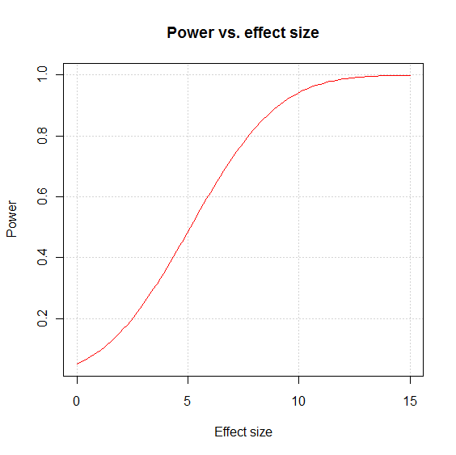
> n <- 15
> crit.val <- qt(p = 0.95, df = n - 1)
> sigma <- sqrt(var(ex5.61))
> curve(expr = 1-pt(q = crit.val, df = n - 1, ncp =
sqrt(n)*x/sigma), xlim = c(0,15), col = "red", xlab
= "Effect size", ylab = "Power", main = "Power vs. effect size",
panel.first = grid(lty = "dotted", col = "lightgray"))

5.62
a)
Point estimate $\overline{y}=74.18$
Confidence interval = (49.71, 98.65)
> ex5.62<-read.table("C:/sdata/ex5-62.txt", header=T, sep=",")
> nrow(ex5.62)
[1] 15
> head(ex5.62)
Day Yield
1 1 57.8
2 2 58.3
3 3 50.3
4 4 38.5
5 5 47.9
6 6 157.0
> mean(ex5.62[,2])
[1] 74.18
> t.test(x = ex5.62[,2], conf.level = 0.95)

One Sample t-test

data: ex5.62[, 2]
t = 6.5027, df = 14, p-value = 1.396e-05
alternative hypothesis: true mean is not equal to 0
95 percent confidence interval:
49.71317 98.64683
sample estimates:
mean of x
74.18

b)
The level of significance is α = 0.05
Confidence interval method:
1.
H_{o}:μ≤50
H_{a}:μ>50
2.
The “one-sided” C.I. for μ is (54.09, ∞)
> t.test(x = ex5.62[,2], alternative = "greater", mu = 50, conf.level = 0.95)

One Sample t-test

data: ex5.62[, 2]
t = 2.1196, df = 14, p-value = 0.0262
alternative hypothesis: true mean is greater than 50
95 percent confidence interval:
54.08771 Inf
sample estimates:
mean of x
74.18

3. Since 50 is outside the interval, reject H_{o}.
4. There is enough evidence to indicate that the average daily output is greater than 50 tons of ore.

Test statistic method:
1.
H_{o}:μ≤50
H_{a}:μ>50
2.
t= 2.1196 (nearly 2.12)
(using the same R code as above)
3.
t_{0.05, 14} = 1.761

> qt(p = 0.95, df = 15-1)
[1] 1.76131

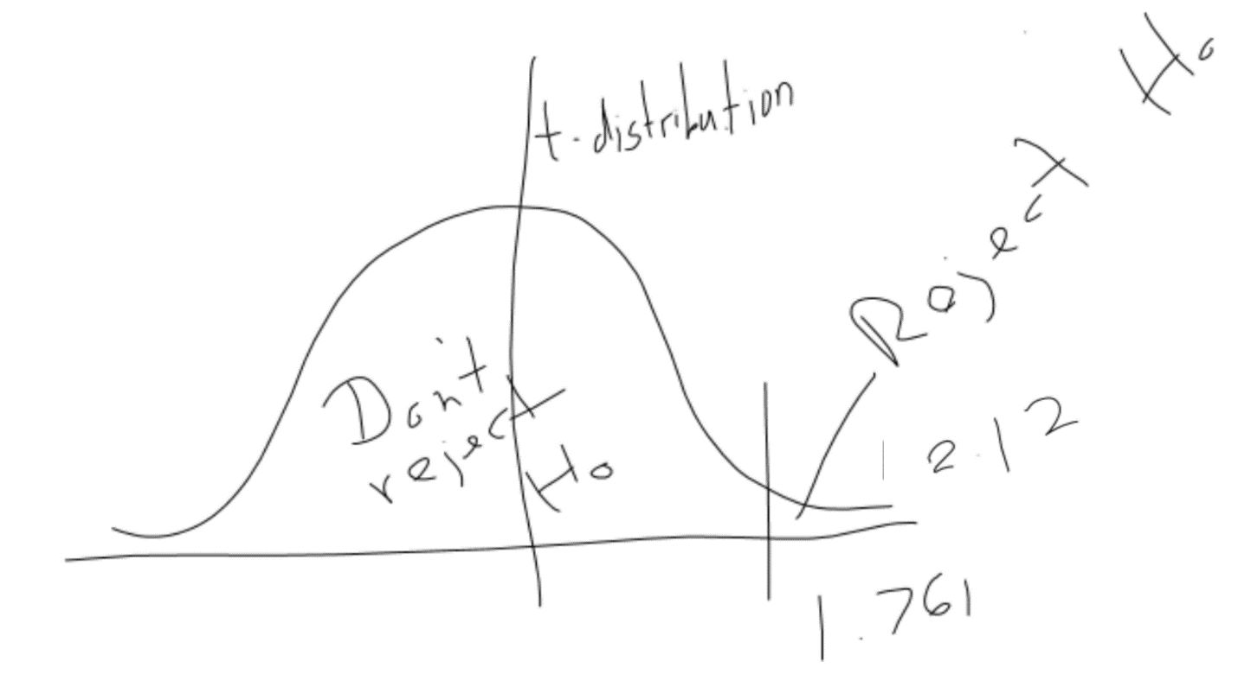

4. Since 2.12 > 1.761, reject H_{o}

5. There is enough evidence to indicate that the average daily output is greater than 50 tons of ore

P-value method:
1.
H_{o}:μ≤50
H_{a}:μ>50
2.
t= 2.1196
The p-value is 0.0262.
(using the same R code as above)
3.
α = 0.05
4. Since 0.0262 < 0.05, reject H_{o}.
5. There is enough evidence to indicate that the average daily output is greater than 50 tons of ore.

