**Inference for one variance**



The purpose of this section is to perform inferences for σ2. Why would this be of interest?

Examples:

* Investing – σ2 is used as a measurement of investment risk. Suppose Y is a random variable denoting daily stock price change for a company. If the daily stock price has a large amount of variability (measured by σ2), then the company may be considered a high-risk investment. If the stock price has a small amount of variability (measured by σ2), then the company may be considered a low-risk investment.

* Quality Control – Suppose a company that produces frozen pizzas wants its pizzas to weigh μ = 16 ounces (this is the stated weight on the package), but will tolerate a standard deviation of σ = 0.1. The 0.1 standard deviation is a measurement of the amount that individual pizzas can deviate from the 16 ounces. One may want to determine if the variability in the pizza weights is larger than 0.1. If σ > 0.1, then the pizza production process may need to be stopped to check for a cause of the larger variability.

Remember that σ2 is estimated by



the sample variance. Why do we use n – 1 in the denominator instead of n to develop an “average” estimate of the square deviation of each observation from the mean?

One can prove that



Thus, on average, the estimate will be off from σ2. To fix this problem, we use



The details for these proofs are available in most mathematical statistics textbooks.

Chi-square probability distribution function

In order to perform inference with respect to σ2, we need to use the chi-square probability distribution. This is another probability distribution which is often used in statistics. Below is its definition:

The continuous random variable X has a chi-square probability distribution, with ν degrees of freedom, if its mathematical function is given by



where ν > 0.

Mean and variance of a random variable with this distribution:

E(X) = μ = ν and Var(X) = σ2 = 2ν

Notes:

* ν is a parameter. Different shapes of the probability distribution result from different values of ν.
* The name “chi-square” could equivalently be expressed as χ2.

Notation:  denotes the 1 – α/2 quantile from a chi-square distribution with ν degrees of freedom.

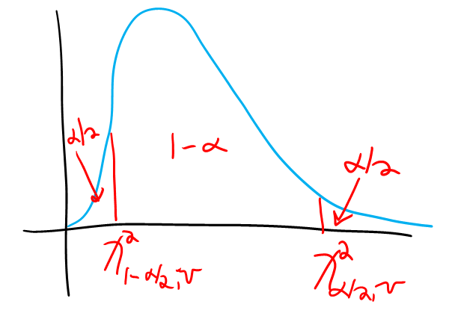



Then P(< X < ) = 1 – α.

Example: Chi-square probability distribution plot (chi_square_dist.xlsx)

This is an interactive file which allows you to see the probability distribution for different degrees of freedom.

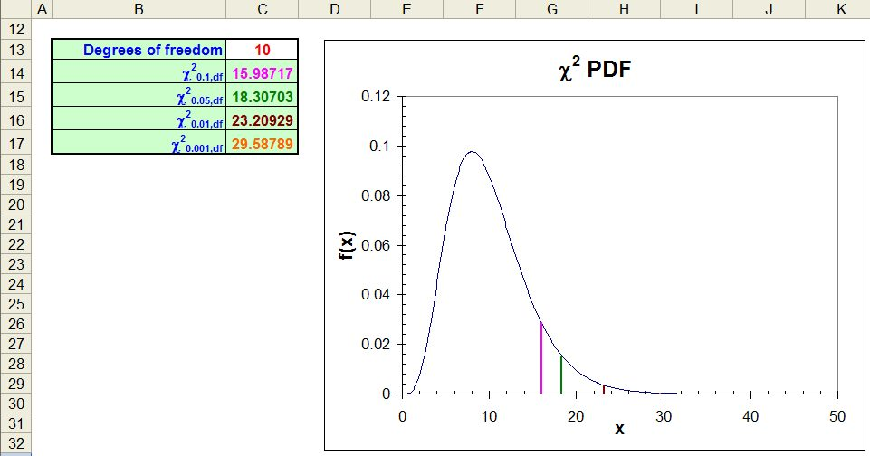

Example: Finding probabilities and quantiles from a chi-square distribution (chi_square_dist.R)

To find P(X < 3.84) with ν = 1, we could use integration:



Instead, we will use the pchisq() function:

> pchisq(q = 3.84, df = 1)

[1] 0.94996

To find the 1 – α/2 quantile from a chi-square distribution, we could use integration:



where we would solve for c in the above equation. Instead, we will use the qchisq() function:

> alpha <- 0.1

> qchisq(p = 1 - alpha/2, df = 1)

[1] 3.8415

The dchisq() function allows us to evaluate f(x) so that we can plot the distribution:

> curve(expr = dchisq(x = x, df = 1), xlim = c(0,5), col

= "red", lwd = 2, main = "Chi-square distribution with

1 DF", ylab = "f(x)", xlab = "x", n = 1000)

> abline(h = 0)



Obviously, the distribution is quite skewed for ν = 1 degree of freedom. Below is another plot of the distribution, but with ν = 10 degrees of freedom:



Some introduction to statistics books provide probabilities corresponding to a particular degrees of freedom in a table format. We will not use a table in this course.

Probability distribution involving S2

In addition to obtaining the probability distribution for , we may want a probability distribution for S2. In order to do this, we need to make the assumption that Y1, Y2, …, Yn are a random sample from a population characterized by a normal probability distribution with E(Yi) = μ and Var(Yi) = σ2. With this assumption, one can show that



has a chi-square probability distribution with ν = n – 1 degrees of freedom.

The reason why a probability distribution for S2 is of interest to us is because it allows statements such as



to be made. Rearranging some terms in the probability expression gives us





This leads to a confidence interval for σ2.

CI for σ2 – If s2 is the observed variance of a random sample of size n from a population characterized by a normal distribution, a (1-α)100% CI for σ2 is

This equation has been corrected for a typo in the video



Note that a confidence interval for just σ can be found as well:



Example: Quality control and hand grenades (grenade.R)

A particular kind of hand grenade has an average explosion time of 5 seconds after its pin is pulled. The manufacturer claims that the standard deviation is 0.2 seconds. To test this claim, a random sample of 10 grenades is taken. Each grenade’s pin is pulled and the number of seconds until an explosion occurs is recorded.

| Grenade | Explosion Time |
| --- | --- |
| 1 | 5.1570 |
| 2 | 5.1171 |
| 3 | 4.6461 |
| 4 | 5.1221 |
| 5 | 4.9337 |
| 6 | 5.0123 |
| 7 | 4.8621 |
| 8 | 4.8758 |
| 9 | 4.8801 |
| 10 | 4.6993 |

Plots:

> grenade

[1] 5.1570 5.1171 4.6461 5.1221 4.9337 5.0123 4.8621

4.8758 4.8801 4.6993

> boxplot(x = grenade, main = "Box and dot

plot", ylab = "Time (seconds)", xlab = "", pars =

list(outpch=NA))

> stripchart(x = grenade, lwd = 2, col = "red", method =

"jitter", vertical = TRUE, pch = 1, main = "Dot plot",

add = TRUE)

> hist(x = grenade, main = "Hand grenade data", xlab =

"Time (seconds)", freq = FALSE, xlim = c(4.5, 5.5))

> curve(expr = dnorm(x = x, mean = mean(grenade), sd =

sd(grenade)), col = "red", add = TRUE)





What do you think about a normal probability distribution assumption for hand grenade explosion time?

Please see how the observations were found in the program!

The 90% CI for σ2 is:







Calculations:

> alpha <- 0.10

> n <- length(grenade)

> qchisq(p = alpha/2, df = n - 1)

[1] 3.3251

> qchisq(p = 1 - alpha/2, df = n - 1)

[1] 16.919

> var(grenade)

[1] 0.030451

> #Interval

> lower <- (n - 1)*var(grenade) / qchisq(p = 1 - alpha/2,

df = n - 1)

> upper <- (n - 1)*var(grenade) / qchisq(p = alpha/2, df =

n - 1)

> data.frame(lower, upper)

lower upper

1 0.016198 0.08242

I am 90% confident that σ2 is between 0.0162 and 0.0824.

Questions:

* What is the confidence interval for σ?  ⇔ 0.1273 < σ < 0.2871
* Is there sufficient evidence to reject the company’s claim that σ = 0.2 (σ2 = 0.04)?
* Using the rule of thumb for the number of standard deviations all data lies from its mean, what may be the shortest time that one would have until a grenade explodes (assuming that μ = 5 seconds)?
* Would you feel better about using a lower or higher level of confidence for this interval? What type of an effect would this have on the interval’s length?

What about hypothesis testing?

Tests can be performed using confidence intervals, test statistics, and p-values in a similar manner as we saw in the previous chapters. We just now use different formulas for confidence intervals and test statistics!

Example: Quality control and hand grenades (grenade.R)

Here are possible hypothesis tests to consider here:

1. Ho: σ2 ≤ 0.04 (= 0.22) vs. Ha: σ2 > 0.04
2. Ho: σ2 ≥ 0.04 vs. Ha: σ2 < 0.04
3. Ho: σ2 = 0.04 vs. Ha: σ2 ≠ 0.04

Which would be of interest?

1. If one rejects Ho, there is a big problem with respect to when a grenade explodes. However, if you don’t reject Ho, could there still be a problem?
2. If one rejects Ho, one would have some sense of relief that the grenade will explode as expected. If you don’t reject Ho, one would be worried a grenade could explode with much more variability that the manufacturer indicates.

I will perform the first test:

CI Method using α = 0.10:

* 1. Ho: σ2 ≤ 0.04  
     Ha: σ2 > 0.04
  2. A one-sided CI



Question: Why is “α” in the subscript for χ2 instead of “α/2”?

Below are the calculations from R:

> (n - 1)*var(grenade) / qchisq(p = 1 - alpha, df = n –

1)

[1] 0.0187

The 90% confidence interval is 0.0187 < σ2 < ∞. For σ itself,

> sqrt((n - 1)*var(grenade) / qchisq(p = 1 - alpha, df

= n - 1))

This code has been corrected for a typo in the video

[1] 0.1366

The interval is 0.1366 < σ < ∞.

* 1. Do not reject Ho because 0.04 is in the interval for σ2.
  2. There is not sufficient evidence to indicate a variance of more than 0.04.

Of course, you could also perform the hypothesis test using the test statistic and p-value methods.

Test statistic: Earlier, we saw that



We can use



then as our test statistic where  is the hypothesized value of σ2 in Ho.

What are the critical values for two-tail, left-tail, and right-tail tests?

P-value for two-tail test:  where X is a random variable that has a chi-square distribution with n – 1 degrees of freedom.

Questions:

* Why isn’t the p-value ?
* What is the p-value formula for a left-tail or right-tail test?

Example: Quality Control and Hand Grenades (grenade.R)

Test statistic method using α = 0.10:

1. Ho: σ2 ≤ 0.04  
   Ha: σ2 > 0.04
2. 

> sigma.sq <- 0.04

> chisquare <- (n - 1)*var(grenade)/sigma.sq

> chisquare

[1] 6.851377

1. 

> qchisq(p = 1 - alpha, df = n - 1)

[1] 14.68366

1.   
   Do not reject Ho because 6.85 < 14.68
2. There is not sufficient evidence to indicate a variance of more than 0.04.

P-value method:

1. Ho: σ2 ≤ 0.04  
   Ha: σ2 > 0.04
2. P(X > χ2) = 0.6530

> 1 - pchisq(q = chisquare, df = n - 1)

[1] 0.6525899

1. α = 0.10
2. Do not reject Ho because 0.6530 > 0.10
3. There is not sufficient evidence to indicate a variance of more than 0.04.

While the methods presented here for inference on σ2 are the most widely used, the normal distribution assumption needed for Y1, …, Yn is a potential problem. Unfortunately, these methods are sensitive to the normality assumption. Are there better alternatives? Yes, but they need large sample sizes to work well. Below are two alternatives:

1. For a large sample, the distribution for S2 can be approximated by a normal distribution with mean parameter of σ2 and variance of



Given this information, one can find a confidence interval for σ2.

1. A statistical procedure known as the bootstrap can be used. This is a nonparametric procedure that uses a computer to estimate a probability distribution for a statistic. Based on this distribution, a confidence interval or hypothesis test can be performed. With respect to confidence interval methods via the bootstrap, the BCa and the studentized are the best.