Partial answer key

8.6

a.

Yes. By looking at the plot, the mean for device A is considerably smaller than the mean for Device D.



#8.6

> ex8.6 <- read.table("ex8-6.txt", header = TRUE, sep = "")

> boxplot(formula = Response ~ Devise, data = ex8.6, col = "lightblue",

main = "Box & dot plot", ylab = "pH readings", xlab = "Device", pars =

list(outpch=NA))

> stripchart(x = Response ~ Devise, data = ex8.6, method = "jitter",

vertical = TRUE, pch = 1,col="red", add=T)

b.

The level of significance is α = 0.05.

Test statistic method:

1. Ho:μA=μB=μC=μD

Ha: At least two design type means are unequal

1. Test statistic: Fobs=4.85

> mod.fit <- aov(formula = Response ~ Devise, data = ex8.6)

> summary(object = mod.fit)

Df Sum Sq Mean Sq F value Pr(>F)

Devise 3 0.58375 0.194583 4.847 0.01077 \*

Residuals 20 0.80290 0.040145

---

Signif. codes: 0 ‘\*\*\*’ 0.001 ‘\*\*’ 0.01 ‘\*’ 0.05 ‘.’ 0.1 ‘ ’ 1

1. Critical Value: = F0.05, 4-1, 24-4 = 3.10

> qf(p = 0.95, df1 = 4 - 1, df2 = 24 - 4)

[1] 3.098391

Because 4.85 > 3.10, reject Ho.

1. There is at least one pair of device type means that are different.

P-value method:

1. Ho:μA=μB=μC=μD

Ha: At least two design type means are unequal

1. P-value is P(X >Fobs)=0.01 where X has an F distribution with 3 and 20 degrees of freedom
2. α = 0.05.
3. Because 0.01 < 0.05, reject Ho.
4. There is at least one pair of device type means that are different.

c.

P-value is 0.01.

d.

The populations for each treatment have approximate normal distributions.

The population variances for each treatment are equal.

8.20

a.

The box and dot plot is:

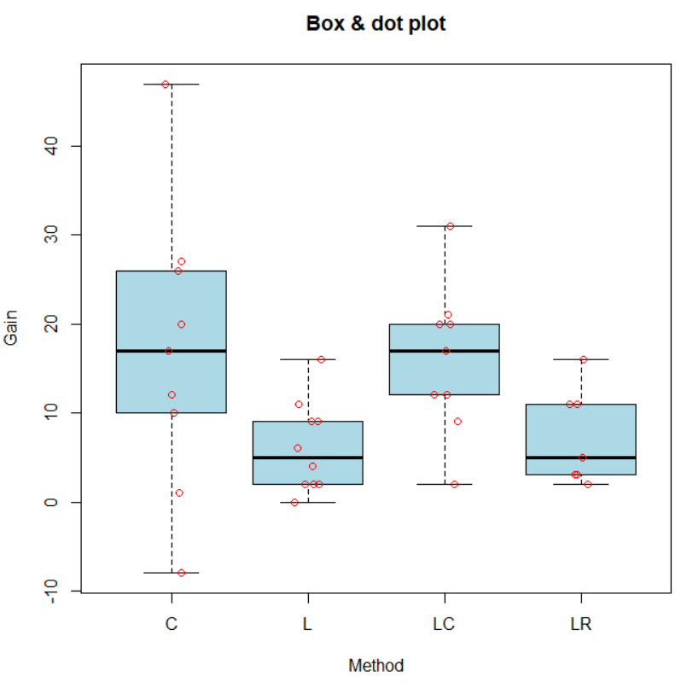

> # This data file is poorly formatted so I just entered data into my program

> # directly

> L <- c(9,2,2,6,16,11,9,0,4,2)

> LR <- c(5,2,3,11,16,11,3)

> LC <- c(9,12,2,17,12,20,20,31,21)

> C <- c(17,12,26,1,47,27,-8,10,20)

> ex8.20 <- rbind(data.frame(Gain = L, Method = "L"),

data.frame(Gain = LR, Method = "LR"),

data.frame(Gain = LC, Method = "LC"),

data.frame(Gain = C, Method = "C"))

Cursory examination suggests Method C or LC is the best on average.

b)

The level of significance is α = 0.05.

Test statistic method:

1) Ho:μL=μLR=μLC=μC

Ha: At least two method of instruction means are unequal

1. Test statistic: Fobs=2.95

> mod.fit <- aov(formula = Gain ~ Method, data = ex8.20)

> summary(object = mod.fit)

Df Sum Sq Mean Sq F value Pr(>F)

Method 3 858.7 286.22 2.949 0.0481 \*

Residuals 31 3009.2 97.07

---

Signif. codes: 0 ‘\*\*\*’ 0.001 ‘\*\*’ 0.01 ‘\*’ 0.05 ‘.’ 0.1 ‘ ’ 1

1. Critical Value: = F0.05, 4-1, 35-4 = 2.91

> qf(p = 0.95, df1 = 4 - 1, df2 = 35 - 4)

[1] 2.911334

Because 2.95 > 2.91, reject Ho.

1. There is at least one pair of method of instruction means that are different.

P-value method:

1. Ho:μL=μLR=μLC=μC

Ha: At least two method of instruction means are unequal

1. P-value is P(X >Fobs)=0.0481 where X has an F distribution with 3 and 31 degrees of freedom
2. α = 0.05.
3. Because 0.0481 < 0.05, reject Ho.
4. There is at least one pair of method of instruction means that are different.

d)

All students at this grade level

e)

Only students from this ‘alternative school’ were selected for the study. This bring into question the applicability of these results to a larger pool of students in a more traditional school setting.

8.29

a.

The box and dot plot is:



> ex8.29 <- read.table("C:/Users/s-bzhang3/Downloads/ex8-29.txt", header =

TRUE, sep="")

> # Need to restructure data

> ex8.29.2 <- rbind(data.frame(Rating = ex8.29$Group.I, Group = 1),

data.frame(Rating = ex8.29$Group.II, Group = 2),

data.frame(Rating = ex8.29$Group.III, Group = 3),

data.frame(Rating = ex8.29$Group.IV, Group = 4))

> boxplot(formula = Rating ~ Group, data = ex8.29, col = "lightblue",

main = "Box & dot plot", ylab = "Ratings", xlab = "Group", pars =

list(outpch=NA))

> stripchart(x = Rating ~ Group, data = ex8.29, method = "jitter", vertical =

TRUE, pch = 1, col = "red", add = TRUE)

Based on the above plot, the assumptions of ANOVA appear to be satisfied (normality and equal variances).

b.

The level of significance is α = 0.05.

Test statistic method:

1. Ho:μ1=μ2=μ3=μ4

Ha: At least two means are unequal

1. Test statistic: Fobs=55.67

> mod.fit <- aov(formula = Rating ~ factor(Group), data = ex8.29.2)

> summary(object = mod.fit)

Df Sum Sq Mean Sq F value Pr(>F)

factor(Group) 3 159.188 53.063 55.672 6.38e-12 \*\*\*

Residuals 28 26.688 0.953

---

Signif. codes: 0 ‘\*\*\*’ 0.001 ‘\*\*’ 0.01 ‘\*’ 0.05 ‘.’ 0.1 ‘ ’ 1

1. Critical Value: = F0.05, 4-1, 32-4 = 2.95

> qf(p = 0.95, df1 = 4 - 1, df2 = 32 - 4)

[1] 2.946685

Because 55.67 > 2.95, reject Ho.

1. There is at least one pair of group type means that are different.

P-value method:

1. Ho:μ1=μ2=μ3=μ4

Ha: At least two means are unequal

1. P-value is P(X > Fobs)<0.0001 where X has an F distribution with 3 and 28 degrees of freedom
2. α = 0.05.
3. Because p-value < 0.05, reject Ho.
4. There is at least one pair of group type means that are different.

9.13

The box and dot plot is:



> ex9.13 <- read.table("ex9-13.txt", header = TRUE, sep = "")

> ex9.13.2 <- rbind(data.frame(loss = ex9.13$A1, agent = "A1"),

data.frame(loss = ex9.13$A2, agent = "A2"),

data.frame(loss = ex9.13$A3, agent = "A3"),

data.frame(loss = ex9.13$A4, agent = "A4"),

data.frame(loss = ex9.13$S, agent = "S"))

> boxplot(formula = loss ~ agent, data = ex9.13, col = "lightblue",

main = "Box & dot plot", ylab = "Weight loss", xlab = "Agent", pars =

list(outpch=NA))

> stripchart(x = loss ~ agent, data = ex9.13, method = "jitter", vertical =

TRUE, pch = 1, col = "red", add = TRUE)

The level of significance is α = 0.05.

Test statistic method:

1. Ho:μA1=μA2=μA3=μA4=μS

Ha: At least two agent type means are unequal

1. Test statistic: Fobs=15.68

> mod.fit <- aov(formula = loss ~ agent, data = ex9.13.2)

> summary(object = mod.fit)

Df Sum Sq Mean Sq F value Pr(>F)

agent 4 61.618 15.4045 15.681 4.164e-08 \*\*\*

Residuals 45 44.207 0.9824

---

Signif. codes: 0 ‘\*\*\*’ 0.001 ‘\*\*’ 0.01 ‘\*’ 0.05 ‘.’ 0.1 ‘ ’ 1

1. Critical Value: = F0.05, 5-1, 50-5 = 2.58

> qf(p = 0.95, df1 = 5 - 1, df2 = 50 - 5)

[1] 2.578739

Because 15.68 > 2.58, reject Ho.

1. There is at least one pair of agent type means that are different.

P-value method:

1. Ho: μA1=μA2=μA3=μA4=μS

Ha: At least two agent type means are unequal

1. P-value is P(X > Fobs) < 0.0001 where X has a F distribution with 4 and 45 degrees of freedom
2. α = 0.05
3. Because p-value < 0.05, reject Ho.
4. There is at least one pair of agent type means that are different.

Some data seem a little skewed (e.g., A1) but overall we don't see any severe violation of the two assumptions.

The pairwise comparisons can be made using LSD:

> aggregate(x = loss ~ agent, data = ex9.13.2, FUN = mean)

agent loss

1 A1 12.05

2 A2 11.02

3 A3 10.27

4 A4 12.24

5 S 9.27

> pairwise.t.test(x = ex9.13.2$loss, g = ex9.13.2$agent, p.adjust.method =

"none", alternative = "two.sided")

Pairwise comparisons using t tests with pooled SD

data: ex9.13.2$loss and ex9.13.2$agent

A1 A2 A3 A4

A2 0.02472 - - -

A3 0.00022 0.09756 - -

A4 0.67023 0.00850 5.7e-05 -

S 1.2e-07 0.00027 0.02898 2.8e-08

P value adjustment method: none

At a αI = 0.05 level, we have:



Using Bonferroni method:

> pairwise.t.test(x = ex9.13.2$loss, g = ex9.13.2$agent, p.adjust.method =

"bonferroni", alternative = "two.sided")

Pairwise comparisons using t tests with pooled SD

data: ex9.13.2$loss and ex9.13.2$agent

A1 A2 A3 A4

A2 0.24716 - - -

A3 0.00222 0.97555 - -

A4 1.00000 0.08499 0.00057 -

S 1.2e-06 0.00274 0.28975 2.8e-07

P value adjustment method: bonferroni

With αE = 0.05 level, we have:



Alternatively, the calculations can be done using the agricolae package:

> library(agricolae)

> LSD.test(y = mod.fit, trt = "agent", alpha = 0.05, group = FALSE, p.adj =

"none", console = TRUE)

Study:

LSD t Test for loss

Mean Square Error: 0.9823778

agent, means and individual ( 95 %) CI

loss std.err replication LCL UCL

A1 12.05 0.2621492 10 11.522004 12.57800

A2 11.02 0.3545890 10 10.305821 11.73418

A3 10.27 0.3245681 10 9.616286 10.92371

A4 12.24 0.2390723 10 11.758484 12.72152

S 9.27 0.3663787 10 8.532075 10.00792

alpha: 0.05 ; Df Error: 45

Critical Value of t: 2.014103

Comparison between treatments means

Difference pvalue sig LCL UCL

A1 - A2 1.03 0.024716 \* 0.1372373 1.922763

A1 - A3 1.78 0.000222 \*\*\* 0.8872373 2.672763

A4 - A1 0.19 0.670225 -0.7027627 1.082763

A1 - S 2.78 0.000000 \*\*\* 1.8872373 3.672763

A2 - A3 0.75 0.097555 . -0.1427627 1.642763

A4 - A2 1.22 0.008499 \*\* 0.3272373 2.112763

A2 - S 1.75 0.000274 \*\*\* 0.8572373 2.642763

A4 - A3 1.97 0.000057 \*\*\* 1.0772373 2.862763

A3 - S 1.00 0.028975 \* 0.1072373 1.892763

A4 - S 2.97 0.000000 \*\*\* 2.0772373 3.862763

> LSD.test(y = mod.fit, trt = "agent", alpha =

0.05, group = FALSE, p.adj = "bonferroni", console = TRUE)

Study:

LSD t Test for loss

P value adjustment method: bonferroni

Mean Square Error: 0.9823778

agent, means and individual ( 95 %) CI

loss std.err replication LCL UCL

A1 12.05 0.2621492 10 11.522004 12.57800

A2 11.02 0.3545890 10 10.305821 11.73418

A3 10.27 0.3245681 10 9.616286 10.92371

A4 12.24 0.2390723 10 11.758484 12.72152

S 9.27 0.3663787 10 8.532075 10.00792

alpha: 0.05 ; Df Error: 45

Critical Value of t: 2.952079

Comparison between treatments means

Difference pvalue sig LCL UCL

A1 - A2 1.03 0.247160 -0.2785257 2.338526

A1 - A3 1.78 0.002221 \*\* 0.4714743 3.088526

A4 - A1 0.19 1.000000 -1.1185257 1.498526

A1 - S 2.78 0.000001 \*\*\* 1.4714743 4.088526

A2 - A3 0.75 0.975555 -0.5585257 2.058526

A4 - A2 1.22 0.084994 . -0.0885257 2.528526

A2 - S 1.75 0.002741 \*\* 0.4414743 3.058526

A4 - A3 1.97 0.000570 \*\*\* 0.6614743 3.278526

A3 - S 1.00 0.289754 -0.3085257 2.308526

A4 - S 2.97 0.000000 \*\*\* 1.6614743 4.278526

15.6

a.

The block-adjusted box and dot plot is:

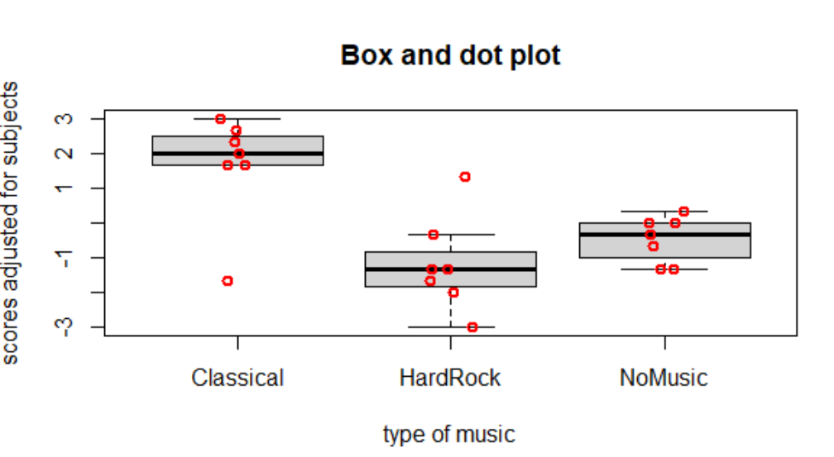

> ex15.6 <- read.table("ex15-6.txt", header=T, sep="\t")

> block.adj <- aggregate(x = TypingEfficiency ~ Subject,

data = ex15.6, FUN = mean)

> gb <- merge(x = ex15.6, y = block.adj, by.x = "Subject", by.y = "Subject",

suffixes = c("","Subject"))

> gb$score.adj <- gb$TypingEfficiency - gb$TypingEfficiencySubject

> boxplot(formula = score.adj ~ TypeMusic, data = gb,

main = "Box and dot plot",ylab = "scores adjusted for subjects",

xlab = "type of music", pars = list(outpch=NA))

> stripchart(x = gb$score.adj ~ gb$Type, lwd = 2, col = "red",

method = "jitter", vertical = TRUE, pch = 1, add = TRUE)

The level of significance is α = 0.05.

Test statistic method:

1. Ho:μ1=μ2=μ3

Ha: At least two music type means are unequal

where type 1,2,3 corresponds to “No music”, “Hard rock” and “Classical” respectively.

1. Test statistic: Fobs=6.54

> mod.fit<-aov(formula = TypingEfficiency~ factor(TypeMusic) +

factor(Subject),data = Ex15.6)

> summary(mod.fit)

Df Sum Sq Mean Sq F value Pr(>F)

factor(TypeMusic) 2 30.952 15.4762 6.5436 0.0119776 \*

factor(Subject) 6 149.333 24.8889 10.5235 0.0003462 \*\*\*

Residuals 12 28.381 2.3651

---

Signif. codes: 0 ‘\*\*\*’ 0.001 ‘\*\*’ 0.01 ‘\*’ 0.05 ‘.’ 0.1 ‘ ’ 1

1. Critical Value: = F0.05, 3-1, 2\*6 = 3.89

> qf(p = 0.95, df1 = 3 - 1, df2 = 12)

[1] 3.885294

1. Because 6.54 > 3.89, reject Ho.
2. There is at least one pair of music type means that are different.

P-value method:

1. Ho:μ1=μ2=μ3

Ha: At least two music type means are unequal

where type 1,2,3 corresponds to “No music”, “Hard rock” and “Classical” respectively.

1. P-value is P(X >F)=0.012 where X has an F distribution with 2 and 12 degrees of freedom.
2. α = 0.05.
3. Because 0.012 < 0.05, reject Ho.
4. There is at least one pair of music type means that are different.

The pairwise comparisons can be made using LSD:

> library(package = agricolae)

> LSD.test(y = mod.fit, trt = "factor(TypeMusic)", alpha = 0.05,

group = FALSE, p.adj = "none", main = "music types", console = TRUE) #LSD

Study: music types

LSD t Test for TypingEfficiency

Mean Square Error: 2.365079

factor(TypeMusic), means and individual ( 95 %) CI

TypingEfficiency std r LCL UCL Min Max

Classical 23.00000 4.123106 7 21.73353 24.26647 16 28

HardRock 20.14286 1.951800 7 18.87639 21.40932 18 23

NoMusic 20.85714 2.968084 7 19.59068 22.12361 17 25

Alpha: 0.05 ; DF Error: 12

Critical Value of t: 2.178813

Comparison between treatments means

difference pvalue signif. LCL UCL

Classical - HardRock 2.8571429 0.0046 \*\* 1.0660885 4.648197

Classical - NoMusic 2.1428571 0.0229 \* 0.3518028 3.933911

HardRock - NoMusic -0.7142857 0.4019 -2.5053400 1.076769

At a αI = 0.05 level, we have:



2 is HardRock, 3 is Classical, and 1 is NoMusic

Using Bonferroni method:

> LSD.test(y = mod.fit, trt = "factor(TypeMusic)", alpha = 0.05,

group = FALSE, p.adj = "bonferroni", main = "music types",

console = TRUE) #bonferroni

Study: music types

LSD t Test for TypingEfficiency

P value adjustment method: bonferroni

Mean Square Error: 2.365079

factor(TypeMusic), means and individual ( 95 %) CI

TypingEfficiency std r LCL UCL Min Max

Classical 23.00000 4.123106 7 21.73353 24.26647 16 28

HardRock 20.14286 1.951800 7 18.87639 21.40932 18 23

NoMusic 20.85714 2.968084 7 19.59068 22.12361 17 25

Alpha: 0.05 ; DF Error: 12

Critical Value of t: 2.779473

Comparison between treatments means

difference pvalue signif. LCL UCL

Classical - HardRock 2.8571429 0.0137 \* 0.5723264 5.141959

Classical - NoMusic 2.1428571 0.0688 . -0.1419593 4.427674

HardRock - NoMusic -0.7142857 1.0000 -2.9991021 1.570531

With αE = 0.05 level, we have:



15.22

The block-adjusted box and dot plot is:

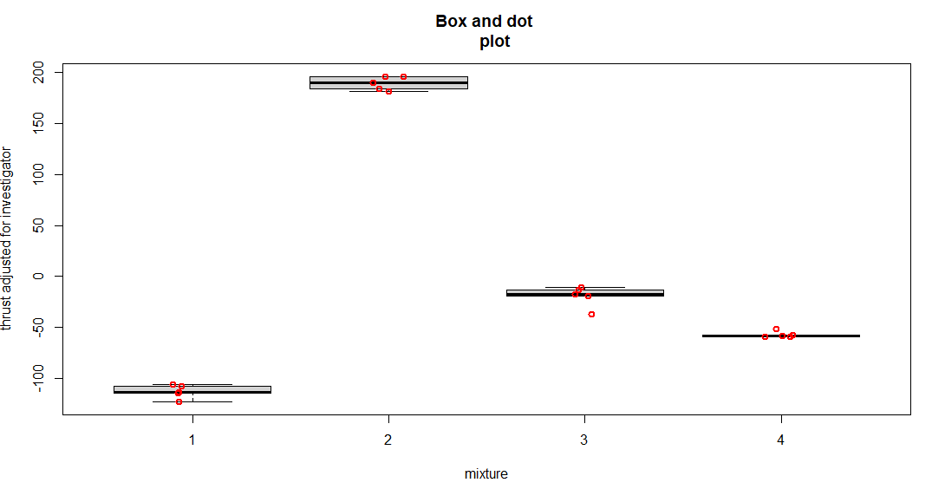

> ex15.22 <- read.table("ex15-22.txt", header=TRUE, sep="")

> block.adj <- aggregate(x = Response ~ Investigator, data = ex15.22,

FUN = mean)

> gb <- merge(x = ex15.22, y = block.adj, by.x = "Investigator",

by.y = "Investigator", suffixes = c("","Investigator"))

> gb$thrust.adj <- gb$Response - gb$ResponseInvestigator

> boxplot(formula = thrust.adj ~ Mixture, data = gb, main = "Box and dot

plot", ylab = "thrust adjusted for investigator", xlab = "mixture", pars

= list(outpch=NA))

> stripchart(x = gb$thrust.adj ~ gb$Mixture, lwd = 2, col = "red",

method = "jitter", vertical = TRUE, pch = 1, add = TRUE)

The level of significance is α = 0.05.

Test statistic method:

1. Ho:μ1=μ2=μ3=μ4

Ha: At least two mixture type means are unequal

1. Test statistic: Fobs=1264.7

> mod.fit<-aov(formula = Response ~ factor(Mixture) + factor(Investigator),

data = ex15.22)

> summary(mod.fit)

Df Sum Sq Mean Sq F value Pr(>F)

factor(Mixture) 3 261261 87087 1264.7269 2.876e-15 \*\*\*

factor(Investigator) 4 452 113 1.6429 0.2273

Residuals 12 826 69

---

Signif. codes: 0 ‘\*\*\*’ 0.001 ‘\*\*’ 0.01 ‘\*’ 0.05 ‘.’ 0.1 ‘ ’ 1

1. Critical Value: = F0.05, 4-1, 3\*4 = 3.49

> qf(p = 0.95, df1 = 4 - 1, df2 = 12)

[1] 3.490295

Because 1264.7 > 3.49, reject Ho.

1. There is at least one pair of mixture type means that are different.

P-value method:

1. Ho:μ1=μ2=μ3=μ4

Ha: At least two mixture type means are unequal

1. P-value is P(X >F)<0.0001 where X has an F distribution with 3 and 12 degrees of freedom.
2. α = 0.05.
3. Because p-value<0.0001 < 0.05, reject Ho.
4. There is at least one pair of mixture type means that are different.

a.

Blocks are investigators and treatments are mixtures.

c.

The variability contributed by each investigator was not taken into account in a CRD.

15.24

The box and dot plot is:



> ex15.24 <- read.table("ex15-24.txt", header=TRUE, sep="")

> block.adj <- aggregate(formula = Productivity ~ Attitude, data = ex15.24,

FUN = mean)

> gb <- merge(x = ex15.24, y = block.adj, by.x = "Attitude", by.y =

"Attitude", suffixes = c("","Attitude"))

> gb$prod.adj <- gb$Productivity - gb$ProductivityAttitude

> boxplot(formula = prod.adj ~ Workshop, data = gb, main = "Box and dot

plot", ylab = "productivity adjusted for attitudes", xlab = "type of

workshop", pars = list(outpch=NA))

> stripchart(x = gb$prod.adj ~

gb$Workshop, lwd = 2, col = "red", method = "jitter", vertical = TRUE,

pch = 1, add = TRUE)

> stripchart(x = gb$prod.adj ~ gb$Workshop, lwd = 2, col = "red",

method = "jitter", vertical = TRUE, pch = 1, add = TRUE)

The level of significance is α = 0.05.

Test statistic method:

1. Ho:μA=μB=μC=μD

Ha: At least two workshop type means are unequal

1. Test statistic: Fobs=66.3

> mod.fit <- aov(formula = Productivity ~ Workshop + factor(Attitude), data =

ex15.24)

> summary(mod.fit)

Df Sum Sq Mean Sq F value Pr(>F)

Workshop 3 922.55 307.52 66.251 9.746e-08 \*\*\*

factor(Attitude) 4 2785.50 696.38 150.027 3.907e-10 \*\*\*

Residuals 12 55.70 4.64

---

Signif. codes: 0 ‘\*\*\*’ 0.001 ‘\*\*’ 0.01 ‘\*’ 0.05 ‘.’ 0.1 ‘ ’ 1

1. Critical Value: = F0.05, 4-1, 3\*4 = 3.49

> qf(p = 0.95, df1 = 4 - 1, df2 = 12)

[1] 3.490295

Because 66.3 > 3.49, reject Ho.

1. There is at least one pair of workshop type means that are different.

P-value method:

1. Ho:μA=μB=μC=μD

Ha: At least two workshop type means are unequal

1. P-value is P(X >Fobs)<0.0001 where X has an F distribution with 3 and 12 degrees of freedom.
2. α = 0.05.
3. Because p-value <0.0001< 0.05, reject Ho.
4. There is at least one pair of workshop type means that are different.

The pairwise comparisons can be made using Tukey’s HSD:

> TukeyHSD(x = mod.fit, conf.level = 0.95, which = "Workshop")

Tukey multiple comparisons of means

95% family-wise confidence level

Fit: aov(formula = prod ~ type + factor(atti), data = ex9.7)

$Workshop

diff lwr upr p adj

B-A 3.8 -0.24541149 7.845411 0.0680951

C-A 7.8 3.75458851 11.845411 0.0004783

D-A 18.2 14.15458851 22.245411 0.0000001

C-B 4.0 -0.04541149 8.045411 0.0529578

D-B 14.4 10.35458851 18.445411 0.0000010

D-C 10.4 6.35458851 14.445411 0.0000313

> aggregate(x = prod.adj ~ Workshop, data = gb, FUN = mean)

Workshop prod.adj

1 A -7.45

2 B -3.65

3 C 0.35

4 D 10.75

Based on the p-values given and αE = 0.05, the results can be displayed as



15.28

The box and dot plot is:

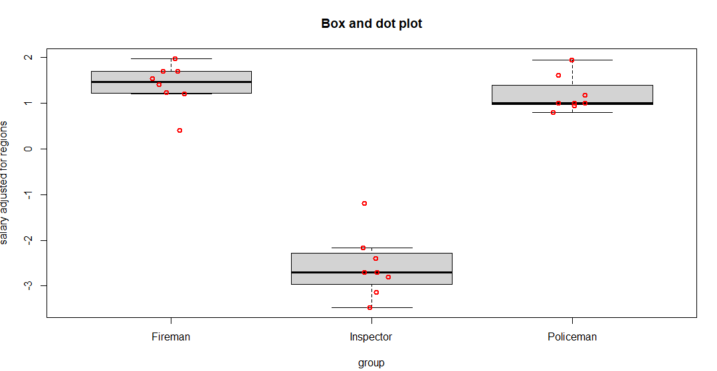

> ex15.28 <- read.table("ex15-28.txt", header=TRUE, sep="")

> block.adj <- aggregate(x = Salary ~ Region, data = ex15.28, FUN =

mean)

> gb <- merge(x = ex15.28, y = block.adj, by.x = "Region", by.y = "Region",

suffixes = c("","Region"))

> gb$salary.adj <- gb$Salary - gb$SalaryRegion

> boxplot(formula = salary.adj ~ Group, data = gb, main = "Box and dot plot",

ylab = "salary adjusted for regions", xlab = "group", pars =

list(outpch=NA))

> stripchart(x = gb$salary.adj ~ gb$Group, lwd = 2, col = "red",

method = "jitter", vertical = TRUE, pch = 1, add = TRUE)

a.

yij = μ + αi + βj + εij for i = 1, 2, 3 and j = 1, …, 8

μ : overall mean

yij : starting salary in region jof job type i

αi : ith job type effect

βj : jth region effect

εij : random error term

b.

The level of significance is α = 0.05.

Test statistic method:

1. Ho:μ1=μ2=μ3

Ha: At least two group means are unequal

where group 1,2,3 corresponds to “Policemen”, “Fireman” and “Inspectors”, respectively.

1. Test statistic: Fobs=94.2

> mod.fit<-aov(formula = Salary ~ factor(Group) + factor(Region), data =

ex15.28)

> summary(mod.fit)

Df Sum Sq Mean Sq F value Pr(>F)

factor(Group) 2 79.491 39.745 94.165 7.594e-09 \*\*\*

factor(Region) 7 42.620 6.089 14.425 2.027e-05 \*\*\*

Residuals 14 5.909 0.422

---

Signif. codes: 0 ‘\*\*\*’ 0.001 ‘\*\*’ 0.01 ‘\*’ 0.05 ‘.’ 0.1 ‘ ’ 1

1. Critical Value: = F0.05, 3-1, 2\*7 = 3.74

> qf(p = 0.95, df1 = 3 - 1, df2 = 14)

[1] 3.738892

Because 94.2 > 3.74, reject Ho.

1. There is at least one pair of group means that are different.

P-value method:

1. Ho:μ1=μ2=μ3

Ha: At least two group means are unequal

where group 1,2,3 corresponds to “Policemen”, “Fireman” and “Inspectors” respectively.

1. P-value is P(X >Fobs)<0.0001 where X has an F distribution with 2 and 14 degrees of freedom.
2. α = 0.05.
3. Because p-value<0.0001 < 0.05, reject Ho.
4. There is at least one pair of group means that are different.

c.

α = 0.05.

d.

The pairwise comparisons can be made using LSD:

> library(package = agricolae)

> LSD.test(y = mod.fit, trt = "factor(Group)", alpha = 0.05, group = FALSE,

p.adj = "none", main = "job types", console = TRUE) #LSD

Study: job types

LSD t Test for Salary

Mean Square Error: 0.4220833

factor(Group), means and individual ( 95 %) CI

Salary std r LCL UCL Min Max

Fireman 30.6375 1.7377633 8 30.14485 31.13015 27.5 32.8

Inspector 26.6750 0.8779033 8 26.18235 27.16765 25.3 27.9

Policeman 30.4250 1.7726091 8 29.93235 30.91765 27.9 33.2

Alpha: 0.05 ; DF Error: 14

Critical Value of t: 2.144787

Comparison between treatments means

difference pvalue signif. LCL UCL

Fireman - Inspector 3.9625 0.0000 \*\*\* 3.2657881 4.6592119

Fireman - Policeman 0.2125 0.5236 -0.4842119 0.9092119

Inspector - Policeman -3.7500 0.0000 \*\*\* -4.4467119 -3.0532881

At a αI = 0.05 level, we have:



2 is Fireman, 3 is Inspector, and 1 is Policeman

Using Bonferroni method:

> LSD.test(y = mod.fit, trt = "factor(Group)", alpha = 0.05, group = FALSE,

p.adj = "bonferroni", main = "job types", console = TRUE) #bonferroni

Study: job types

LSD t Test for Salary

P value adjustment method: bonferroni

Mean Square Error: 0.4220833

factor(Group), means and individual ( 95 %) CI

Salary std r LCL UCL Min Max

Fireman 30.6375 1.7377633 8 30.14485 31.13015 27.5 32.8

Inspector 26.6750 0.8779033 8 26.18235 27.16765 25.3 27.9

Policeman 30.4250 1.7726091 8 29.93235 30.91765 27.9 33.2

Alpha: 0.05 ; DF Error: 14

Critical Value of t: 2.717755

Comparison between treatments means

difference pvalue signif. LCL UCL

Fireman - Inspector 3.9625 0 \*\*\* 3.0796652 4.845335

Fireman - Policeman 0.2125 1 -0.6703348 1.095335

Inspector - Policeman -3.7500 0 \*\*\* -4.6328348 -2.867165

With αE = 0.05 level, we have:

